# Marine biotoxin depuration rates: management applications, research priorities, and predictions for unstudied species

Christopher M. Free1,2*, Yutian Fang2

1 Marine Science Institute, University of California, Santa Barbara, Santa Barbara, CA, 93106, USA

2 Bren School of Environmental Science and Management, University of California, Santa Barbara, Santa Barbara, CA, 93106, USA

**\* Corresponding author:** Marine Science Institute, University of California, Santa Barbara, Santa Barbara, CA, 93106, USA; [cfree14@gmail.com](mailto:cfree14@gmail.com)

## Abstract (251 of 250 word max)

Monitoring and managing the public health risk posed by marine biotoxins is a daunting challenge. With expansive coastlines, 1000s of seafood species, and dozens of biotoxins, monitoring cannot occur everywhere at once. Improving the cost-effectiveness of biotoxin monitoring is thus critical to expanding coverage to include more species, toxins, and locations. Notably, understanding the rate at which seafood species depurate biotoxins can be used to optimize the cadence of monitoring. We conducted a systematic review to collate marine biotoxin depuration rates and synthesize the factors that influence them; identify knowledge gaps, best practices, and research priorities; and generate predictions of depuration rates for unstudied species. We found that only 61 marine species have been studied for their biotoxin depuration rates. Depuration rates for non-bivalves and for toxins besides paralytic shellfish toxins (PSTs) are especially understudied. Depuration half-lives varied from 0.03 to 693 days based on species, toxin, tissue, and environmental conditions. In general, depuration accelerates with increased temperature and food availability, with implications for aquaculture siting, depuration enhancement, and biotoxin monitoring. We identified XX unstudied bivalve species that are highly produced and vulnerable to HABs that are high priorities for future research. Finally, we used a Bayesian regression model to predict PST depuration ratesfor 102 unstudied bivalve species, the only clade-syndrome with sufficient training data. These predictions can guide efficient monitoring and management until lab- or field-based depuration rates become available. We recommend that future studies directly estimate depuration rates to ensure their comparability across studies and utility to managers.

**Keywords (7 words max):** harmful algal blooms, phycotoxin, toxin, elimination, detoxification, excretion, toxicokinetics

## 

## Highlights (3-5 bullets; 85 characters max)

* Knowing biotoxin depuration rates can improve efficiency of marine biotoxin monitoring
* We conduct a systematic review and meta-analysis of marine biotoxin depuration rates
* Only 61 species have depuration rates; non-bivalves and non-PSTs are understudied
* Half-lives vary from 0.03-693 days based on species, toxin, tissue, and environment
* We predict depuration rates for unstudied species and prioritize rates for future study

**Target journal:** [*Harmful Algae*](https://www.sciencedirect.com/journal/harmful-algae/publish/guide-for-authors)

**Key documents:** [Google Drive](https://drive.google.com/drive/u/1/folders/1oaZk0Z3dkgFd479qe6MOzUjxJlR33eXI) | [old text](https://docs.google.com/document/d/1BIoVDlmriQVgeHpvDG4KFdsauJexlAOzRBHHfXbYrtc/edit?tab=t.0) | [WoS search](https://www.webofscience.com/wos/woscc/summary/d347e12f-f4bf-45fc-8c6b-b1243b039d28-011949e01c/relevance/1) | [Database round 2](https://docs.google.com/spreadsheets/d/1vDVXWgxhW4GzJXlQYnRa1jWu3kw6cyWo8eXeb1D673M/edit?gid=377321280#gid=377321280) | [cover letter](https://docs.google.com/document/d/113Raga08V9VKVyNhi23DRak0GICGaLp3Ag4BC36qcK4/edit?tab=t.0)

## To-do list

* Intro/methods
  + Clarify 1 vs 2 compartment model
* Methods
  + Explain RE scenarios
  + Any adhoc analyses?
* Results
  + Expand to include Round 2
* Supplemental Tables and Figures
  + Figure S1 - Finalize numbers
  + Figure S7 - Fit and compare models
* Analyses
  + Fit and compare 1 vs 2 models
  + Plot 1 vs 2 models
  + Incorporate Chinese literature
* Discussion
  + Conclusions paragraph
* Later
  + Build/add form for entering new data to GitHub
  + PRISMA protocol appendices

## 

## 1. Introduction

Harmful algal blooms (HABs) that produce biotoxins that accumulate in seafood species represent a growing threat to public health and marine fisheries and aquaculture [(Hallegraeff et al., 2021)](https://www.zotero.org/google-docs/?Ag4IuC). More than 200 taxa of marine algae produce biotoxins that threaten human health [(Lundholm et al., 2009)](https://www.zotero.org/google-docs/?WwjK29), with risk present in nearly all coastal waters [(OBIS, 2025)](https://www.zotero.org/google-docs/?OCTRGK). Collectively, these toxins cause seven major poisoning syndromes in humans – paralytic, amnesic, diarrhetic, neurotoxic, azaspiracid, cyanotoxin, and ciguatera poisoning – with new toxins and syndromes discovered each decade [(Nicolas et al., 2017)](https://www.zotero.org/google-docs/?IdHnoD). These syndromes cause symptoms ranging from gastrointestinal issues to neurological issues to death [(Grattan et al., 2016)](https://www.zotero.org/google-docs/?7cV471). As a result, managers often close fisheries and aquaculture to protect public health, which can cause significant socioeconomic impacts from lost commercial, recreational, and cultural activities [(Moore et al., 2020)](https://www.zotero.org/google-docs/?qvQztM). HABs are expected to increase in frequency, duration, and intensity with climate change [(IPCC, 2019)](https://www.zotero.org/google-docs/?StJVRV), making them critical to study to ensure that seafood can safely remain a source of healthy, sustainable food for a growing human population.

To protect public health, many governments use biotoxin monitoring programs to track seafood safety and manage fisheries and aquaculture operations that are vulnerable to biotoxin risk [(Andersen et al., 2004)](https://www.zotero.org/google-docs/?CqOQ32). In general, these programs monitor the toxicity of seafood species and trigger management actions when toxicity rises above a threshold deemed unsafe for human consumption, commonly referred to as the “action threshold” [(Langlois and Morton, 2018)](https://www.zotero.org/google-docs/?Vu7GJk). The management action, which could be a closure or an evisceration requirement (i.e., required removal of toxic body parts), is not ceased until toxicity falls below the action threshold, often after several successive tests to ensure safety. Ideally, all vulnerable species would be monitored to fully protect public health [(Costa et al., 2017)](https://www.zotero.org/google-docs/?fXkx7E) and sampling would be highly spatially and temporally resolved to protect public health while also avoiding unnecessary management restrictions [(Free et al., 2022)](https://www.zotero.org/google-docs/?ZG3jpa). However, given limited resources to support expensive lab testing, expansive taxonomic, spatial, and temporal coverage is rarely possible [(Langlois and Morton, 2018)](https://www.zotero.org/google-docs/?1lX1cU). Improving the cost-effectiveness of biotoxin monitoring is thus necessary to monitor more species, in more places, at more times. This could be achieved by either lowering the cost of each test (i.e., cheaper monitoring) or by lowering the number of tests required to effectively manage risk (i.e., more efficient monitoring).

One pathway for improving the efficiency of biotoxin monitoring programs is to tailor the frequency of sampling to the toxicokinetics of the monitored species [(Blanco, 2009)](https://www.zotero.org/google-docs/?rKN9Jq). Toxicokinetics describe the processes and rates of accumulation (a.k.a., uptake, adsorption), distribution, metabolism, and depuration (a.k.a., excretion, elimination, detoxification) of biotoxins within a species [(Landrum et al., 1992)](https://www.zotero.org/google-docs/?1pqK14). The rate at which species accumulate toxins determines how quickly monitoring should begin and proceed after a HAB is detected. For example, monitoring could begin later and advance more slowly if accumulation is slow but should begin sooner and advance more quickly if accumulation is fast. The distribution of toxin burden among different tissues is important because it determines what tissue is the most useful indicator of public health risk and whether a species could be safely consumed and successfully marketed following the evisceration (removal) of the most toxic tissue. The metabolism of the consumed toxin into new compounds, which can be either more or less toxic than the original compound [(Bricelj and Shumway, 1998)](https://www.zotero.org/google-docs/?xe89MO), contributes to the duration of seafood toxicity. Finally, the rate of depuration determines how frequently monitoring is needed after a species becomes toxic to facilitate the timely end of management actions. It can also be used to provide seafood harvesters, processors, and dealers forecasts of when management actions are likely to cease.

The use of depuration rates to design more efficient biotoxin monitoring and management is particularly promising because of the availability of good mathematical models for describing depuration and forecasting the duration of high toxicity. In general, depuration kinetics are theorized to follow either one- or two-compartment exponential decay [(Blanco, 2009)](https://www.zotero.org/google-docs/?CDQVUG). In a one-compartment model, biotoxins are assumed to accumulate within a single “compartment”, which can represent a single tissue, a group of tissues, or even a whole organism, and are assumed to be exponentially lost to the environment at a single rate. For example, a toxin might accumulate in the digestive system following ingestion and then be quickly eliminated through egestion. In a two-compartment model, biotoxins are assumed to accumulate in an initial compartment (e.g., the digestive system) with some transference to a second compartment (e.g., muscle) with a slower exponential depuration rate. A two compartment model can also be conceptualized and parameterized to represent the depuration of labile and strongly bound toxins or sub-tissues within a single compartment. Theoretically, depuration rates could be described using even more compartments, though statistical support for increasingly complex models to offer more parsimonious fits seems unlikely; to our knowledge, the maximum number of compartments used in practice is three [(Ye et al., 2021)](https://www.zotero.org/google-docs/?Bw1TIa). With knowledge of the exponential decay constants for any of these models, managers could forecast depuration timelines (**Fig. 1**) and provide themselves, fishermen, and aquaculture farmers with valuable predictions of when seafood is expected to be safe for consumption.

To illustrate how knowledge of depuration rates could improve the efficiency of biotoxin monitoring, we consider a species that depurates a biotoxin at 0.03 day-1 (2.9% day-1; 23.1 day half-life) based on one-compartment depuration kinetics (**Fig. 1**). This is roughly equivalent to the rate at which Atlantic surfclams (*Spisula solidissima*) depurate paralytic shellfish toxins (PSTs) under warm conditions [(Bricelj et al., 2014)](https://www.zotero.org/google-docs/?i28m5b). After reaching peak toxicity, managers could use this depuration rate to forecast when toxicity is expected to fall below the action threshold and tailor the cadence of monitoring accordingly (**Fig. 1A**). Specifically, managers could pause regular testing while toxicity is expected to remain well above the action threshold and resume it when toxicity is expected to approach the threshold. In this example, optimized testing eliminates the need for four tests, which accumulates when applied across many management zones (e.g., 10 zones = 40 saved tests). This frees up resources to monitor new management zones or new species at the same cost as the original monitoring program. Importantly, knowledge of depuration rates can improve efficiency even before peak toxicity is attained (**Fig. 1B**). If the first test conducted after a forecast is higher than expected (because the species is still accumulating toxins from an ongoing bloom or from toxins in the food web), the forecast can be repeated and the cadence of monitoring updated accordingly.

The widespread use of depuration rates to increase the efficiency of biotoxin monitoring programs requires the consolidation of known depuration rates, identification of the factors that affect biotoxin depuration, and prioritization of depuration rates still needing study. This is partially supported by a small number of review papers. A review by [(Fernandez et al., 2003)](https://www.zotero.org/google-docs/?pgpZ4m) provided biotoxin “retention times”, the time required for toxicity to fall below either the action threshold or the limit of detection, for 34 species-toxin combinations representing 31 bivalve species and five toxin syndromes (paralytic, diarrhetic, amnesic, neurotoxic, other). Although these values provide credible evidence that depuration rates are species- and toxin-specific, they are challenging to interpret and cannot be operationalized as rates. A review by [(Bricelj and Shumway, 1998)](https://www.zotero.org/google-docs/?ID7Q9Y) provides operational PST depuration rates (% per day) for 21 species of bivalves. A handful of research papers provide non-systematically collated depuration rates to place measured depuration rates within a broader context [(Garcia-Corona et al., 2024; Martins et al., 2020; Schultz et al., 2013)](https://www.zotero.org/google-docs/?uM4dhY). While valuable, these reviews collectively lack depuration rates for non-bivalves, three notable biotoxin syndromes (ciguatera, cyanotoxin, azaspiracid), and over two decades of research into marine biotoxin depuration processes.

Here, we seek to empower more efficient marine biotoxin monitoring and management through a multi-pronged assessment of biotoxin depuration rates. First, we conducted a systematic literature review to collate published depuration rates, synthesize information on the factors that impact biotoxin depuration, and identify best practices for future depuration studies. Second, we prioritized species for future depuration study by identifying highly produced seafood species that are vulnerable and exposed to each biotoxin syndrome yet have no published depuration rates. Finally, we used a Bayesian regression model trained on our database of biotoxin depuration rates to predict rates for unstudied species, which can be used to guide monitoring programs until depuration studies are completed. Overall, we demonstrate how biotoxin depuration rates can forecast depuration timelines, which can be used to design more efficient monitoring programs and to support informed management and business decisions.

## 2. Methods

### 2.1 Literature review

#### 2.1.1 Database development

We conducted a systematic review of marine biotoxin depuration rates following the PRISMA review protocol (**Fig. S1**) [(Page et al., 2021)](https://www.zotero.org/google-docs/?mnkc9s). First, we identified 797 candidate papers by using the following search query in Web of Science on July 30, 2025: (“depurat*” or “excret*” or “eliminat*” or “detox*”) AND (“toxin*” or “biotoxin*” or “phycotoxin” or “domoic” or “okadaic” or “saxitoxin” or “brevetoxin” or “azaspiracid” or “cyanotoxin” or “ciguatoxin”) AND (“marine” or “ocean”). This query was designed to identify papers that study the depuration (a.k.a. excretion, elimination, or detoxification; term 1) of marine phycotoxins (term 2) from marine species (term 3). We only considered papers that either quantified the depuration rates of biotoxins produced by harmful algae from marine species or presented the data required for us to externally quantify depuration rates. Thus, we excluded 642 papers that did not study a marine species, did not study a biotoxin produced by a harmful algae species, or did not quantify a depuration rate or present the data needed to externally derive a depuration rate (**Fig. S1**).

We reviewed the resulting 155 papers (**Fig. S2**) and extracted the following attributes of the study (**Table S1**): species studied (common and scientific name), biotoxin studied and its causative agent, tissue studied (e.g., meat, viscera, hepatopancreas; **Table S2**), study type (lab or field), feeding conditions during depuration (starved, fed a non-toxic diet, or foraged in the wild), and other experimental conditions (e.g., varied temperature, salinity, diets, etc.). If the depuration rate (exponential decay constant or half life) was directly reported, we recorded the rate and whether it was derived from a one- or two-compartment exponential decay model (details below). These are also known as first- or second-order or one- or two-phase (biphasic) decay models. We grouped the studied biotoxins into eight syndromes of shellfish poisoning [(Nicolas et al., 2017)](https://www.zotero.org/google-docs/?xwbf99): amnesic, diarrhetic, paralytic, ciguatera, neurotoxic, azaspiracid, cyanotoxin, and other shellfish poisoning (**Table 1**). Cyanotoxin poisoning describes toxins formed by cyano-bacteria including microcystin, nodularin, and homoanotoxin. The other category includes yessotoxins, pectenotoxins, tetrodotoxins, gymnodimines, and karlotoxins.

#### 2.1.2 Deriving depuration rates

If the depuration rate was not directly reported as either an exponential decay constant or half life, we extracted the data needed to derive the depuration rate using WebPlotDigitizer [(Rohatgi, 2025)](https://www.zotero.org/google-docs/?jqhMMZ). We then fit both one- and two-compartment exponential decay models to the depuration phase of the data (**Fig. S3**). For field studies with long time series, depuration rates were often estimated for discrete depuration events **(Fig. S4**). We calculated tissue-specific depuration rates. Thus, our one-compartment model assumes that biotoxins are lost at a single rate from the study tissue such that:

$$N_{t}=N_{o}e^{-kt}$$

where toxicity at time *t* (*Nt*) is a function of initial toxicity (*N0*) and the decay constant *k*. Our two-compartment model accommodates the estimation of fast and slow depuration rates, which could result from sub-compartment structure in the tissue or the presence of labile and strongly bound toxin compounds, such that::

$$N_{t}=N_{o,1}e^{-k1t}+N_{o,2}e^{-k2t}$$

where *N0,1* and *N0,2* are the initial concentrations in compartments 1 and 2, respectively, and *k1* and *k2* are the depuration rates from compartments 1 and 2, respectively. Although a two-compartment model should generally fit the data better given its two extra parameters, it may not be more parsimonious than a simpler one-compartment model. We selected the most parsimonious model as the model generating the smallest small-sample corrected Akaike information criterion (AICc) value [(Burnham and Anderson, 2004)](https://www.zotero.org/google-docs/?fGVMsr). Even if a two-compartment model was selected as the most parsimonious model, we used the fast depuration rate as the primary depuration rate for further analysis, to maintain consistency with the majority of studies directly reporting a depuration rate (**Fig. 3E**).

We calculated the half life, the time required for toxicity to halve, associated with each reported or derived one-compartment model depuration rate as:

$$t_{1/2}=ln(2)/k$$

If a paper reported a half life but not the decay constant (*k*), we inverted this equation to calculate the decay constant. We standardized all decay constants and half lives to be in terms of days (i.e., some fast depuration rates were reported or derived in terms of hours). Finally, we calculated the percent daily loss of biotoxin burden as:

*% daily loss = 1 – exp(-k)*

#### 2.1.3 Ad hoc meta-analyses

Insert text here.

### 2.2 Priority species for depuration study

We identified priority species for depuration study as vulnerable species that have high commercial harvests from countries with HAB exposure but that lack published depuration rates. First, we identified countries exposed to HAB species associated with each biotoxin syndrome (**Table 1**) using data from the Ocean Biodiversity Information System (OBIS) [(OBIS, 2025)](https://www.zotero.org/google-docs/?88lq1U), which provides geotagged observations of HAB species (**Fig. S5**). We classified a country’s waters as exposed to biotoxin syndrome if an associated species (OBIS) has ever been recorded within its Exclusive Economic Zone (EEZ) [(Flanders Marine Institute, 2025)](https://www.zotero.org/google-docs/?awYdN7).

Second, we identified shellfish and finfish species that are vulnerable to HABs and harvested in exposed countries using national fisheries and aquaculture production data from the Food and Agriculture Organization (FAO) of the United Nations [(FAO, 2024)](https://www.zotero.org/google-docs/?oNii0x). We identified vulnerable shellfish as filter-feeding molluscs (e.g., oysters, mussels, clams, scallops), as they readily accumulate toxins by directly consuming HAB species, even within aquaculture facilities where they generally feed directly from the surrounding environment. We excluded predatory molluscs (e.g., cephalopods), grazing molluscs (e.g., gastropods), and non-mollusc shellfish (e.g., crustaceans, echinoderms), which are challenging to prioritize because their indirect biotoxin accumulation pathways make their vulnerability to biotoxins highly heterogeneous. The shellfish prioritization excludes ciguatera, which is principally a finfish biotoxin syndrome.

We identified vulnerable finfish as those vulnerable to ciguatera, the primary biotoxin syndrome affecting finfish. Ciguatera is most common in large, tropical, reef-associated, predators [(Lewis and Holmes, 1993; Randall, 1958)](https://www.zotero.org/google-docs/?ahUxa5). We thus used information on habitat associations, maximum length, and trophic level from FishBase [(Boettiger et al., 2012; Froese and Pauly, 2025)](https://www.zotero.org/google-docs/?Tpv9e5) to identify reef-associated predators larger than 25 cm that are harvested in capture fisheries. A threshold of 25 cm was selected as the smallest fish with detectable ciguatoxins in the review of [(Li et al., 2023)](https://www.zotero.org/google-docs/?FRemAK) was striated surgeonfish (*Ctenochaetus striatus*) at 26 cm maximum length. Because FishBase information on trophic level is relatively sparse, we could only exclude known herbivores (i.e., we could not filter for known predators). FishBase also identifies fish with known ciguatera observations; these species were considered in the prioritization even if they did not meet the criteria above. We excluded aquaculture production from the finfish prioritization analysis because predatory finfish are generally fed non-toxic food and are thus less exposed to ciguatoxins through the food web.

Finally, we identified the 20 vulnerable species with the highest annual production (bivalves: aquaculture+fisheries; finfish: fisheries only) from 2014-2023 in EEZs exposed to each biotoxin syndrome and classified species without published depuration rates as priorities for study. We highlighted unstudied species that would provide the first depuration estimate at the order, family, or genus levels as particularly valuable. To illustrate the value of these estimates, we quantified the (1) number of currently harvested species in the taxonomic group using the FAO data and (2) total number of species in the group using FishBase and SeaLifeBase [(Palomares and Pauly, 2025)](https://www.zotero.org/google-docs/?E6G7Rl), which captures potential future harvest diversity.

Although we did not prioritize non-bivalve invertebrates for depuration study, we compared maximum biotoxin toxicities observed in non-bivalves in select review papers (citations) relative to common international action thresholds (citation) to assess the importance of conducting depuration studies for non-bivalve vectors of seafood poisoning syndromes. These review papers were opportunistically selected from the systematic literature search but do not constitute a systematic review of all observed non-bivalve toxicities.

### 2.3 Phylogenetic meta-analysis

We compared the ability for one generalized linear model and three mixed effects models to predict paralytic shellfish toxin (PST) depuration rates in marine bivalves. We focused on PST depuration rates in bivalves based on the *a priori* expectation that this was the only clade-syndrome combination with sufficient data (**Fig. 2**) to generate a model with good predictive skill. All four models predict the log depuration rate to normalize the response variable and to constrain predictions to positive depuration rates (i.e., exponential decay rather than exponential growth). All four models also include five fixed effects: (1) study type (lab vs. field), (2) tissue type; (3) maximum length (cm), (4) von Bertallanffy somatic growth rate (1/yr), and (5) preferred temperature (°C). These variables were selected based on hypotheses that (a) depuration rates would be faster in the lab, where species are fed non-toxic diets; (b) depuration rates would vary by tissue; and (c) depuration rates would be faster for smaller, faster growing, warmer water species, which are expected to have faster metabolisms [(Robinson et al., 1983)](https://www.zotero.org/google-docs/?4DIMU9) and therefore faster egestion. We retrieved the maximum length, growth rate, and preferred temperature from SeaLifeBase [(Palomares and Pauly, 2025)](https://www.zotero.org/google-docs/?T4bV5k) using the *rfishbase* R package [(Boettiger et al., 2012)](https://www.zotero.org/google-docs/?m4ZCpz). When values were missing for a species, we preferentially used the genus-, family-, order-, or class-level median, depending on availability.

The first model includes only the fixed effects (the “fixed effects only” model) while the subsequent models use different approaches for incorporating taxonomic random effects. The “phylogenetic random effects” evaluates the hypothesis that depuration rates are phylogenetically conserved and determined by ancestry. This model includes species-specific random effects that were modelled using a variance-covariance matrix derived from the bivalve phylogenetic tree. We constructed a phylogenetic tree of all bivalve species using the Open Tree of Life API [(Hinchliff et al., 2015)](https://www.zotero.org/google-docs/?uZsR5B) via the *rotl* R package [(Michonneau et al., 2016)](https://www.zotero.org/google-docs/?ERa6to). We estimated branch lengths using the Grafen method [(Grafen, 1997)](https://www.zotero.org/google-docs/?UVlYHS), which scales internal nodes to approximate evolutionary divergence when branch-length information is incomplete, implemented through the *ape* R package [(Paradis and Schliep, 2019)](https://www.zotero.org/google-docs/?MCncE1). The “non-phylogenetic model” includes species-level random effects that are not structured by phylogeny. This model provides a null model against which to compare; statistical support for this model would suggest that depuration rates vary idiosyncratically between species for reasons not fully explained by the fixed effects. The “taxonomically nested model” has hierarchically nested order, family, genus, and species random effects. Statistical support for this model would suggests that species within hierarchical clades share depuration rates (e.g., species within a family are similar), but that differences between clades of the same level is not explained by relatedness of those clades (the phylogenetic model).

We fit all four models using a Bayesian estimation approach implemented through the *brms* R package [(Bürkner, 2017)](https://www.zotero.org/google-docs/?K4WlGX). The models were compared using efficient approximate leave-one-out cross-validation (LOO) using the *loo* R package [(Vehtari et al., 2024)](https://www.zotero.org/google-docs/?u5m37r), where the best model was identified as the one with the largest expected log predictive density (ELPD), which characterizes the ability of the model to predict the data withheld in the cross-validation. The fit of all four models was also evaluated through the estimation of a Bayesian R2 [(Gelman et al., 2019)](https://www.zotero.org/google-docs/?wdaPrK). We evaluated the coefficients and conditional effects of predictors in the best fitting model to understand the impact of each variable on PST depuration rates. Finally, we used the best fitting model to estimate PST depuration rates for all harvested marine bivalves, as determined through the analysis of the FAO production data [(FAO, 2024)](https://www.zotero.org/google-docs/?K1tDXY) described above. We included all harvested bivalves, not just those harvested from EEZs with known PST occurrence (**Fig. S5**), given that PST may be present but undetected in many of these EEZs and the potential for the range of PST causative agents to expand in the future. The life history traits for these species were also retrieved from SeaLifeBase using the *rfishbase* R package.

## 3. Results

### 3.1 Literature review

#### 3.1.1 General characteristics

Biotoxin depuration rates have been studied in 85 marine species spanning 66 genera, 39 families, 26 orders, and 10 classes (**Fig. 2A; Table S3**). Marine invertebrates, especially bivalves, have been much more studied than marine vertebrates: only 14 papers (9%) have evaluated biotoxin depuration rates in finfish whereas 143 papers (92%) have assessed biotoxin depuration rates in invertebrates. Most of the evaluated papers studied bivalves (122 papers; 79%), with a particular focus on blue mussels (33 papers; 21%), Mediterranean mussels (17 papers; 11%), Pacific oysters (12 papers; 7%), eastern oysters (8 papers; 5%), and king scallops (6 papers; 4%). Notably, blue mussels are the only species with depuration rates estimated for six of the eight biotoxin syndromes (**Fig. 2B**).

The depuration of PSTs from marine species has been studied more than the depuration of any other biotoxin (61 papers; 39%) (**Fig. 2B**). Domoic acid ( 26 papers, 17%), diarrhetic shellfish toxin (DST) (24 papers; 16%), and cyanotoxin (18 papers; 12%) depuration rates have received similar levels of attention. Brevetoxin depuration has been evaluated in 9 papers (6%), which evaluate 4 bivalve and 2 finfish species. Ciguatoxin depuration has only been studied in three finfish species (3 papers) and azaspiracid depuration has only been measured in a single paper on blue mussels. Twelve papers (8%) have assessed the depuration rates of “other” biotoxins (**Table 1**), which include yessotoxins, tetrodotoxins, pectenotoxins, karlotoxins, and gymnodimines (**Fig. 2B**).

Biotoxin depuration has been studied in many tissue types (**Fig. S6**) with some papers comparing depuration rates among many tissues (**Fig. 3B**). In general, the tissues most evaluated are those that either harbor the greatest toxin burden or are consumed by people. For bivalves, studies have largely focused on the soft tissue (eaten by people) and the hepatopancreas (greatest toxin burden, [(Bricelj and Shumway, 1998)](https://www.zotero.org/google-docs/?s0SAFx)). Similarly, crustacean depuration rates have only been evaluated in the hepatopancreas (greatest toxin burden, [(Schultz et al., 2013)](https://www.zotero.org/google-docs/?Hq4F1N)) and the soft tissue (eaten by people). For finfish, the dominant tissues studied are the liver and muscle (eaten by people). All gastropod studies have measured depuration in the foot (eaten by people), all cephalopod studies have focused exclusively on the viscera, and all zooplankton studies have exclusively analyzed the whole organism (**Fig. S6**).

Most depuration studies occur in the lab (71%; 76 papers), where depuration can be measured under controlled diet and environmental conditions (**Fig. 3C**). 22% (24 papers) of depuration studies occur in the field, where organisms are potentially exposed to toxic algae while depurating (i.e., depuration may be offset by uptake), but where depuration is quantified in a real-world setting. Four studies (4%) depurate organisms fed toxic algae in the lab at non-toxic field sites to mimic depuration in a natural, but non-toxic, setting. Three studies (3%) directly compare lab and field depuration rates. [(Houle et al., 2023)](https://www.zotero.org/google-docs/?bwVhd1) find that PST depuration in Purple-hinged rock scallop (*Crassadoma gigantea*) is 3.1 times slower in the field. Although [(Alvarez et al., 2020)](https://www.zotero.org/google-docs/?1t9yCI) do not make direct quantitative comparisons, our analysis of their data shows that Peruvian calico scallops (*Argopecten purpuratus*) depurate domoic acid XX times slower in the field (**Fig. S7A**). Similarly, our reanalysis of ​[(Chen and Chou, 2002)](https://www.zotero.org/google-docs/?deFOvd) indicates that purple clams (*Hiatula rostrata*) depurate​ PSTs XX times slower in the field (**Fig. S7B**). Our meta-analysis confirms this result for all species with depuration rates estimated for common tissues in field and lab studies (**Fig. S8**).

#### 3.1.2 Experimental results

Many of the evaluated papers assessed depuration rates under different experimental treatments (**Fig. 3F**). In particular, many lab studies considered the impacts of water temperature, dietary factors, and biotoxin exposure intensity on depuration rates. A few lab studies also considered the impacts of size and/or age on depuration rates, the ability for industrial additives to enhance depuration rates, and the sensitivity of depuration rate estimates to measurement technique. Many field studies assessed depuration rates across different locations and/or years, and two field studies compared depuration rates at the seafloor and surface. Two studies directly compared depuration rates in the lab, where organisms are fed a controlled non-toxic diet, versus the field, where organisms experience a natural diet that may not be completely toxin-free (**Fig. 3G**).

##### 3.1.2.1 Impacts of exposure intensity

* [(Sephton et al., 2007)](https://www.zotero.org/google-docs/?mvB1n0) Blue mussel (Mytilus edulis) - Paralytic
* [(Tang et al., 2021)](https://www.zotero.org/google-docs/?Cu8XRd) Korean hard-shelled mussel (Mytilus coruscus) - Paralytic
* [(Gibble et al., 2016)](https://www.zotero.org/google-docs/?wVZeei) California mussel (Mytilus californianus) - Cyanotoxin
* [(Lewis et al., 2022)](https://www.zotero.org/google-docs/?uSs1o1) Mussels (Mytilus spp.) - Paralytic; found that mussels depurated PSTs at similar rates under different diets of different HAB species but that diet impacted the toxin profile, suggesting that causative agents could be determined based on toxin profiles.
* [(Kim et al., 2017)](https://www.zotero.org/google-docs/?RUn34N) Pacific oyster (Crassostrea gigas) - Cyanotoxin
* [(Kim et al., 2017)](https://www.zotero.org/google-docs/?gXXKVt) Blue mussel (Mytilus edulis) - Cyanotoxin
* [(Kim et al., 2018)](https://www.zotero.org/google-docs/?Qeja6j) Pacific oyster (Crassostrea gigas) - Cyanotoxin
* [(Kim et al., 2018)](https://www.zotero.org/google-docs/?MJWxn4) Blue mussel (Mytilus edulis) - Cyanotoxin
* [(Min et al., 2018)](https://www.zotero.org/google-docs/?2fDAje) Mysid crustacean (Neomysis awatschensis) - Cyanotoxin
* [(Jauffrais et al., 2012)](https://www.zotero.org/google-docs/?69CfeD) Blue mussel (Mytilus edulis) - Azaspiracid; found slight differences in the azaspiracid depuration of blue mussels fed different diets

##### 3.1.2.2 Impacts of dietary factors

The eleven papers that evaluate the impact of dietary factors on biotoxin depuration rates generally find that individuals depurate faster when fed than when starved and that they depurate even faster when provided more food or when hungrier. This is generally believed to occur because depuration largely occurs through egestion of feces or pseudofeces and egestion is generally higher when eating [(Bricelj and Shumway, 1998)](https://www.zotero.org/google-docs/?L1sJdX). Faster depuration has been found for fed versus starved individuals for: (i) PSTs in Pacific oysters (*Crassostrea gigas*) [(Medhioub et al., 2012)](https://www.zotero.org/google-docs/?6D9E0G) and Jinjiang oysters (*Ostrea rivularis*) [(Yang et al., 2021)](https://www.zotero.org/google-docs/?gbHWZC); (ii) okadaic acid in blue mussels [(Marcaillou et al., 2010)](https://www.zotero.org/google-docs/?po80F4); (iii) domoic acid in Dungeness crab (*Metacarcinus magister*) [(Lund et al., 1997)](https://www.zotero.org/google-docs/?hSgIlE); and (iv) gymnodimines in grooved carpet shells (*Ruditapes decussatus*) [(Medhioub et al., 2010)](https://www.zotero.org/google-docs/?l6DBRp). Blue mussels depurated okadaic acid faster when fed more food [(Marcaillou et al., 2010)](https://www.zotero.org/google-docs/?k8a5dW). Relatedly, field-collected brown crabs (*Cancer pagrus*) in poor body condition (hungrier) depurated faster okadaic acid faster than lab-fed brown crabs in better body condition (less hungry). The depuration rate of okadaic acid [(Svensson, 2003)](https://www.zotero.org/google-docs/?2uCKU2) and domoic acid [(Wohlgeschaffen et al., 1992)](https://www.zotero.org/google-docs/?yvephG) from blue mussels and of domoic acid from three *Calanus* copepod species (*C. finmarchicus, C. glacialis, C. finmarchicus*) [(Hardardottir et al., 2019; Leandro et al., 2010)](https://www.zotero.org/google-docs/?eGB1ST) were all so rapid that they were not affected by whether they were starved or fed. Only northern quahog (*Mercenaria mercenaria*) and constricted tagelus (*Sinonovacula constricta*) were found to depurate karlotoxins faster when starved than when fed [(Li et al., 2024)](https://www.zotero.org/google-docs/?d2oaDz). The authors hypothesize that this surprising finding may be because stomach contents, including residual toxic algae, are evacuated more efficiently when starved.

##### 3.1.2.3 Impacts of temperature

The seven papers that evaluated the impact of temperature on biotoxin rates generally find that depuration is faster in warmer waters. Blue mussels (*Mytilus edulis*) depurated domoic acid faster at 11°C than 6°C [(Novaczek et al., 1992)](https://www.zotero.org/google-docs/?8oNgFv). Similarly, wedge shells (*Donax trunculus*) depurated okadaic acid 71% faster at 20°C than at 17°C [(Botelho et al., 2018)](https://www.zotero.org/google-docs/?uVgKC7). Atlantic surfclams (*Spisula solidissima*) viscera, where toxicity is highest, depurated okadaic acid faster under warmer conditions though temperature did not impact depuration rates in other tissues [(Bricelj et al., 2014)](https://www.zotero.org/google-docs/?lYj1bK). On the other hand, [(Svensson and Förlin, 2004)](https://www.zotero.org/google-docs/?TRQlo8) found that even though blue mussels (*Mytilus edulis*) eliminated lipids faster in warmer waters, water temperature did not affect the depuration rate of okadaic acid, a lipophilic phycotoxin. [(Farrell et al., 2015)](https://www.zotero.org/google-docs/?WOYRdJ) found that Sydney rock oyster (*Saccostrea glomerata*) and diploid Pacific oysters (*Crassostrea gigas*) depurated PST faster at 27°C than at 22°C, but that temperature did not affect depuration rates for triploid Pacific oysters. Finally, in the only study examining the impact of temperature on the biotoxin depuration rate of a finfish, [(Barbosa et al., 2019)](https://www.zotero.org/google-docs/?goHmyr) found that gilthead seabream (*Sparus aurata*) depurated PST so quickly that an impact of temperature could not be measured.

##### 3.1.2.4 Impacts of body size and age

The five papers that considered the impact of size or age on biotoxin depuration rates generally found that smaller/younger individuals depurate faster than larger/older individuals. [(Bogan et al., 2007)](https://www.zotero.org/google-docs/?avp6eE) found that smaller king scallops (*Pecten maximus*) depurated domoic acid faster than larger scallops. [(Mafra et al., 2010)](https://www.zotero.org/google-docs/?wEN7Dd) found that smaller Eastern oysters (*Crassostrea virginica*) depurated domoic acid faster than larger oysters but that size did not affect the domoic acid depuration rates of blue mussels (*Mytilus edulis*). Similarly, [(Duinker et al., 2007a)](https://www.zotero.org/google-docs/?CSEnyj) found no difference in the okadaic acid depuration rates of 1- and 2-year-old blue mussels. Finally, [(Min et al., 2018)](https://www.zotero.org/google-docs/?6OqyJQ) show that cyanotoxin depuration began earlier for juvenile mysid crustaceans (*Neomysis awatschensis*) than for adults; although they did not directly compare rates, our analysis of their data shows that the juveniles depurate faster (**Fig. S7C**).

##### 3.1.2.5 Impacts of depuration enhancers

A few papers examined the ability for additives to enhance the depuration process. [(Xie et al., 2013)](https://www.zotero.org/google-docs/?MCfQtS) found that supplementing Jinjiang oyster (*Ostrea rivularis*) diets with chitosan, a natural polymer that adsorbs PST toxins and prevents their reuptake by depurating filter feeders, significantly accelerated their PST depuration. [(Qiu et al., 2018)](https://www.zotero.org/google-docs/?cKwyrQ) found that adding activated carbon, which also adsorbs PST toxins and prevents their reuptake by depurating filter feeders, to depuration tanks significantly accelerated PST depuration from both Mediterranean mussels (*Mytilus galloprovincialis*) and Farrer’s scallops (*Chlamys farreri*). Activated carbon is a highly effective biotoxin adsorbent because of its high porosity, surface area, and cationic charge. Similarly, [(Peña-Llopis et al., 2014)](https://www.zotero.org/google-docs/?7rJubj) found that adding N-Acetylcysteine, which boosts the production of compounds central to the detoxification process, resulted in a four-fold increase in the depuration of domoic acid from king scallops (*Pecten maximus*), one of the slowest depurating bivalve species [(Blanco et al., 2002)](https://www.zotero.org/google-docs/?qLq9bl). On the other hand, [(Leal et al., 2023)](https://www.zotero.org/google-docs/?zpMht3) found that adding cation-exchange resins (CER), which adsorb positively charged toxic compounds, did not significantly accelerate PST depuration in blue mussel (*Mytilus edulis*).

#### 3.1.3 Depuration rates by species

Only 41% (n=44) of the evaluated studies reported biotoxin depuration rates in terms of exponential decay constants or half lives, which are quantitative values that can be directly compared across studies, species, tissues, experimental conditions, biotoxins, etc. (**Fig. 3E**). The remaining 59% of studies (n=63) described depuration rates in bespoke terms that are not directly comparable across studies, such as “*after 14 days, the [domoic acid] concentration in the fed crabs decreased by 73%*” [(Lund et al., 1997)](https://www.zotero.org/google-docs/?nYkt0o) or “*[toxicity decreased]* f*rom 3.1 μg [okadaic acid] g-1 …. at day 1 to 1.51 μg [okadaic acid] g-1 at day 32*” [(Svensson, 2003)](https://www.zotero.org/google-docs/?bVhSCz). Among the 44 studies that reported exponential decay constants or half lives, 36 (82%) estimated these values using one-compartment exponential decay models, 2 (4%) estimated these values using two-compartment models [(Choi et al., 2003; Yu et al., 2005)](https://www.zotero.org/google-docs/?QRNbXM), and 6 (14%) compared the results of one- and two-compartment models [(Alvarez et al., 2020; Jauffrais et al., 2012; Lopes et al., 2014; Mafra et al., 2010; Moroño et al., 2003; Nielsen et al., 2016)](https://www.zotero.org/google-docs/?mrshar). Only two of the studies comparing one- and two-compartment models found significantly more support for the two-compartment model [(Jauffrais et al., 2012; Nielsen et al., 2016)](https://www.zotero.org/google-docs/?8tR8Du). Note that many studies (n=X) compared depuration rates among different tissues (**Figs. 3B**), which also provides information on multi-compartment depuration rates (see *Section 3.1.1*).

Describe depuration rate patterns by species, tissue, and toxin? (**Fig. 4**)

### 3.2 Priority species for depuration study

Ten of the top-20 most harvested marine filter-feeding mollusc species from countries exposed to PSTs have had their PST depuration rates studied (**Fig. 5A**), the highest of any of the biotoxin types (**Fig. 5**). However, neither of the two most intensely harvested species have had their PST depuration rates examined: Japanese carpet shell (*Ruditapes philippinarum*) or constricted tagelus (*Sinonovacula constricta*). PST depuration rates for 1 new order, 2 new families, and 4 new genera could be gained through the evaluation of 7 of the 10 unstudied species (**Table S4**). In particular, evaluation of blood cockle (*Tegillarca granosa*) would provide information for 8 harvested and 360 total species in the Arcoida order.

Only six of the top-20 most harvested marine filter-feeding mollusc species from countries exposed to domoic acid have had their domoic acid depuration rates studied (**Fig. 5B**). Notably, none of the four most intensely harvested species have had their domoic acid depuration rates examined: Japanese carpet shell, constricted tagelus, blood cockle (*Tegillarca granosa*), or Chilean mussel (*Mytilus chilensis*). Domoic acid depuration rates for 1 new order, 4 new families, and 2 new genera could be gained through the evaluation of 11 of the 14 unstudied species (**Table S4**). In particular, evaluation of Japanese carpet shell (*Ruditapes philippinarum*), striped venus (*Chamelea gallina*), or northern quahog (*Mercenaria mercenaria*) would provide information for 22 harvested and 428 total species in the Veneridae family.

Only three of the top-20 most harvested marine filter-feeding mollusc species from countries exposed to DSTs have had their DST depuration rates studied (**Fig. 5C**). Notably, none of the seven most intensely harvested species have had their DST depuration rates examined: Japanese carpet shell, constricted tagelus, Pacific oyster (*Magallana gigas*), Japanese scallop (*Mizuhopecten yessoensis*), blood cockle, Chilean mussel, and Atlantic sea scallop (*Placopecten magellanicus*). DST depuration rates for 2 new orders, 3 new families, and 7 new genera could be gained through the evaluation of 14 of the 17 unstudied species (**Table S4**). In particular, evaluation of blood cockle would provide information for 8 harvested and 360 total species in the Arcoida order.

Only four of the top-20 most harvested marine filter-feeding mollusc species from countries exposed to cyanotoxins have had their cyanotoxin depuration rates studied (**Fig. 5D**). Notably, neither of the two most intensely harvested species have had their cyanotoxin depuration rates examined: Chilean mussel or Atlantic sea scallop. Cyanotoxin depuration rates for 4 new families, and 2 new genera could be gained through the evaluation of 14 of the 16 unstudied species (**Table S4**). In particular, evaluation of Atlantic sea scallop (*Placopecten magellanicus*), Patagonian scallop (*Zygochlamys patagonica*), or king scallop (*Pecten maximus*) would provide information for 20 harvested and 297 total species in the Pectinidae family.

Only two of the top-20 most harvested marine filter-feeding mollusc species from countries exposed to brevetoxins have had their brevetoxin depuration rates studied (**Fig. 5E**). Notably, none of the six most intensely harvested species have had their brevetoxin depuration rates examined: Japanese carpet shell, constricted tagelus, Japanese scallop, blood cockle, Chilean mussel, or Pacific oyster. Brevetoxin depuration rates for 2 new orders, 5 new families, and 5 new genera could be gained through the evaluation of 17 of the 18 unstudied species (**Table S4**). In particular, evaluation of Japanese scallop (*Mizuhopecten yessoensis*), Atlantic sea scallop, king scallop, or queen scallop (*Aequipecten opercularis*) would provide information for 20 harvested and 297 total species in the Pectinidae family.

Only one of the top-20 most harvested marine filter-feeding mollusc species from countries exposed to azaspiracids have had their azaspiracid depuration rates studied (**Fig. 5F**). Notably, none of the seven most intensely harvested species have had their azaspiracid depuration rates examined: Japanese carpet shell, constricted tagelus, blood cockle, greenshell mussel (*Perna canaliculus*), Mediterranean mussel (*Mytilus galloprovincialis*), Peruvian calico scallop (*Argopecten purpuratus*), or Patagonian scallop (*Zygochlamys patagonica*). Azaspiracid depuration rates for 4 new orders and 2 new genera could be gained through the evaluation of 17 of the 19 unstudied species (**Table S4**). In particular, evaluation of Japanese carpet shell, constricted tagelus, striped venus, common cockle (*Cerastoderma edule*), grooved carpet shell (*Ruditapes decussatus*), triangular tivela (*Tivela mactroides*), or smooth callista (*Callista chione*) would provide information for 58 harvested and 2549 total species in the Veneroida order.

None of the top-20 most harvested large, predatory, reef-associated finfish from countries exposed to ciguatera have had their ciguatera depuration rates studied (**Fig. S9**). Ciguatera depuration rates have only been quantified for minor fisheries species. Pinfish (*Lagodon rhomboides*) [(Bennett and Robertson, 2021)](https://www.zotero.org/google-docs/?fi5PIO), orange-spotted grouper (*Epinephelus coioides*) [(Li et al., 2020)](https://www.zotero.org/google-docs/?MyB1Vb), and lionfish (*Pterois volitans*) [(Leite et al., 2021)](https://www.zotero.org/google-docs/?24llyq) have had depuration rates measured but are the 105th, 118th, and 141th most important large, predatory, reef-associated fisheries species occurring in countries where ciguatera is known to occur.

### 3.3 Phylogenetic meta-analysis

All four models exhibited good convergence (R̂ < 1.01, no divergent transitions) and passed posterior predictive checks (**Figure S10**). The models with taxonomic random effects significantly outperformed the model with only life history, location, and tissue fixed effects (ΔELPD > 28; **Table S5**). The models with taxonomic random effects exhibited similar performance with the greatest statistical support for the taxonomically random effects model (ELPD=-219.1, R2=0.71) followed by the non-phylogenetic random effects model (ΔELPD=2.4, ΔELPD-SE=0.5, ΔR2=0.01) then the phylogenetic random effects model (ΔELPD=4.3, ΔELPD-SE=0.3, ΔR2=0.02). The taxonomic random effects model was therefore selected as the best performing model.

The taxonomic random effects model estimated that depuration rates are significantly slower (smaller) in the field relative to the lab (**Fig. 6A; Fig. S11A**). On average, field depuration rates are 3 times slower than lab depuration rates. The model estimated non-significant impacts of the three life history variables effects variables, which exhibited a mixture of non-significant positive (growth rate) and negative (maximum length, preferred temperature) effects. The model estimated significant differences in PST depuration rates among bivalve tissues with the hepatopancreas and soft tissues exhibiting faster depuration rates than other tissues. The conditional effects of the fixed effects variable, which estimate the depuration rate with all other effects estimated at their average, are shown in **Fig. S11**. The greater statistical support for this model over the “fixed effects only” model indicates a significant impact of taxonomy on depuration rates with the relative impacts of taxonomy on depuration rates illustrated in **Fig. 6B**. The greater support of this model over the phylogenetic model suggests that, based on the current data, while depuration rates vary by clade, they do not vary based on the relatedness of clades (**Table S5**).

The field-based PST depuration rates for species included in model fitting were estimated to vary from 0.0009 day-1 for smooth clam (*Callista chione*) to 0.20 day-1 for noble scallop (*Mimachlamys crassicostata*) (**Fig. 7; Table S6**). The field-based PST depuration rates for all harvested bivalves were estimated to vary from 0.0009 day-1 for smooth clam to 1.94 day-1 for Pacific calico scallop (*Argopecten ventricosus*) (**Fig. 8; Table S7**), after excluding exceptionally high and uncertain estimated depuration rates for giant clam (*Tridacna gigas*) and mangrove cupped oyster (*Crassostrea rhizophorae*). Giant clam (91.5 day-1) and mangrove copper oyster (16.7 day-1) exhibited high depuration rates because of their exceptionally large maximum size (137 cm) and fast growth rate (2.8 yr-1), respectively. Because no species in the Arcida or Liminda order were available in the training dataset, predictions for species in this order are not informed by taxonomic information. The lab- and field-based depuration rates predicted for harvested marine bivalves are provided in **Table S7**.

## 4. Discussion

Ensuring the safety of marine seafood is a daunting task. An estimated ~200 taxa produce biotoxins that accumulate in marine food webs and threaten public health [(Lundholm et al., 2009)](https://www.zotero.org/google-docs/?R4n57v). These taxa produce a diverse range of toxins, which require independent chemical assays to detect and monitor [(Hallegraeff et al., 2004)](https://www.zotero.org/google-docs/?eI7Pub). With over 3,000 species of marine fish and invertebrates harvested by commercial fisheries and aquaculture along hundreds of thousands of kilometers of coastline [(FAO, 2024)](https://www.zotero.org/google-docs/?1avbJi), it is impossible for biotoxin monitoring to cover all species, toxins, and locations. Thus, managers need every tool in the toolbox to design cost-effective biotoxin monitoring programs that protect public health while also limiting closures to commercially, recreationally, and culturally important coastal food systems.

Forecasting depuration timelines using depuration rates offers one such tool. With knowledge of how quickly a species eliminates toxins, managers can predict when toxicity will fall to levels deemed safe for human consumption. This information is valuable for several reasons. First, it provides seafood businesses with predictions of how long production is likely to be delayed, which can empower adaptive business decisions. For example, during long delays, harvesters may decide to pivot to new species, fishing grounds, or even alternative livelihoods [(Moore et al., 2020)](https://www.zotero.org/google-docs/?OStdEx). Second, such predictions could help managers decide whether to close fisheries, which could be preferred during short depuration timelines, or let them operate under an “evisceration order” that requires the removal of toxic viscera before sale, which can lower product value [(Hackett et al., 2003)](https://www.zotero.org/google-docs/?pSgFAa), but may be preferable to closures during long depuration timelines. Finally, as described in the introduction, such predictions could be used to improve the efficiency of biotoxin monitoring [(Blanco, 2009)](https://www.zotero.org/google-docs/?KwyWVE). Eliminating unnecessary tests would free up limited resources to allow monitoring of more sites or species, which has large economic and public health benefits. Monitoring more sites increases the resolution of biotoxin management and could lead to less restrictive fisheries closures [(Free et al., 2022)](https://www.zotero.org/google-docs/?Iyq6nB) while monitoring previously unmonitored species could more fully protect public health [(Costa et al., 2017)](https://www.zotero.org/google-docs/?XnIG8I).

Our results show that depuration is slower in the field than in the lab, which has important implications for the application of lab-based depuration rates in natural settings. While lab studies quantify depuration rates while organisms are either staved or fed a non-toxic diet, field studies quantify depuration while organisms continue the uptake of biotoxins from dwindling blooms [(Rourke et al., 2021)](https://www.zotero.org/google-docs/?j6d8bN), residual biotoxins in the food web [(Yang et al., 2016)](https://www.zotero.org/google-docs/?Me9hsC), or dormant benthic cysts, which can be directly consumed by detritivores or planktivores if resuspended [(Persson et al., 2006)](https://www.zotero.org/google-docs/?EFz1zK). This means that depuration timelines projected using lab-based depuration rates are likely to be optimistic (i.e., forecast faster declines in toxicity than reality). Fortunately, this is a favorable bias as testing sooner than necessary protects public health without unnecessarily delaying openings to fisheries or aquaculture operations [(Free et al., 2022)](https://www.zotero.org/google-docs/?B86aqL). The opposite bias (slower declines than reality) would be less favorable as it could delay testing until after toxicity has fallen below the action threshold, resulting in unnecessarily long closures to fisheries and aquaculture operations. However, managers may want to assume slower depuration rates than predicted by lab studies as more accurate forecasts will result in higher cost savings while still protecting public health and avoiding unnecessary closures. For example, managers could assume that depuration occurs 3 times more slowly in the field, the average estimated by our best performing Bayesian regression model.

Managers may also adjust the expected depuration rate and associated cadence of monitoring based on observations of temperature, food availability, body condition, or other factors that impact depuration rates. For example, managers may expect faster than average depuration rates if temperatures are warm [(Bricelj et al., 2014)](https://www.zotero.org/google-docs/?WRRZta), food availability and consumption is high [(Bricelj and Shumway, 1998)](https://www.zotero.org/google-docs/?beeVgW), or body condition is poor [(Castberg et al., 2004)](https://www.zotero.org/google-docs/?nFnLUP). However, caution is necessary as these factors can have confounding impacts on bloom toxicity and biotoxin uptake. If warm water stimulates HAB productivity and toxicity [(McKibben et al., 2017)](https://www.zotero.org/google-docs/?CHWiVe), elevated uptake may offset accelerated depuration. Similarly, if consumption is high due to either high food availability or low body condition, then rapid toxin uptake may offset accelerated depuration. Adjusting depuration rates based on these considerations may therefore be most useful once there is evidence that the bloom has abated and there is significantly less biotoxin available for uptake. Then, managers can use knowledge of recent temperature, food availability, or body condition to adjust the expected depuration rate and recalculate the optimized cadence of biotoxin monitoring.

Our review indicates that aquaculture farmers can take several actions to accelerate biotoxin depuration. Because depuration rates increase with food ingestion and egestion [(Bricelj and Shumway, 1998)](https://www.zotero.org/google-docs/?Gg6h6n), farms can enhance depuration by increasing food availability and/or stimulating food consumption. In the case of fed aquaculture for finfish and crustaceans, this could involve providing more food than usual. In the case of unfed bivalve aquaculture, consumption could be stimulated by reducing stocking density to reduce competition for ambient food [(Cubillo et al., 2012)](https://www.zotero.org/google-docs/?QiTnQE). Another strategy could be to limit or inhibit feeding during a bloom to avoid biotoxin accumulation but also to reduce body condition and increase hunger to stimulate rapid consumption and depuration after the bloom abates [(Castberg et al., 2004)](https://www.zotero.org/google-docs/?SCOBbL). Because depuration rates increase with temperature, which increases metabolism, consumption, and egestion [(Bricelj et al., 2014; Novaczek et al., 1992)](https://www.zotero.org/google-docs/?IrG6X3), farmers could move racks, lines, rafts, or nets into warmer areas after a HAB to accelerate depuration. Furthermore, if warm water does not result in increased mortality, disease, HAB risk, or other detrimental effects, aquaculture could be strategically sited in warm areas to enhance depuration when necessary. Relatedly, aquaculture species with fast depuration rates (and slow uptake rates) may be good candidates for areas with high HAB risk. Finally, there is evidence that a number of industrial additives can be used to enhance depuration rates [(Bian et al., 2024; Martinez-Albores et al., 2020)](https://www.zotero.org/google-docs/?XYQuwt), but these are often cost prohibitive or not allowed by regulation [(Leal and Cristiano, 2024)](https://www.zotero.org/google-docs/?dxxVrB).

Biotoxin depuration rates of marine seafood species are understudied, especially for non-filter feeders. Higher trophic level species, including herbivorous gastropods, detritivorous crustaceans, and carnivorous fish, are particularly understudied, despite observations of unsafe levels of toxicity in these species [(Costa et al., 2017; Deeds et al., 2008; Lefebvre and Robertson, 2010)](https://www.zotero.org/google-docs/?wS9YQT) (**Fig. S12**). The quantification of depuration rates for vulnerable gastropods, crustaceans, and finfish and their broader inclusion in biotoxin monitoring programs, where they are often overlooked [(Costa et al., 2017)](https://www.zotero.org/google-docs/?jE6uv4), is thus important for fully protecting public health. It is frequently asserted that biotoxins in finfish pose minimum human health risk because the toxins do not accumulate in muscle tissue (e.g., [(Deeds et al., 2008; K. Lefebvre et al., 2002)](https://www.zotero.org/google-docs/?8Qpq29)); however, the consumption of non-muscle tissue is common in many cultures and many preparation techniques use the whole fish [(Golden et al., 2021)](https://www.zotero.org/google-docs/?JDmkbg). Furthermore, the processing of planktivorous forage fish into fish meal and fish oil uses the whole fish, presenting a potential pathway for unmonitored toxins to enter aquaculture and livestock feed [(Adeyemo-Eleyode et al., 2025)](https://www.zotero.org/google-docs/?M35Ljx). Finally, the study of species that are not harvested by humans but represent important nodes in marine food webs is critical to understanding the trophic transfer of biotoxins [(Holmes and Lewis, 2022; K. A. Lefebvre et al., 2002)](https://www.zotero.org/google-docs/?jfsKCK). Besides three unharvested copepod species (*Calanus finmarchicus* are harvested in Norway; [(FAO, 2024)](https://www.zotero.org/google-docs/?ys0w9w)), we found that only two unharvested species (opossum shrimp, *Neomysis awatschensis* and Pacific mole crab, *Emerita analoga*) have had their depuration rates studied.

Although bivalves have undergone the most study, depuration rates have still not been quantified for most bivalve species harvested in commercial fisheries and aquaculture. For example, PST depuration rates are unquantified for 104 species, 60 entire genera, 12 entire families, and 2 entire orders of harvested marine bivalves. To our knowledge, we provide the first evidence that PST depuration rates are structured by bivalve taxonomy, meaning that closely related species exhibit similar depuration rates. Although we did not find evidence that PST depuration rates are phylogenetically conserved, this may be due to low taxonomic representation in current depuration studies, given that nested taxonomic identity was found to be an important predictor of PST depuration rates. As a result, managers can use either our predicted depuration rates or collated observed depuration rates from related species as proxies for species without known depuration rates. This finding also highlights the immense value of empirically quantifying PST depuration rates for a new order, family, or genus to provide guidance on depuration rates for the greatest number of new species. The expanded quantification of depuration rates would be useful to confirm whether depuration rates are taxonomically structured, or even phylogenetically conserved, across other toxins and taxonomic classes (i.e., not just a result for PSTs in bivalves). We suspect this is the case given the similarity in physiology and feeding ecology among related organisms [(Leahy et al., 2025)](https://www.zotero.org/google-docs/?Tfz7nd).

Biotoxin monitoring programs present a direct and underutilized data source for measuring depuration rates under natural conditions. Although marine biotoxin monitoring programs are used by many wealthy coastal countries [(Andersen et al., 2004)](https://www.zotero.org/google-docs/?N16bEa), our literature review found only 14 papers that directly reported depuration rates quantified from monitoring programs. These programs document the rise and fall of biotoxins in diverse species across many sites and years, representing a large and informative store of already collected data on seafood toxicokinetics. The analysis of these data would yield depuration rates for new species and toxins (e.g., [(Mcguire et al., 2025)](https://www.zotero.org/google-docs/?2n9GSl) provide the only source of DST depuration rates for eastern oyster, *Crassostrea virginica*) and would quantify the variability in depuration rates stemming from different environmental conditions (e.g., [(Blanco et al., 1997)](https://www.zotero.org/google-docs/?N28kBr) show that impacts of salinity, temperature, light availability, and primary productivity on PST depuration in mussels), all without additional field or lab costs. As a start, we quantified depuration rates for 45 species-toxin combinations from 30 field studies that did not directly estimate depuration rates but were discovered in our systematic review due to the inclusion of depuration-related words in their abstract or keywords (e.g., [(Haya et al., 2003; Kvrgić et al., 2022; Rourke et al., 2021)](https://www.zotero.org/google-docs/?pMTbQC)). However, this still overlooks the likely large number of biotoxin monitoring programs that are either not documented, are documented without these keywords, or are only documented in the grey or non-English literature. The optimization of monitoring programs using depuration rates derived from their own data would free up resources to expand monitoring to new species, thereby funding the iterative derivation of depuration rates and optimization of monitoring.

The utility of new depuration studies would be maximized through the adoption of a few best practices. In particular, surprisingly few of the evaluated studies (44% of papers) directly quantified depuration rates using standard depuration models, which complicates comparisons between studies and limits utility to managers. New studies should use standard depuration models (see [(Blanco, 2009)](https://www.zotero.org/google-docs/?lionQw)) to quantify depuration rates to ease interpretability and use. Furthermore, given the frequent support for two-compartment models found here (X% of models), new studies should consider higher order models. A best practice would be to fit both single- and multi-compartment models and use AIC to select the most parsimonious model, recognizing that multi-compartment models have more parameters and should nearly always generate tighter, though not necessarily more parsimonious, fits [(Burnham and Anderson, 2004)](https://www.zotero.org/google-docs/?F42pmr). All of the studies comparing one- and two-compartment models compared fits using either *R2* (e.g., [(Nielsen et al., 2016)](https://www.zotero.org/google-docs/?mYlaxV)), which is biased to favor more complex models, or subjective judgements of fit and parsimony (e.g., [(Kennedy et al., 1992)](https://www.zotero.org/google-docs/?5j0Gj9)), which is not replicable. Next, given that depuration in real-world fisheries and aquaculture settings is likely to occur while feeding, new studies should always include a scenario in which the treated organism is fed during the depuration phase. 24% of the evaluated studies only considered depuration under starved conditions (e.g., [(Duinker et al., 2007b)](https://www.zotero.org/google-docs/?zoOrJk)), limiting their relevance to real-world settings. Finally, depuration studies should consider management-relevant tissues to maximize utility. For example, X% of the evaluated studies did not generate a depuration rate for tissues targeted for consumption by people or with the greatest toxin burden (e.g., focused only on the hemolymph; [(Schultz et al., 2008)](https://www.zotero.org/google-docs/?Pm9Qh5)).

**Conclusions:**

As HABs become worse due to the combined effects of eutrophication and climate change, we need every tool to improve the cost effectiveness of biotoxin monitoring. We will need to monitor more frequently, in more places, for more species, and for more biotoxins. This will require advances across the board in monitoring HABs, in monitoring seafood, and in monitoring indicators of risk such as marine mammal and seabird strandings. This will be vastly improved through technologies that make monitoring more cost effective and technologies that improve forecasting skill.

## 

## Acknowledgements

This work is the result of research funded by NOAA’s National Centers for Coastal Ocean Science Competitive Research Program, Climate Program Office, Ocean Acidification Program, and the U.S. Integrated Ocean Observing System Office under award NA22NOS4780171 to Oregon State University, and to NOAA's Pacific Marine Environmental Laboratory.

## References

[Adeyemo-Eleyode, V.O., Adetuyi, B.O., Olajide, P.A., Chidume, C.C., Okunlola, F.O., Oni, P.G., Awe, A.I., 2025. Exploring the Origin and Epidemiology of Biotoxins in Foods and Feeds: An Updated Perspective, in: Biotoxins in Food. CRC Press.](https://www.zotero.org/google-docs/?OGLU4L)

[Alvarez, G., Rengel, J., Araya, M., Alvarez, F., Pino, R., Uribe, E., Diaz, P.A., Rossignoli, A.E., Lopez-Rivera, A., Blanco, J., 2020. Rapid Domoic Acid Depuration in the Scallop Argopecten purpuratus and Its Transfer from the Digestive Gland to Other Organs. Toxins. https://doi.org/10.3390/toxins12110698](https://www.zotero.org/google-docs/?OGLU4L)

[Andersen, P., Enevoldsen, H., Anderson, D., 2004. Harmful algal monitoring programme and action plan design, in: Manual on Harmful Marine Algae. UNESCO Publishing, Paris, France.](https://www.zotero.org/google-docs/?OGLU4L)

[Arnich, N., Thébault, A., 2018. Dose-Response Modelling of Paralytic Shellfish Poisoning (PSP) in Humans. Toxins 10, 141. https://doi.org/10.3390/toxins10040141](https://www.zotero.org/google-docs/?OGLU4L)

[Barbosa, V., Santos, M., Anacleto, P., Maulvault, A.L., Pousao-Ferreira, P., Costa, P.R., Marques, A., 2019. Paralytic Shellfish Toxins and Ocean Warming: Bioaccumulation and Ecotoxicological Responses in Juvenile Gilthead Seabream (Sparus aurata). Toxins. https://doi.org/10.3390/toxins11070408](https://www.zotero.org/google-docs/?OGLU4L)

[Bennett, C.T., Robertson, A., 2021. Depuration Kinetics and Growth Dilution of Caribbean Ciguatoxin in the Omnivore Lagodon rhomboides: Implications for Trophic Transfer and Ciguatera Risk. Toxins. https://doi.org/10.3390/toxins13110774](https://www.zotero.org/google-docs/?OGLU4L)

[Bian, Y., Feng, X., Zhang, Y., Du, C., Wen, Y., 2024. Marine toxins in environment: Recent updates on depuration techniques. Ecotoxicol. Environ. Saf. https://doi.org/10.1016/j.ecoenv.2024.116990](https://www.zotero.org/google-docs/?OGLU4L)

[Blanco, J., 2009. Modelling as a mitigation strategy for harmful algal blooms. Shellfish Saf. Qual., Woodhead Publishing Series in Food Science Technology and Nutrition.](https://www.zotero.org/google-docs/?OGLU4L)

[Blanco, J., Acosta, C.P., Bermúdez de la Puente, M., Salgado, C., 2002. Depuration and anatomical distribution of the amnesic shellfish poisoning (ASP) toxin domoic acid in the king scallop *Pecten maximus*. Aquat. Toxicol. 60, 111–121. https://doi.org/10.1016/S0166-445X(01)00274-0](https://www.zotero.org/google-docs/?OGLU4L)

[Blanco, J., Morono, A., Franco, J., Reyero, M., 1997. PSP detoxification kinetics in the mussel Mytilus galloprovincialis. One- and two-compartment models and the effect of some environmental variables. Mar. Ecol. Prog. Ser. https://doi.org/10.3354/meps158165](https://www.zotero.org/google-docs/?OGLU4L)

[Boettiger, C., Lang, D.T., Wainwright, P.C., 2012. rfishbase: exploring, manipulating and visualizing FishBase data from R. J. Fish Biol. 81, 2030–2039. https://doi.org/10.1111/j.1095-8649.2012.03464.x](https://www.zotero.org/google-docs/?OGLU4L)

[Bogan, Y.M., Harkin, A.L., Gillespie, J., Kennedy, D.J., Hess, P., Slater, J.W., 2007. The influence of size on domoic acid concentration in king scallop, Pecten maximus (L.). Harmful Algae. https://doi.org/10.1016/j.hal.2006.05.005](https://www.zotero.org/google-docs/?OGLU4L)

[Botelho, M.J., Vale, C., Joaquim, S., Costa, S.T., Soares, F., Roque, C., Matias, D., 2018. Combined effect of temperature and nutritional regime on the elimination of the lipophilic toxin okadaic acid in the naturally contaminated wedge shell Donax trunculus. Chemosphere. https://doi.org/10.1016/j.chemosphere.2017.09.100](https://www.zotero.org/google-docs/?OGLU4L)

[Bricelj, V.M., Cembella, A.D., Laby, D., 2014. Temperature effects on kinetics of paralytic shellfish toxin elimination in Atlantic surfclams, Spisula solidissima. Deep-Sea Res. Part II-Top. Stud. Oceanogr. https://doi.org/10.1016/j.dsr2.2013.05.014](https://www.zotero.org/google-docs/?OGLU4L)

[Bricelj, V.M., Shumway, S.E., 1998. Paralytic Shellfish Toxins in Bivalve Molluscs: Occurrence, Transfer Kinetics, and Biotransformation. Rev. Fish. Sci. https://doi.org/10.1080/10641269891314294](https://www.zotero.org/google-docs/?OGLU4L)

[Bürkner, P.-C., 2017. brms: An R Package for Bayesian Multilevel Models Using Stan. J. Stat. Softw. 80, 1–28. https://doi.org/10.18637/jss.v080.i01](https://www.zotero.org/google-docs/?OGLU4L)

[Burnham, K.P., Anderson, D.R., 2004. Multimodel Inference: Understanding AIC and BIC in Model Selection. Sociol. Methods Res. 33, 261–304. https://doi.org/10.1177/0049124104268644](https://www.zotero.org/google-docs/?OGLU4L)

[Castberg, T., Torgersen, T., Aasen, J., Aune, T., Naustvoll, L., 2004. Diarrhoetic shellfish poisoning toxins in Cancer pagurus Linnaeus, 1758 (Brachyura, Cancridae) in Norwegian waters. Sarsia. https://doi.org/10.1080/00364820410002550](https://www.zotero.org/google-docs/?OGLU4L)

[Chen, C., Chou, H., 2002. Fate of paralytic shellfish poisoning toxins in purple clam Hiatula rostrata, in outdoor culture and laboratory culture. Mar. Pollut. Bull. https://doi.org/10.1016/S0025-326X(01)00307-1](https://www.zotero.org/google-docs/?OGLU4L)

[Choi, M., Hsieh, D., Lam, P., Wang, W., 2003. Field depuration and biotransformation of paralytic shellfish toxins in scallop Chlamys nobilis and green-lipped mussel Perna viridis. Mar. Biol. https://doi.org/10.1007/s00227-003-1148-y](https://www.zotero.org/google-docs/?OGLU4L)

[Costa, P.R., Costa, S.T., Braga, A.C., Rodrigues, S.M., Vale, P., 2017. Relevance and challenges in monitoring marine biotoxins in non-bivalve vectors. Food Control. https://doi.org/10.1016/j.foodcont.2016.12.038](https://www.zotero.org/google-docs/?OGLU4L)

[Cubillo, A.M., Peteiro, L.G., Fernández-Reiriz, M.J., Labarta, U., 2012. Influence of stocking density on growth of mussels (*Mytilus galloprovincialis*) in suspended culture. Aquaculture 342–343, 103–111. https://doi.org/10.1016/j.aquaculture.2012.02.017](https://www.zotero.org/google-docs/?OGLU4L)

[Deeds, J.R., Landsberg, J.H., Etheridge, S.M., Pitcher, G.C., Longan, S.W., 2008. Non-Traditional Vectors for Paralytic Shellfish Poisoning. Mar. Drugs 6, 308–348. https://doi.org/10.3390/md6020308](https://www.zotero.org/google-docs/?OGLU4L)

[Duinker, A., Bergslien, M., Strand, O., Olseng, C.D., Svardal, A., 2007a. The effect of size and age on depuration rates of diarrhetic shellfish toxins (DST) in mussels (Mytilus edulis L.). Harmful Algae. https://doi.org/10.1016/j.hal.2006.10.003](https://www.zotero.org/google-docs/?OGLU4L)

[Duinker, A., Bergslien, M., Strand, O., Olseng, C.D., Svardal, A., 2007b. The effect of size and age on depuration rates of diarrhetic shellfish toxins (DST) in mussels (Mytilus edulis L.). Harmful Algae. https://doi.org/10.1016/j.hal.2006.10.003](https://www.zotero.org/google-docs/?OGLU4L)

[FAO, 2024. The State of World Fisheries and Aquaculture 2024. FAO, Rome.](https://www.zotero.org/google-docs/?OGLU4L)

[Farrell, H., Seebacher, F., O’Connor, W., Zammit, A., Harwood, D.T., Murray, S., 2015. Warm temperature acclimation impacts metabolism of paralytic shellfish toxins from Alexandrium minutum in commercial oysters. Glob. Change Biol. https://doi.org/10.1111/gcb.12952](https://www.zotero.org/google-docs/?OGLU4L)

[Fernandez, M., Shumway, S., Blanco, J., 2003. Management of shellfish resources.](https://www.zotero.org/google-docs/?OGLU4L)

[Flanders Marine Institute, 2025. MarineRegions.org.](https://www.zotero.org/google-docs/?OGLU4L)

[Free, C.M., Moore, S.K., Trainer, V.L., 2022. The value of monitoring in efficiently and adaptively managing biotoxin contamination in marine fisheries. Harmful Algae 114, 102226. https://doi.org/10.1016/j.hal.2022.102226](https://www.zotero.org/google-docs/?OGLU4L)

[Froese, R., Pauly, D., 2025. FishBase [WWW Document]. URL www.fishbase.org](https://www.zotero.org/google-docs/?OGLU4L)

[Garcia-Corona, J.L., Fabioux, C., Vanmaldergem, J., Petek, S., Derrien, A., Terre-Terrillon, A., Bressolier, L., Breton, F., Hegaret, H., 2024. The amnesic shellfish poisoning toxin, domoic acid: The tattoo of the king scallop Pecten maximus. Harmful Algae. https://doi.org/10.1016/j.hal.2024.102607](https://www.zotero.org/google-docs/?OGLU4L)

[Gelman, A., Goodrich, B., Gabry, J., Vehtari, A., 2019. R-squared for Bayesian Regression Models. Am. Stat. 73, 307–309. https://doi.org/10.1080/00031305.2018.1549100](https://www.zotero.org/google-docs/?OGLU4L)

[Gibble, C.M., Peacock, M.B., Kudela, R.M., 2016. Evidence of freshwater algal toxins in marine shellfish: Implications for human and aquatic health. Harmful Algae. https://doi.org/10.1016/j.hal.2016.09.007](https://www.zotero.org/google-docs/?OGLU4L)

[Golden, C.D., Koehn, J.Z., Shepon, A., Passarelli, S., Free, C.M., Viana, D.F., Matthey, H., Eurich, J.G., Gephart, J.A., Fluet-Chouinard, E., Nyboer, E.A., Lynch, A.J., Kjellevold, M., Bromage, S., Charlebois, P., Barange, M., Vannuccini, S., Cao, L., Kleisner, K.M., Rimm, E.B., Danaei, G., DeSisto, C., Kelahan, H., Fiorella, K.J., Little, D.C., Allison, E.H., Fanzo, J., Thilsted, S.H., 2021. Aquatic foods to nourish nations. Nature 598, 315–320. https://doi.org/10.1038/s41586-021-03917-1](https://www.zotero.org/google-docs/?OGLU4L)

[Grafen, A., 1997. The phylogenetic regression. Philos. Trans. R. Soc. Lond. B Biol. Sci. 326, 119–157. https://doi.org/10.1098/rstb.1989.0106](https://www.zotero.org/google-docs/?OGLU4L)

[Grattan, L.M., Holobaugh, S., Morris, J.G., 2016. Harmful algal blooms and public health. Harmful Algae, Harmful Algal Blooms and Public Health 57, 2–8. https://doi.org/10.1016/j.hal.2016.05.003](https://www.zotero.org/google-docs/?OGLU4L)

[Hackett, S.C., Krachey, M.J., Dewees, C.M., 2003. An economic overview of Dungeness crab (Cancer magister) processing in California 44, 8.](https://www.zotero.org/google-docs/?OGLU4L)

[Hallegraeff, G.M., Anderson, D.M., Belin, C., Bottein, M.-Y.D., Bresnan, E., Chinain, M., Enevoldsen, H., Iwataki, M., Karlson, B., McKenzie, C.H., Sunesen, I., Pitcher, G.C., Provoost, P., Richardson, A., Schweibold, L., Tester, P.A., Trainer, V.L., Yñiguez, A.T., Zingone, A., 2021. Perceived global increase in algal blooms is attributable to intensified monitoring and emerging bloom impacts. Commun. Earth Environ. 2, 117. https://doi.org/10.1038/s43247-021-00178-8](https://www.zotero.org/google-docs/?OGLU4L)

[Hallegraeff, G.M., Anderson, D.M., Cembella, A.D. (Eds.), 2004. Manual on Harmful Marine Algae. UNESCO Publishing, Paris, France.](https://www.zotero.org/google-docs/?OGLU4L)

[Hardardottir, S., Hjort, D.M., Wohlrab, S., Krock, B., John, U., Nielsen, T.G., Lundholm, N., 2019. Trophic interactions, toxicokinetics, and detoxification processes in a domoic acid-producing diatom and two copepod species. Limnol. Oceanogr. https://doi.org/10.1002/lno.11078](https://www.zotero.org/google-docs/?OGLU4L)

[Haya, K., Martin, JL, Robinson, S., Martin, JD, Khots, A., 2003. Does uptake of Alexandrium fundyense cysts contribute to the levels of PSP toxin found in the sea scallop, Placopecten magellanicus? Harmful Algae. https://doi.org/10.1016/S1568-9883(02)00068-9](https://www.zotero.org/google-docs/?OGLU4L)

[Hinchliff, C.E., Smith, S.A., Allman, J.F., Burleigh, J.G., Chaudhary, R., Coghill, L.M., Crandall, K.A., Deng, J., Drew, B.T., Gazis, R., Gude, K., Hibbett, D.S., Katz, L.A., Laughinghouse, H.D., McTavish, E.J., Midford, P.E., Owen, C.L., Ree, R.H., Rees, J.A., Soltis, D.E., Williams, T., Cranston, K.A., 2015. Synthesis of phylogeny and taxonomy into a comprehensive tree of life. Proc. Natl. Acad. Sci. 112, 12764–12769. https://doi.org/10.1073/pnas.1423041112](https://www.zotero.org/google-docs/?OGLU4L)

[Holmes, M.J., Lewis, R.J., 2022. Origin of Ciguateric Fish: Quantitative Modelling of the Flow of Ciguatoxin through a Marine Food Chain. Toxins. https://doi.org/10.3390/toxins14080534](https://www.zotero.org/google-docs/?OGLU4L)

[Houle, K.C., Bill, B.D., Christy, A., Davis, J.P., Leighfield, T.A., Morton, S.L., Shumway, S.E., Trainer, V.L., Vadopalas, B., Hudson, B., 2023. Biotoxin uptake, retention, and depuration trends in purple-hinged rock scallops, Crassadoma gigantea (Gray 1825). J. SHELLFISH Res. https://doi.org/10.2983/035.042.0209](https://www.zotero.org/google-docs/?OGLU4L)

[IPCC, 2019. IPCC Special Report on the Ocean and Cryosphere in a Changing Climate.](https://www.zotero.org/google-docs/?OGLU4L)

[Jauffrais, T., Marcaillou, C., Herrenknecht, C., Truquet, P., Sechet, V., Nicolau, E., Tillmann, U., Hess, P., 2012. Azaspiracid accumulation, detoxification and biotransformation in blue mussels (Mytilus edulis) experimentally fed Azadinium spinosum. Toxicon. https://doi.org/10.1016/j.toxicon.2012.04.351](https://www.zotero.org/google-docs/?OGLU4L)

[Kennedy, C.J., Schulman, L., Baden, D.G., Walsh, P.J., 1992. Toxicokinetics of brevetoxin PBTX-3 in the Gulf toadfish, Opsanus beta, following intravenous administration. Aquat. Toxicol. https://doi.org/10.1016/0166-445X(92)90032-I](https://www.zotero.org/google-docs/?OGLU4L)

[Kim, B.-M., Haque, Md.N., Lee, D.-H., Nam, S.-E., Rhee, J.-S., 2018. Comparative Toxicokinetics and Antioxidant Response in the Microcystin-LR-Exposed Gill of Two Marine Bivalves, *Crassostrea gigas* and *Mytilus edulis*. J. Shellfish Res. 37, 497–506. https://doi.org/10.2983/035.037.0305](https://www.zotero.org/google-docs/?OGLU4L)

[Kim, Y.D., Kim, W.J., Shin, Y.K., Lee, D.-H., Kim, Y.-J., Kim, J.K., Rhee, J.-S., 2017. Microcystin-LR bioconcentration induces antioxidant responses in the digestive gland of two marine bivalves Crassostrea gigas and Mytilus edulis. Aquat. Toxicol. https://doi.org/10.1016/j.aquatox.2017.05.003](https://www.zotero.org/google-docs/?OGLU4L)

[Kvrgić, K., Lešić, T., Džafić, N., Pleadin, J., 2022. Occurrence and Seasonal Monitoring of Domoic Acid in Three Shellfish Species from the Northern Adriatic Sea 12.](https://www.zotero.org/google-docs/?OGLU4L)

[Landrum, P.F., Lydy, M.J., Lee, H., 1992. Toxicokinetics in aquatic systems: Model comparisons and use in hazard assessment. Environ. Toxicol. Chem. 11, 1709–1725. https://doi.org/10.1002/etc.5620111205](https://www.zotero.org/google-docs/?OGLU4L)

[Langlois, G.W., Morton, S.L., 2018. Marine Biotoxin and Harmful Algae Monitoring and Management, in: Harmful Algal Blooms. John Wiley & Sons, Ltd, pp. 377–418. https://doi.org/10.1002/9781118994672.ch10](https://www.zotero.org/google-docs/?OGLU4L)

[Leahy, L., Chown, S.L., Riskas, H.L., Wright, I.J., Carlesso, A.G., Hammer, I.J., Sanders, N.J., Bishop, T.R., Parr, C.L., Gibb, H., 2025. Metabolic traits are shaped by phylogenetic conservatism and environment, not just body size. Proc. Natl. Acad. Sci. 122, e2501541122. https://doi.org/10.1073/pnas.2501541122](https://www.zotero.org/google-docs/?OGLU4L)

[Leal, J.F., Bombo, G., Amado, P.S.M., Pereira, H., Cristiano, M.L.S., 2023. Cation-Exchange Resin Applied to Paralytic Shellfish Toxins Depuration from Bivalves Exposed to Gymnodinium catenatum. Foods. https://doi.org/10.3390/foods12040768](https://www.zotero.org/google-docs/?OGLU4L)

[Leal, J.F., Cristiano, M.L.S., 2024. Why are bivalves not detoxified? Curr. Opin. Food Sci. https://doi.org/10.1016/j.cofs.2024.101162](https://www.zotero.org/google-docs/?OGLU4L)

[Leandro, L.F., Teegarden, G.J., Roth, P.B., Wang, Z., Doucette, G.J., 2010. The copepod Calanus finmarchicus: A potential vector for trophic transfer of the marine algal biotoxin, domoic acid. J. Exp. Mar. Biol. Ecol. https://doi.org/10.1016/j.jembe.2009.11.002](https://www.zotero.org/google-docs/?OGLU4L)

[Lefebvre, K., Silver, M., Coale, S., Tjeerdema, R., 2002. Domoic acid in planktivorous fish in relation to toxic Pseudo-nitzschia cell densities. Mar. Biol. https://doi.org/10.1007/s00227-001-0713-5](https://www.zotero.org/google-docs/?OGLU4L)

[Lefebvre, K.A., Bargu, S., Kieckhefer, T., Silver, M.W., 2002. From sanddabs to blue whales: the pervasiveness of domoic acid. Toxicon 40, 971–977. https://doi.org/10.1016/S0041-0101(02)00093-4](https://www.zotero.org/google-docs/?OGLU4L)

[Lefebvre, K.A., Robertson, A., 2010. Domoic acid and human exposure risks: A review. Toxicon, Toxins in Seafood 56, 218–230. https://doi.org/10.1016/j.toxicon.2009.05.034](https://www.zotero.org/google-docs/?OGLU4L)

[Leite, I. do P., Sdiri, K., Taylor, A., Viallon, J., Gharbia, H.B., Mafra Junior, L.L., Swarzenski, P., Oberhaensli, F., Darius, H.T., Chinain, M., Bottein, M.-Y.D., 2021. Experimental Evidence of Ciguatoxin Accumulation and Depuration in Carnivorous Lionfish. Toxins. https://doi.org/10.3390/toxins13080564](https://www.zotero.org/google-docs/?OGLU4L)

[Lewis, A.M., Dean, K.J., Hartnell, D.M., Percy, L., Turner, A.D., Lewis, J.M., 2022. The value of toxin profiles in the chemotaxonomic analysis of paralytic shellfish toxins in determining the relationship between British Alexandrium spp. and experimentally contaminated Mytilus sp. Harmful Algae. https://doi.org/10.1016/j.hal.2021.102131](https://www.zotero.org/google-docs/?OGLU4L)

[Lewis, R., Holmes, M., 1993. Origin and transfer of toxins involved in ciguatera. Comp. Biochem. Physiol. C-Pharmacol. Toxicol. Endocrinol. https://doi.org/10.1016/0742-8413(93)90217-9](https://www.zotero.org/google-docs/?OGLU4L)

[Li, J., Mak, Y.L., Chang, Y.-H., Xiao, C., Chen, Y.-M., Shen, J., Wang, Q., Ruan, Y., Lam, P.K.S., 2020. Uptake and Depuration Kinetics of Pacific Ciguatoxins in Orange-Spotted Grouper (Epinephelus coioides). Environ. Sci. Technol. https://doi.org/10.1021/acs.est.9b07888](https://www.zotero.org/google-docs/?OGLU4L)

[Li, Q., Mahmudiono, T., Mohammadi, H., Nematollahi, A., Hoseinvandtabar, S., Mehri, F., Hasanzadeh, V., Limam, I., Fakhri, Y., Thai, V.N., 2023. Concentration ciguatoxins in fillet of fish: A global systematic review and meta-analysis. Heliyon 9. https://doi.org/10.1016/j.heliyon.2023.e18500](https://www.zotero.org/google-docs/?OGLU4L)

[Li, Y., Chen, R., Zhu, Z., Mu, T., Ran, Z., Xu, J., Zhou, C., Yan, X., 2024. Accumulation and depuration of 4,5-dihydro-KmTx2 from Karlodinium veneficum in the bivalves, Mercenaria mercenaria and Sinonovacula constricta. Harmful Algae. https://doi.org/10.1016/j.hal.2024.102736](https://www.zotero.org/google-docs/?OGLU4L)

[Lopes, V.M., Baptista, M., Repolho, T., Rosa, R., Costa, P.R., 2014. Uptake, transfer and elimination kinetics of paralytic shellfish toxins in common octopus (Octopus vulgaris). Aquat. Toxicol. https://doi.org/10.1016/j.aquatox.2013.11.011](https://www.zotero.org/google-docs/?OGLU4L)

[Lund, J.A.K., Barnett, H.J., Hatfield, C.L., Gauglitz, E.J., Wekell, J.C., Rasco, B., 1997. Domoic acid uptake and depuration in Dungeness crab (Cancer magister Dana 1852). J. Shellfish Res. 16, 225–231.](https://www.zotero.org/google-docs/?OGLU4L)

[Lundholm, N., Bernard, C., Churro, C., Escalera, L., Fraga, S., Hoppenrath, M., Iwataki, M., Larsen, J., Mertens, K., Moestrup, Ø., Murray, S., Salas, R., Tillmann, U., Zingone, A., 2009. IOC-UNESCO Taxonomic Reference List of Harmful Micro Algae. Accessed at https://www.marinespecies.org/hab on yyyy-mm-dd. https://doi.org/10.14284/362](https://www.zotero.org/google-docs/?OGLU4L)

[Mafra, L.L., Jr., Bricelj, V.M., Fennel, K., 2010. Domoic acid uptake and elimination kinetics in oysters and mussels in relation to body size and anatomical distribution of toxin. Aquat. Toxicol. https://doi.org/10.1016/j.aquatox.2010.07.002](https://www.zotero.org/google-docs/?OGLU4L)

[Marcaillou, C., Haure, J., Mondeguer, F., Courcoux, A., Dupuy, B., Penisson, C., 2010. Effect of food supply on the detoxification in the blue mussel, Mytilus edulis, contaminated by diarrhetic shellfish toxins. Aquat. Living Resour. https://doi.org/10.1051/alr/2010026](https://www.zotero.org/google-docs/?OGLU4L)

[Martinez-Albores, A., Lopez-Santamarina, A., Rodriguez, J.A., Ibarra, I.S., Mondragón, A. del C., Miranda, J.M., Lamas, A., Cepeda, A., 2020. Complementary Methods to Improve the Depuration of Bivalves: A Review. Foods 9, 129. https://doi.org/10.3390/foods9020129](https://www.zotero.org/google-docs/?OGLU4L)

[Martins, J.C., Dominguez-Perez, D., Azevedo, C., Braga, A.C., Costae, P.R., Osorio, H., Vasconcelos, V., Campos, A., 2020. Molecular Responses of Mussel Mytilus galloprovincialis Associated to Accumulation and Depuration of Marine Biotoxins Okadaic Acid and Dinophysistoxin-1 Revealed by Shotgun Proteomics. Front. Mar. Sci. https://doi.org/10.3389/fmars.2020.589822](https://www.zotero.org/google-docs/?OGLU4L)

[Mcguire, B.T., Sanderson, M.P., Smith, J.L., Gobler, C.J., 2025. Clearance rates and toxin accumulation by North Atlantic bivalves during harmful algal blooms caused by the dinoflagellate, Dinophysis acuminata, in estuaries. Harmful Algae. https://doi.org/10.1016/j.hal.2024.102745](https://www.zotero.org/google-docs/?OGLU4L)

[McKibben, S.M., Peterson, W., Wood, A.M., Trainer, V.L., Hunter, M., White, A.E., 2017. Climatic regulation of the neurotoxin domoic acid. Proc. Natl. Acad. Sci. 114, 239–244. https://doi.org/10.1073/pnas.1606798114](https://www.zotero.org/google-docs/?OGLU4L)

[Medhioub, W., Gueguen, M., Lassus, P., Bardouil, M., Truquet, P., Sibat, M., Medhioub, N., Soudant, P., Kraiem, M., Amzil, Z., 2010. Detoxification enhancement in the gymnodimine-contaminated grooved carpet shell, Ruditapes decussatus (Linne). Harmful Algae. https://doi.org/10.1016/j.hal.2009.10.002](https://www.zotero.org/google-docs/?OGLU4L)

[Medhioub, W., Lassus, P., Truquet, P., Bardouil, M., Amzil, Z., Sechet, V., Sibat, M., Soudant, P., 2012. Spirolide uptake and detoxification by Crassostrea gigas exposed to the toxic dinoflagellate Alexandrium ostenfeldii. Aquaculture. https://doi.org/10.1016/j.aquaculture.2012.06.023](https://www.zotero.org/google-docs/?OGLU4L)

[Michonneau, F., Brown, J.W., Winter, D.J., 2016. rotl: an R package to interact with the Open Tree of Life data. Methods Ecol. Evol. 7, 1476–1481. https://doi.org/10.1111/2041-210X.12593](https://www.zotero.org/google-docs/?OGLU4L)

[Min, B.-H., Ravikumar, Y., Lee, D.-H., Choi, K.S., Kim, B.-M., Rhee, J.-S., 2018. Age-dependent antioxidant responses to the bioconcentration of microcystin-LR in the mysid crustacean, Neomysis awatschensis. Environ. Pollut. https://doi.org/10.1016/j.envpol.2017.09.050](https://www.zotero.org/google-docs/?OGLU4L)

[Moore, S.K., Dreyer, S.J., Ekstrom, J.A., Moore, K., Norman, K., Klinger, T., Allison, E.H., Jardine, S.L., 2020. Harmful algal blooms and coastal communities: Socioeconomic impacts and actions taken to cope with the 2015 U.S. West Coast domoic acid event. Harmful Algae 96, 101799. https://doi.org/10.1016/j.hal.2020.101799](https://www.zotero.org/google-docs/?OGLU4L)

[Moroño, A., Arévalo, F., Fernández, M., Maneiro, J., Pazos, Y., Salgado, C., Blanco, J., 2003. Accumulation and transformation of DSP toxins in mussels Mytilus galloprovincialis during a toxic episode caused by Dinophysis acuminata. Aquat. Toxicol. https://doi.org/10.1016/S0166-445X(02)00105-4](https://www.zotero.org/google-docs/?OGLU4L)

[Nicolas, J., Hoogenboom, R.L.A.P., Hendriksen, P.J.M., Bodero, M., Bovee, T.F.H., Rietjens, I.M.C.M., Gerssen, A., 2017. Marine biotoxins and associated outbreaks following seafood consumption: Prevention and surveillance in the 21st century. Glob. Food Secur. 15, 11–21. https://doi.org/10.1016/j.gfs.2017.03.002](https://www.zotero.org/google-docs/?OGLU4L)

[Nielsen, L.T., Hansen, P.J., Krock, B., Vismann, B., 2016. Accumulation, transformation and breakdown of DSP toxins from the toxic dinoflagellate Dinophysis acuta in blue mussels, Mytilus edulis. Toxicon. https://doi.org/10.1016/j.toxicon.2016.03.021](https://www.zotero.org/google-docs/?OGLU4L)

[Novaczek, I., Madhyastha, M., Ablett, R., Donald, A., Johnson, G., Nijjar, M., Sims, D., 1992. Depuration of domoic acid from live blue mussels (Mytilus edulis). Can. J. Fish. Aquat. Sci. https://doi.org/10.1139/f92-035](https://www.zotero.org/google-docs/?OGLU4L)

[OBIS, 2025. OBIS HAB node.](https://www.zotero.org/google-docs/?OGLU4L)

[Page, M.J., McKenzie, J.E., Bossuyt, P.M., Boutron, I., Hoffmann, T.C., Mulrow, C.D., Shamseer, L., Tetzlaff, J.M., Akl, E.A., Brennan, S.E., Chou, R., Glanville, J., Grimshaw, J.M., Hróbjartsson, A., Lalu, M.M., Li, T., Loder, E.W., Mayo-Wilson, E., McDonald, S., McGuinness, L.A., Stewart, L.A., Thomas, J., Tricco, A.C., Welch, V.A., Whiting, P., Moher, D., 2021. The PRISMA 2020 statement: an updated guideline for reporting systematic reviews. BMJ 372, n71. https://doi.org/10.1136/bmj.n71](https://www.zotero.org/google-docs/?OGLU4L)

[Palomares, M.L.D., Pauly, D., 2025. SeaLifeBase.](https://www.zotero.org/google-docs/?OGLU4L)

[Paradis, E., Schliep, K., 2019. ape 5.0: an environment for modern phylogenetics and evolutionary analyses in R. Bioinformatics 35, 526–528. https://doi.org/10.1093/bioinformatics/bty633](https://www.zotero.org/google-docs/?OGLU4L)

[Peña-Llopis, S., Serrano, R., Pitarch, E., Beltran, E., Ibanez, M., Hernandez, F., Pena, J.B., 2014. N-Acetylcysteine boosts xenobiotic detoxification in shellfish. Aquat. Toxicol. https://doi.org/10.1016/j.aquatox.2014.05.006](https://www.zotero.org/google-docs/?OGLU4L)

[Persson, A., Smith, B.C., Wikfors, G.H., Quilliam, M., 2006. Grazing on toxic *Alexandrium fundyense* resting cysts and vegetative cells by the eastern oyster (*Crassostrea virginica*). Harmful Algae 5, 678–684. https://doi.org/10.1016/j.hal.2006.02.004](https://www.zotero.org/google-docs/?OGLU4L)

[Qiu, J., Fan, H., Liu, T., Liang, X., Meng, F., Quilliam, M.A., Li, A., 2018. Application of activated carbon to accelerate detoxification of paralytic shellfish toxins from mussels Mytilus galloprovincialis and scallops Chlamys farreri. Ecotoxicol. Environ. Saf. https://doi.org/10.1016/j.ecoenv.2017.10.005](https://www.zotero.org/google-docs/?OGLU4L)

[Randall, J.E., 1958. A Review of Ciguatera, Tropical Fish Poisoning, with a Tentative Explanation of its Cause. Bull. Mar. Sci. 8, 236–267.](https://www.zotero.org/google-docs/?OGLU4L)

[Robinson, W.R., Peters, R.H., Zimmermann, J., 1983. The effects of body size and temperature on metabolic rate of organisms. Can. J. Zool. 61, 281–288. https://doi.org/10.1139/z83-037](https://www.zotero.org/google-docs/?OGLU4L)

[Rohatgi, A., 2025. WebPlotDigitizer.](https://www.zotero.org/google-docs/?OGLU4L)

[Rourke, W.A., Justason, A., Martin, J.L., Murphy, C.J., 2021. Shellfish Toxin Uptake and Depuration in Multiple Atlantic Canadian Molluscan Species: Application to Selection of Sentinel Species in Monitoring Programs. Toxins. https://doi.org/10.3390/toxins13020168](https://www.zotero.org/google-docs/?OGLU4L)

[Schultz, I.R., Skillman, A., Sloan-Evans, S., Woodruff, D., 2013. Domoic acid toxicokinetics in Dungeness crabs: New insights into mechanisms that regulate bioaccumulation. Aquat. Toxicol. https://doi.org/10.1016/j.aquatox.2013.04.011](https://www.zotero.org/google-docs/?OGLU4L)

[Schultz, I.R., Skillman, A., Woodruff, D., 2008. Domoic acid excretion in dungeness crabs, razor clams and mussels. Mar. Environ. Res., Pollutant Responses in Marine Organisms (PRIMO 14 66, 21–23. https://doi.org/10.1016/j.marenvres.2008.02.012](https://www.zotero.org/google-docs/?OGLU4L)

[Sephton, D.H., Haya, X., Martin, J.L., LeGresley, M.M., Page, F.H., 2007. Paralytic shellfish toxins in zooplankton, mussels, lobsters and caged Atlantic salmon, Salmo salar, during a bloom of Alexandrium fundyense off Grand Manan Island, in the Bay of Fundy. Harmful Algae. https://doi.org/10.1016/j.hal.2007.03.002](https://www.zotero.org/google-docs/?OGLU4L)

[Svensson, S., 2003. Depuration of Okadaic acid (Diarrhetic Shellfish Toxin) in mussels, Mytilus edulis (Linnaeus), feeding on different quantities of nontoxic algae. Aquaculture. https://doi.org/10.1016/S0044-8486(02)00504-5](https://www.zotero.org/google-docs/?OGLU4L)

[Svensson, S., Förlin, L., 2004. Analysis of the importance of lipid breakdown for elimination of okadaic acid (diarrhetic shellfish toxin) in mussels, Mytilus edulis:: results from a field study and a laboratory experiment. Aquat. Toxicol. https://doi.org/10.1016/j.aquatox.2003.11.002](https://www.zotero.org/google-docs/?OGLU4L)

[Tang, Y., Zhang, H., Wang, Y., Fan, C., Shen, X., 2021. Combined Effects of Temperature and Toxic Algal Abundance on Paralytic Shellfish Toxic Accumulation, Tissue Distribution and Elimination Dynamics in Mussels Mytilus coruscus. Toxins. https://doi.org/10.3390/toxins13060425](https://www.zotero.org/google-docs/?OGLU4L)

[Vehtari, A., Gabry, J., Magnusson, M., Yao, Y., Bürkner, P., Paananen, T., Gelman, A., 2024. loo: Efficient leave-one-out cross-validation and WAIC for Bayesian models.](https://www.zotero.org/google-docs/?OGLU4L)

[Wohlgeschaffen, G., Mann, K., Rao, D., Pocklington, R., 1992. Dynamics of the phycotoxin domoic acid - accumulation and excretion in 2 commercially important bivalves. J. Appl. Phycol. https://doi.org/10.1007/BF02185786](https://www.zotero.org/google-docs/?OGLU4L)

[Xie, W., Liu, X., Yang, X., Zhang, C., Bian, Z., 2013. Accumulation and depuration of paralytic shellfish poisoning toxins in the oyster Ostrea rivularis Gould – Chitosan facilitates the toxin depuration. Food Control 30, 446–452. https://doi.org/10.1016/j.foodcont.2012.07.035](https://www.zotero.org/google-docs/?OGLU4L)

[Yang, X., Hu, X., Dong, Z., Li, M., Zheng, Z., Xie, W., 2021. Effect of carboxymethyl chitosan on the detoxification and biotransformation of paralytic shellfish toxins in oyster Ostrea rivularis. Toxicon. https://doi.org/10.1016/j.toxicon.2021.03.006](https://www.zotero.org/google-docs/?OGLU4L)

[Yang, Z., Luo, Q., Liang, Y., Mazumder, A., 2016. Processes and pathways of ciguatoxin in aquatic food webs and fish poisoning of seafood consumers. Environ. Rev. 24, 144–150. https://doi.org/10.1139/er-2015-0054](https://www.zotero.org/google-docs/?OGLU4L)

[Ye, L., Liu, J., Wang, Y., Sun, L., Fang, Z., Deng, Q., Qiu, M., Zhao, J., 2021. Development of a three-compartment toxicokinetic model for T-2 toxin in shrimp by blindfold particle swarm optimization algorithm. Ecotoxicol. Environ. Saf. https://doi.org/10.1016/j.ecoenv.2020.111698](https://www.zotero.org/google-docs/?OGLU4L)

[Yu, K., Choi, M., Shen, X., Wu, R., Wang, W., Lam, P., 2005. Modeling of depuration of paralytic shellfish toxins in Chlamys nobilis and Perna viridis. Mar. Pollut. Bull. https://doi.org/10.1016/j.marpolbul.2005.01.019](https://www.zotero.org/google-docs/?OGLU4L)

## Tables and Figures

**Table 1.** Marine biotoxin poisoning syndromes and their causative organisms.

|  |  |  |
| --- | --- | --- |
| **Syndrome** | **Biotoxin** | **Causative organisms** |
| Amnesic (ASP) | Domoic acid (DA) | Diatom: Pseudo-nitzschia spp. |
| Diarrhetic (DSP) | Diarrhetic shellfish toxins (DSTs) | Dinoflagellate: Dinophysis spp., Prorocentrum spp. |
| Paralytic (PSP) | Paralytic shellfish toxins (PSTs)2 | Dinoflagellate: Alexandrium spp, Pyrodinium bahamense, Gymnodinium catenatum |
| Azaspiracid (AZP) | Azaspiracid (AZA) | Dinoflagellate: Azadinium spp., Amphidoma spinosum |
| Ciguatera (CFP) | Ciguatoxin (CTX) | Dinoflagellate: Gambierdiscus spp., Fukuyoa spp. |
| Neurotoxic (NSP) | Brevetoxin (PbTx) | Dinoflagellate: Karenia spp. |
| Cyanotoxin | Cyanotoxins3 | Cyanobacteria |
| Other | Other phycotoxins1 | Dinoflagellate: Protoceratium reticulatum, Lingulodinium polyedra, Gonyaulax spp. |

1 Okadaic acid (OA), dinophysistoxin (DTX)

2 Saxitoxin (STX), gonyautoxin (GTX)

3 Microcystin, nodularin, homanatoxin, cylindrospermopsin

4 Yessotoxin (YTX), pectenotoxin (PTX, associated with DSTs but do not cause DSP), tetrodotoxin (TTX), gymnodimine (GYM), karlotoxin

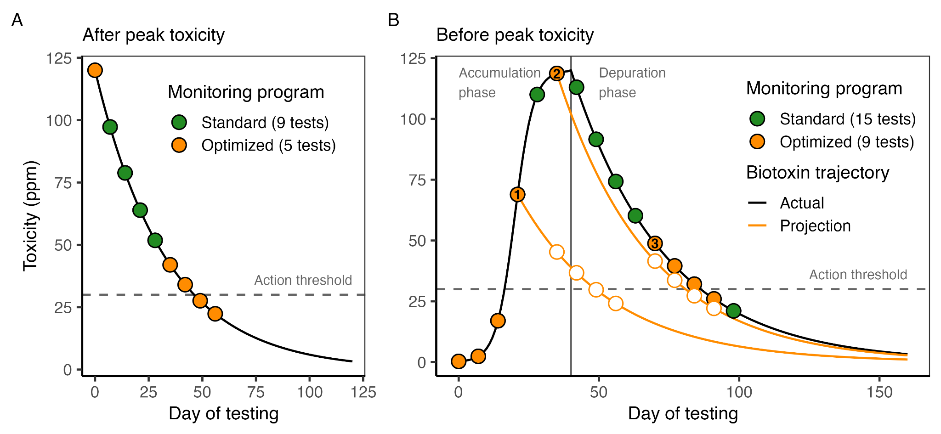**Figure 1.** An illustration of the value of biotoxin depuration rates in efficiently monitoring and managing biotoxin risk both **(A)** after and **(B)** before peak toxicity is attained. In both panels, the black curve shows a hypothetical accumulation (B only) and depuration trajectory for a marine seafood species that depurates at 0.03 day-1. The points indicate weekly sampling that ceases once toxicity falls below the management action threshold (horizontal dashed line) in two consecutive weeks, a common requirement for opening a fishery closed due to biotoxin risk. In **(A)**, standard weekly sampling would require nine tests (all points), but pausing testing until two weeks before toxicity is projected to fall below the action threshold would require only five tests (orange points only). In **(B)**, scheduling tests based on three projections (marked by numbers) eliminates the need for six tests. The white circles indicate the projected testing schedule that is updated when toxicity is found to be higher than expected.

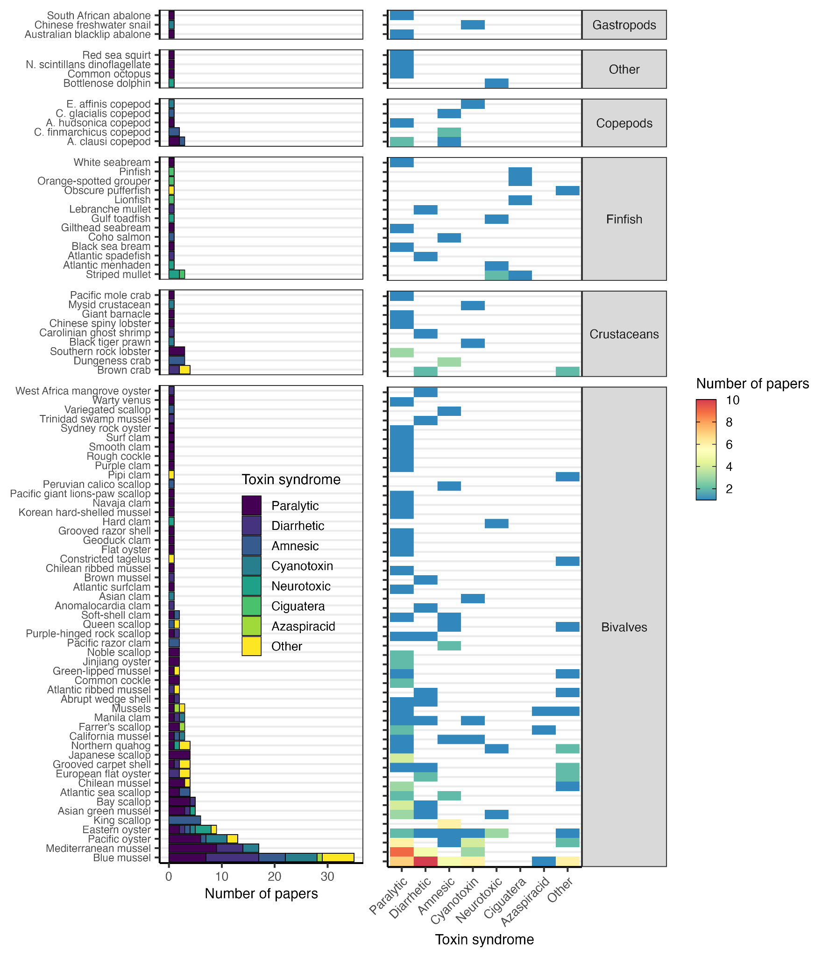**Figure 2.** The number of papers measuring depuration rates by species and biotoxin. Species are grouped by taxonomic class and are ordered by increasing sample size (bottom to top). Biotoxins are also ordered by increasing sample size (left to right). See **Table S3** for the scientific names of all species shown here.

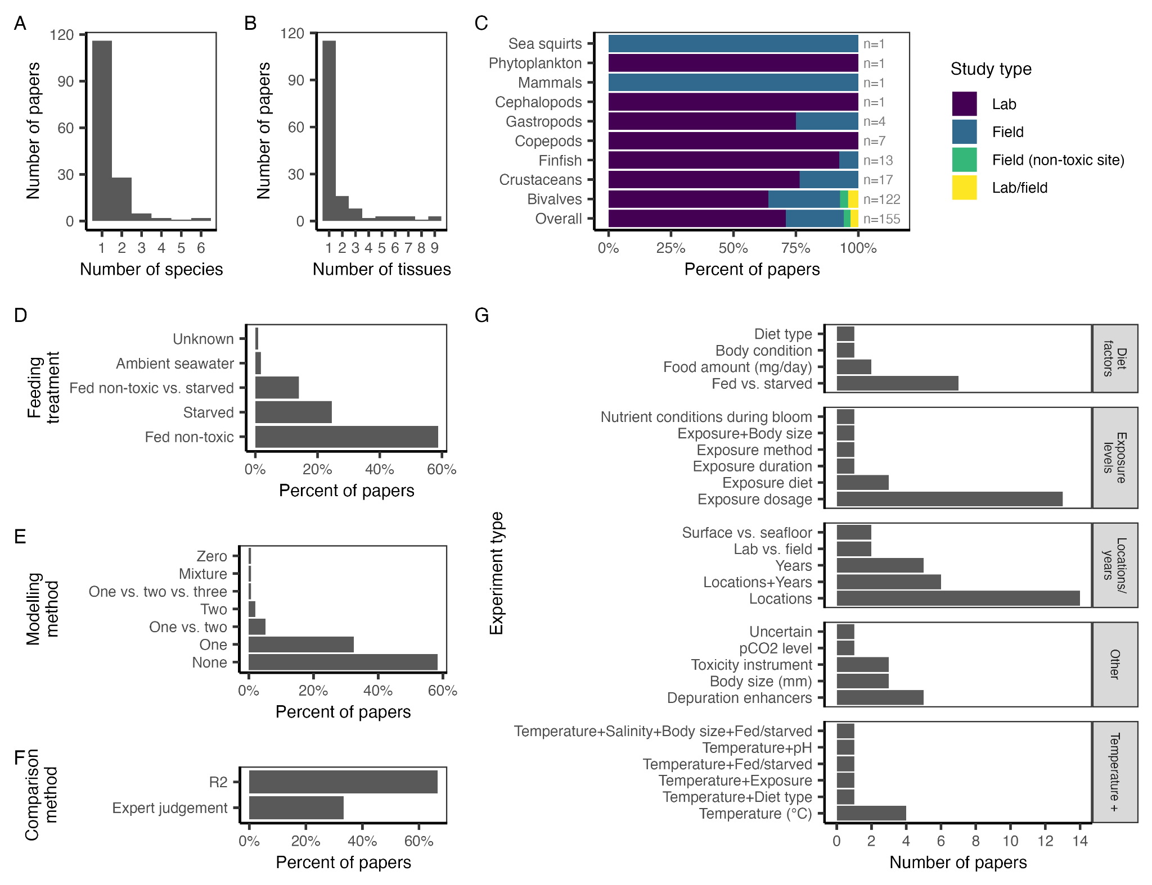

**Figure 3.** Characteristics of papers measuring biotoxin depuration in marine species. Panel **A** shows the number of species studied in a paper. Panel **B** shows the number of tissues evaluated in a paper. Panel **C** shows the percent of papers that conduct lab and/or field studies of depuration rates; a few studies conduct depuration studies at non-toxic field sites. Panel **D** shows the feeding treatment used during the depuration phase of each study; all field studies use wild diets. Panel **E** shows the modeling method used to quantify depuration rates (i.e., one- or two-compartment exponential decay models). Panel **F** shows the method used to compare models with different numbers of compartments in papers making such comparisons. Panel **G** shows the number of studies conducting experiments to measure depuration rates under different conditions. Experiment types are grouped into broader categories.

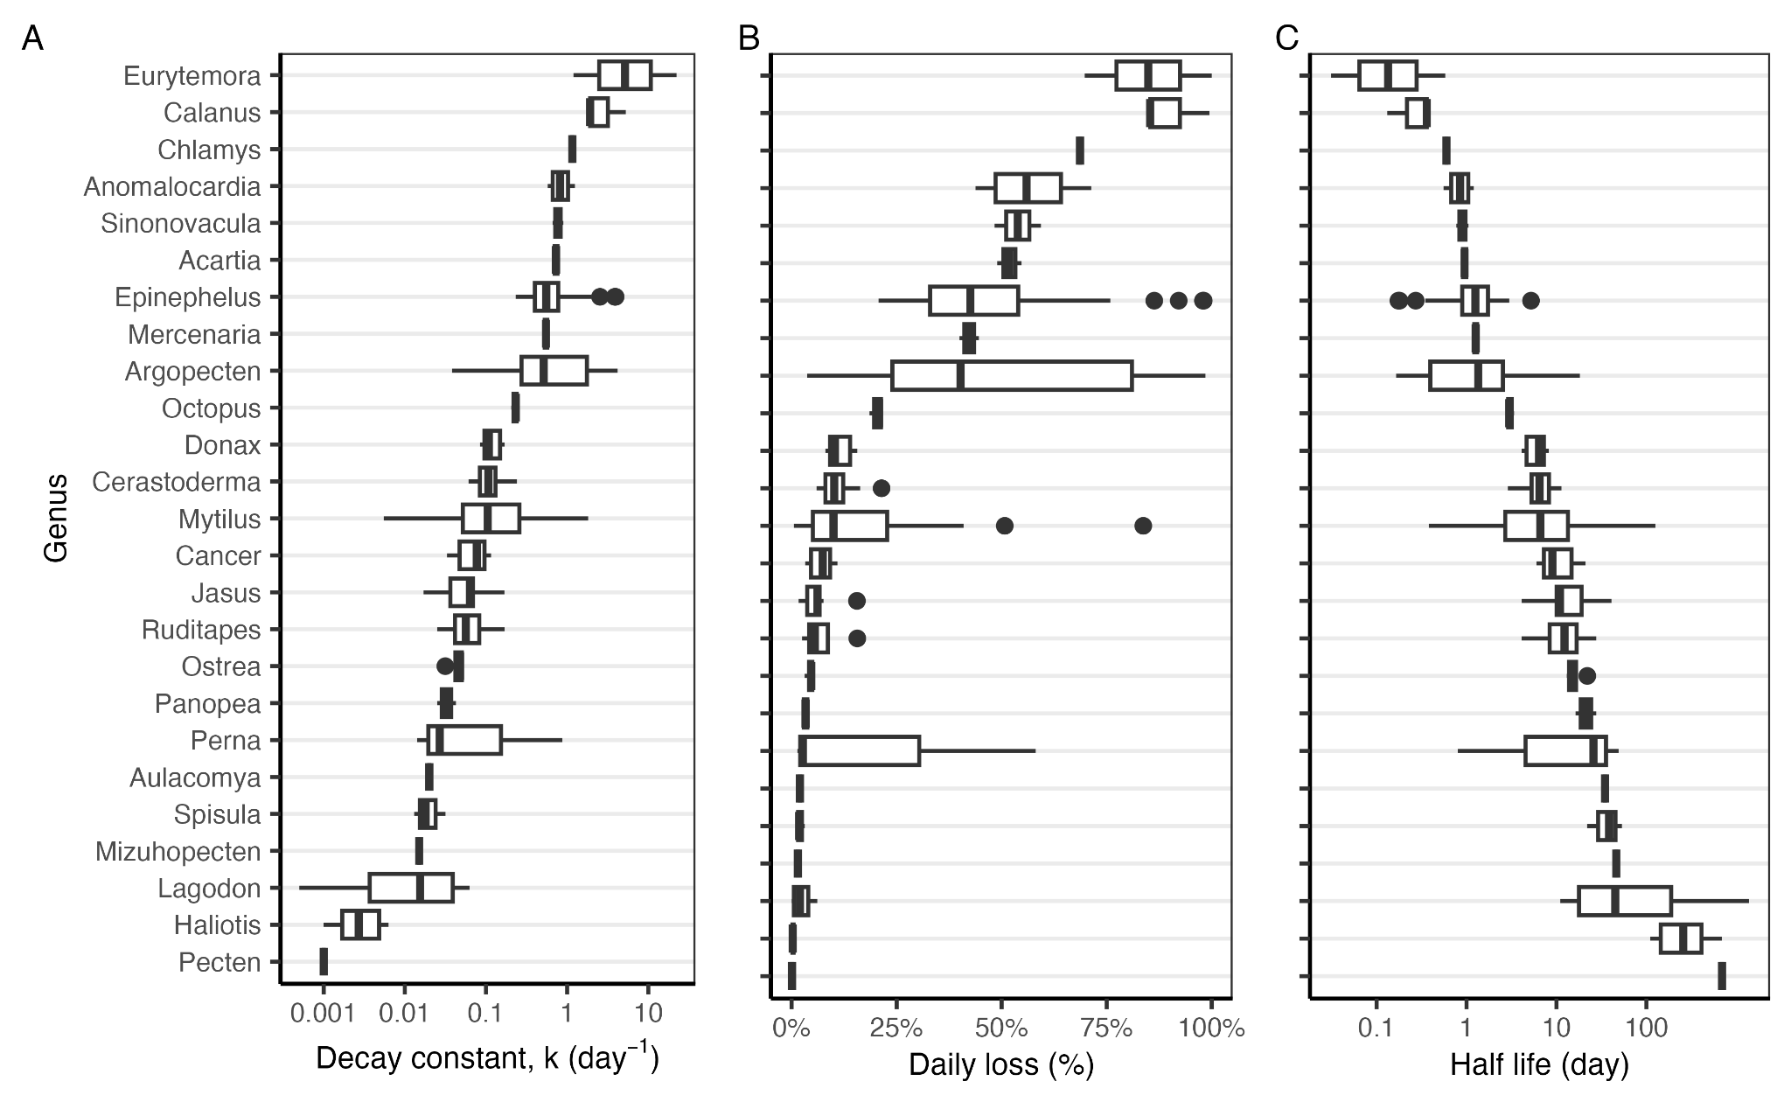**Figure 4.** The **(A)** exponential decay constant (k, day-1), **(B)** daily percent loss (%), and **(C)** half life (days) of marine biotoxins by genera. In the boxplots, the solid line indicates the median, the box indicates the interquartile range (IQR; 25th to 75th percentiles), the whiskers indicate 1.5 times the IQR, and points indicate outliers.

To-do list:

* Complete depuration rates
* Reduce to tissue of interest?
* Convey syndrome?
* Group genera by order? Family? Class?

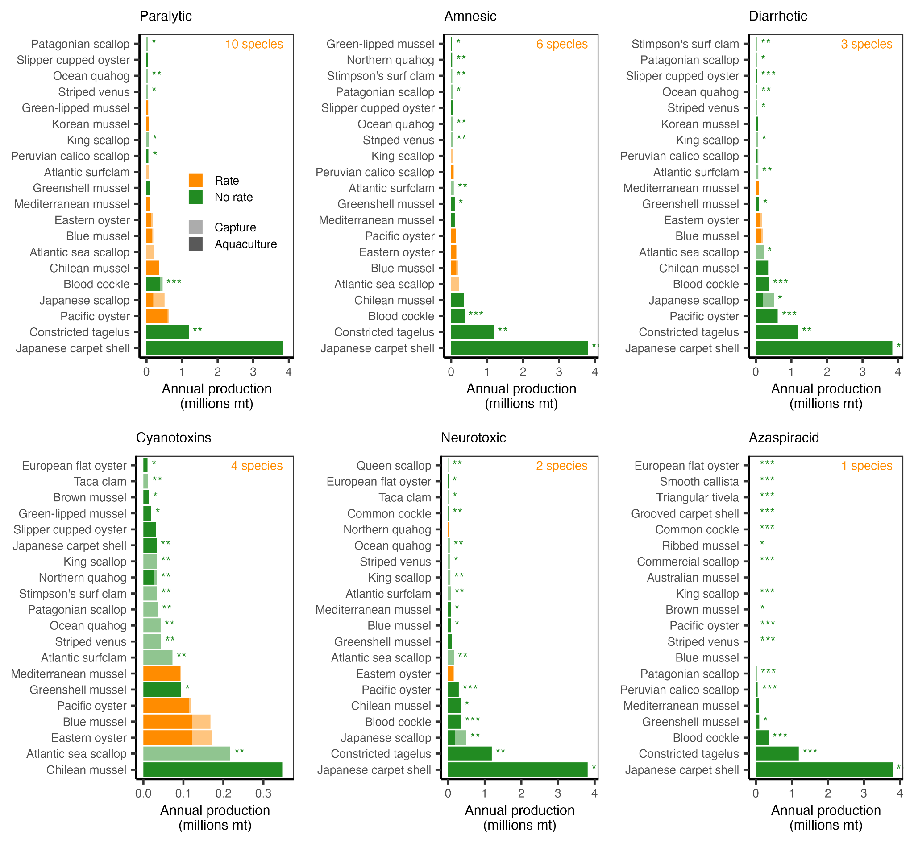**Figure 5.** The twenty filter-feeding marine mollusc species with the greatest annual production (millions mt, 2014-2023) within Exclusive Economic Zones (**Fig. S5**) exposed to harmful algal blooms causing each of the evaluated biotoxin syndromes and an indication of whether (blue) or not (red) the depuration rate of the causative biotoxin has been studied. The species are sorted in order of decreasing annual production across both aquaculture (solid) and fisheries (transparent). The number of species whose depuration rates have been studied is printed in the top-right corner of each plot. The asterisks mark species whose depuration rate would contribute a new order (***), family (**), or genus (*) if studied. Ciguatera is evaluated separately because it is more strongly associated with large, predatory, tropical reef fish (**Fig. S9**).

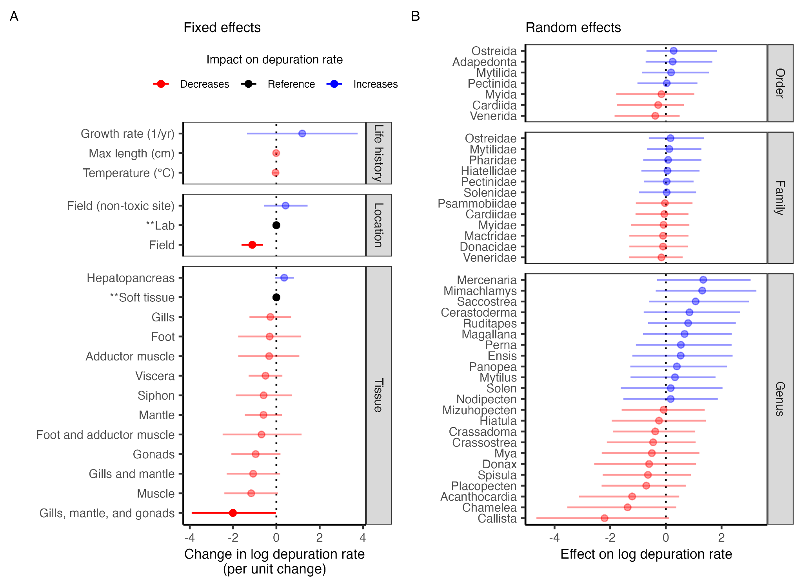**Figure 6.** The **(A)** fixed effects and **(B)** random effects coefficients estimated by the final model. Points indicate the median estimate and lines indicate the 95% credible interval. Color indicates the impact of the point estimate of the effect on depuration rates. Transparency indicates whether the 95% credible intervals overlap with zero (solid=no overlap, transparent=overlap). The categorical fixed effects (location and tissue) are estimated relative to a reference level, which is marked with asterisks and is indicated in black. The conditional effects of the fixed effects variables are shown in **Fig. S11**.

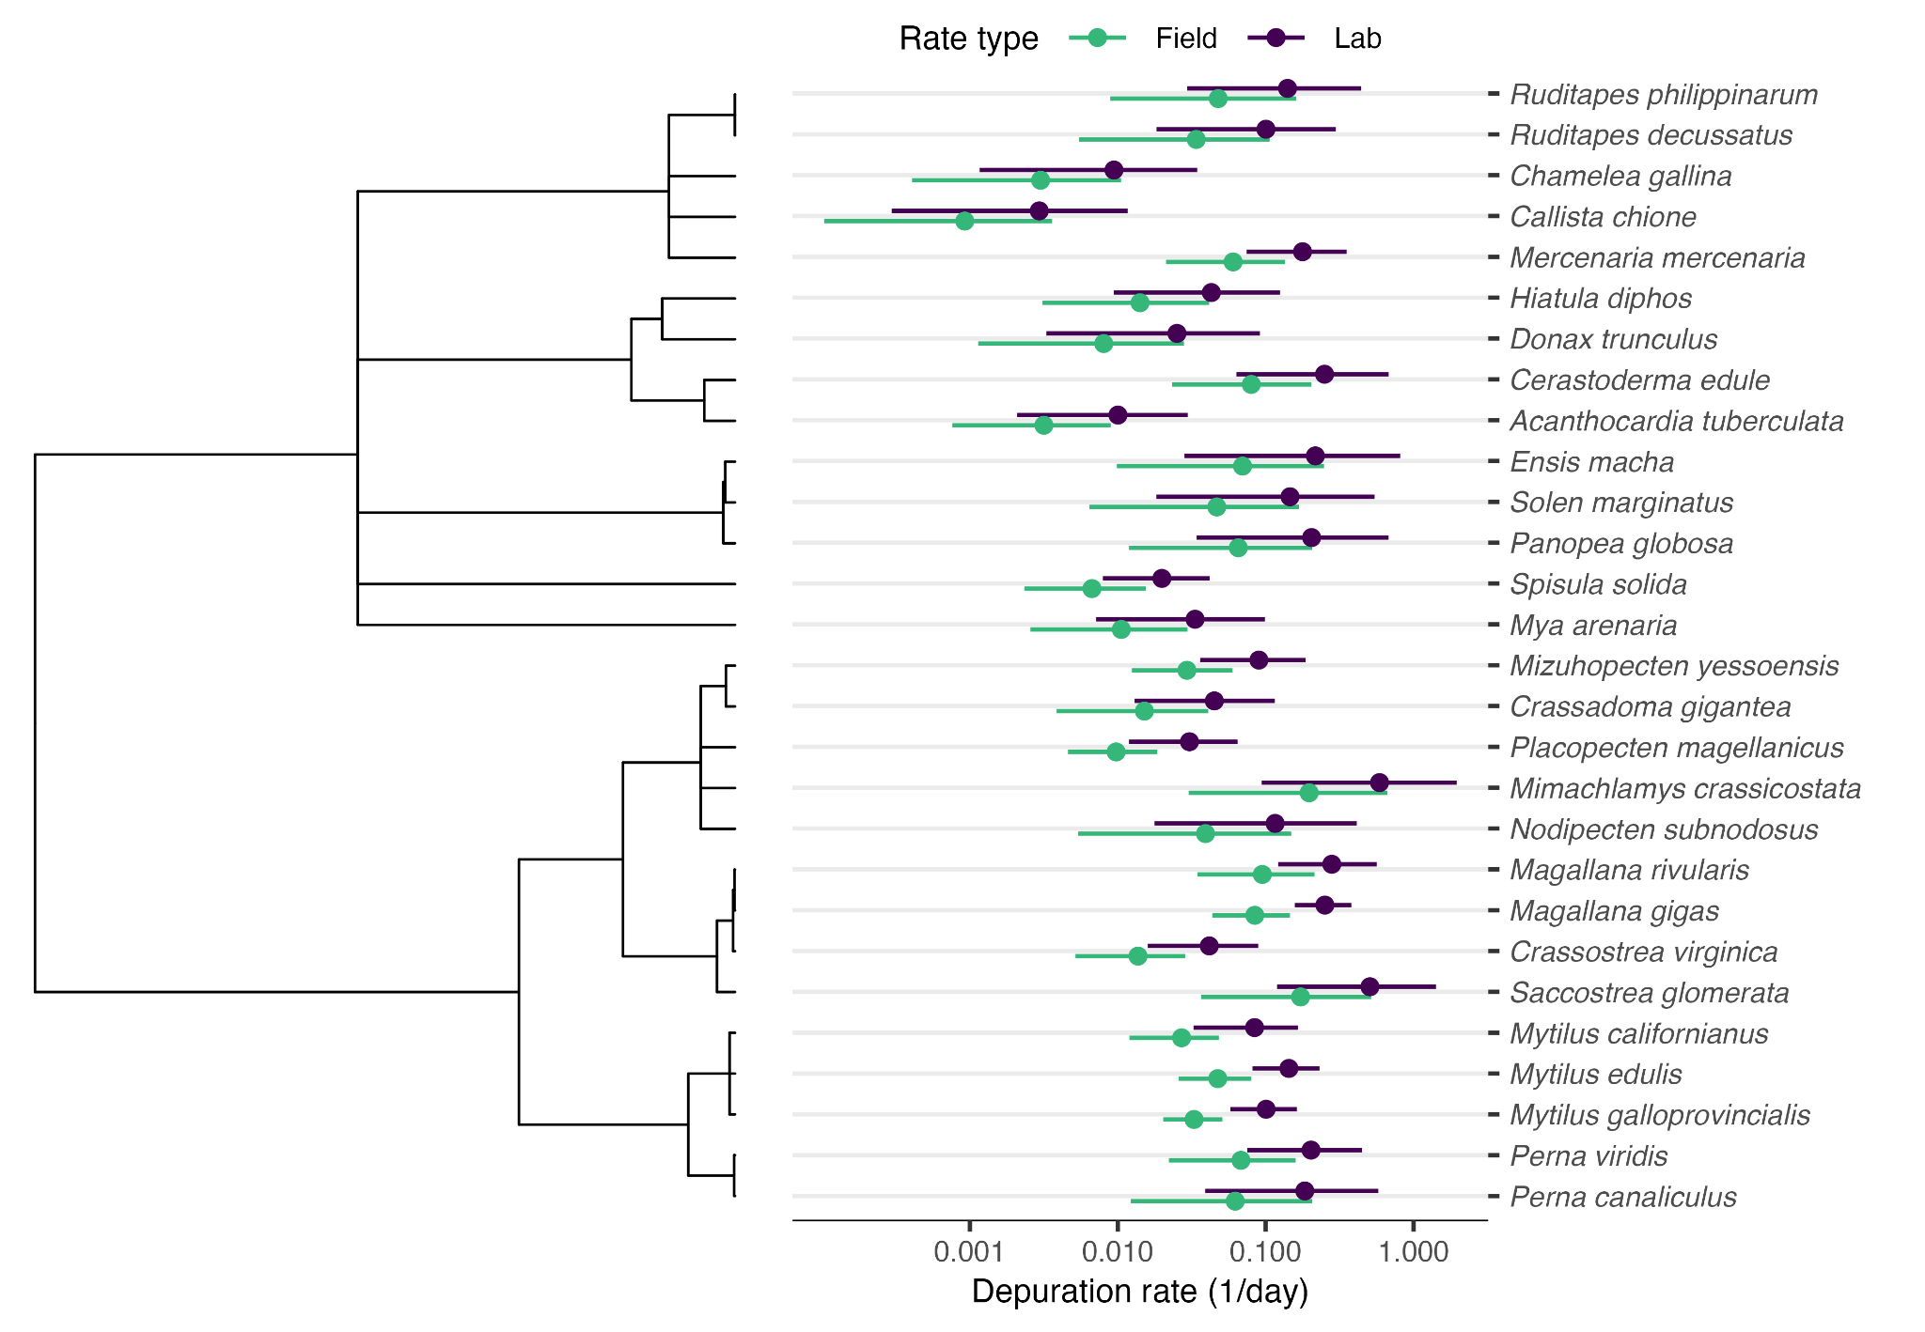**Figure 7.** Paralytic shellfish toxin (PST) depuration rate estimates for species with measured depuration rates from the final regression model. Species are organized by phylogeny. Points indicate the median estimate and lines indicate the 95% credible interval. See **Table S6** for details.

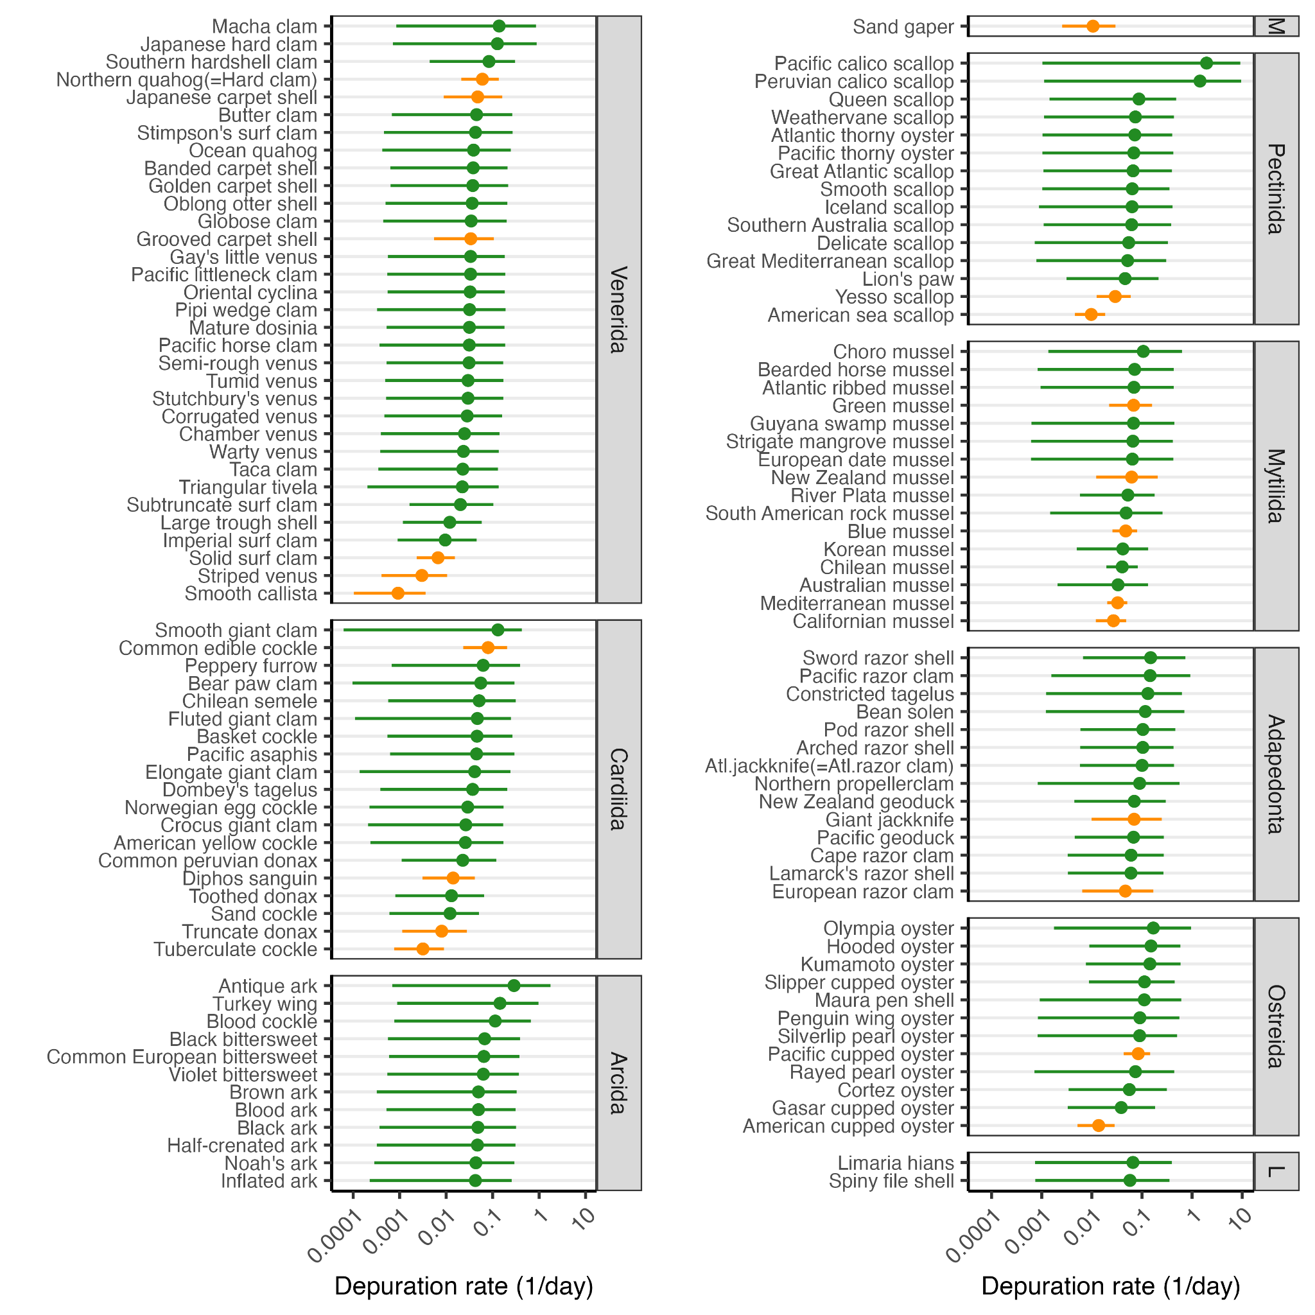**Figure 8.** Paralytic shellfish toxin (PST) depuration rates for harvest marine bivalve species predicted by the final regression model. Species are organized by taxonomic order (M=Myida, L=Limida). Points indicate the median estimate and lines indicate the 95% credible interval. Species represented in the training data are marked in blue. Large predicted depuration rates for giant clam (*Tridacna gigas*) and mangrove cupped oyster (*Crassostrea rhizophorae*) are suppressed to ease visualization. See **Table S7** for details on the predicted depuration rates.

## Supplemental Tables and Figures

### Supplemental Tables

**Table S1.** Attributes of papers that conduct studies of biotoxin depuration for aquatic organisms collected for the literature review analysis.

|  |  |  |
| --- | --- | --- |
| **Column** | **Description** | **Details** |
| paper_id | Paper id | Example: Lund et al. (1997) |
| comm_name | Common name | Example: Dungeness crab |
| sci_name | Scientific name | Example: Metacarcinus magister |
| syndrome | Syndrome | Amnesic, Diarrhetic, Paralytic, Azaspiracid, Ciguatera, Neurotoxic, Cyanotoxin |
| hab_species | HAB species | Examples: Pseudo-nitzschia australis |
| biotoxin | Biotoxin | Domoic acid, DSTs,PSTs, Azaspiracid, Ciguatoxin, Brevetoxin, Cyanotoxin, Other |
| subtoxin | Sub-biotoxin | Examples: dcSTX, GTX3, okadaic acid, etc |
| study_type | Study type | Llab, field, field (non-toxic) |
| exp_type | Experiment type | Examples: Temperature, Exposure, Diet type, etc. |
| treatment | Experimental treatment | Examples: 18°C, 20°C, 30 psu, 35 psu, etc. |
| feed_scenario | Feeding scenario | Fed clean, starved, ambient seawater, wild |
| tissue | Tissue type | Examples: digestive gland, hepatopancreas |
| source | Source of depuration rate | Examples: Figure 1, Table 1, Supplemental Data 1, Results 3.2 |
| rate_type | Derivation of depuration rate | provided, derived, digitized |
| ncomp | Number of compartments | None, zero, one, two, one vs. two, one vs. two vs. three |
| rate_hr | Depuration rate (1/hr) |  |
| hlife_hr | Half life (hr) |  |
| rate_d | Depuration rate (1/day) |  |
| hlife_d | Half life (day) |  |
| notes | General notes |  |

**Table S2.** Tissue harmonization by class.

|  |  |
| --- | --- |
| **Harmonized tissue** | **Synonyms** |
| *Malacostraca* |  |
| Hepatopancreas | Hepatopancreas, digestive gland |
| Soft tissue | Soft tissue, whole |
| *Gastropoda* |  |
| Foot | Foot, muscle |
| Hepatopancreas | Hepatopancreas, digestive gland |
| *Bivalvia* |  |
| Hepatopancreas | Hepatopancreas, digestive gland |
| Soft tissue | Soft tissue, tissue, edible portion, meat, whole flesh, whole |

**Table S3.** The number of papers providing depuration rates by species and syndrome (par=paralytic; amn=amnesic; dia=diahhretic; cya=cyanotoxin; neu=neurotoxic; cig=ciguatera; aza=azaspiracid; oth=other).

|  |  |  |  |  |  |  |  |  |  |  |  |
| --- | --- | --- | --- | --- | --- | --- | --- | --- | --- | --- | --- |
| Class | Family | Scientific name | Common name | Par | Amn | Dia | Cya | Neu | Cig | Aza | Oth |
| Ascidiacea | Pyuridae | Pyura chilensis | Red sea squirt | 1 |  |  |  |  |  |  |  |
| Bivalvia | Cardiidae | Acanthocardia tuberculata | Rough cockle | 1 |  |  |  |  |  |  |  |
| Bivalvia | Cardiidae | Cerastoderma edule | Common cockle | 2 |  |  |  |  |  |  |  |
| Bivalvia | Cyrenidae | Corbicula fluminea | Asian clam |  |  |  | 1 |  |  |  |  |
| Bivalvia | Donacidae | Donax trunculus | Abrupt wedge shell | 1 |  | 1 |  |  |  |  |  |
| Bivalvia | Hiatellidae | Panopea globosa | Geoduck clam | 1 |  |  |  |  |  |  |  |
| Bivalvia | Mactridae | Spisula solida | Surf clam | 1 |  |  |  |  |  |  |  |
| Bivalvia | Mactridae | Spisula solidissima | Atlantic surfclam | 1 |  |  |  |  |  |  |  |
| Bivalvia | Mesodesmatidae | Paphies australis | Pipi clam |  |  |  |  |  |  |  | 1 |
| Bivalvia | Myidae | Mya arenaria | Soft-shell clam | 1 | 1 |  |  |  |  |  |  |
| Bivalvia | Mytilidae | Aulacomya atra | Chilean ribbed mussel | 1 |  |  |  |  |  |  |  |
| Bivalvia | Mytilidae | Geukensia demissa | Atlantic ribbed mussel |  |  | 1 |  |  |  |  | 1 |
| Bivalvia | Mytilidae | Mytella guyanensis | Trinidad swamp mussel |  |  | 1 |  |  |  |  |  |
| Bivalvia | Mytilidae | Mytilus californianus | California mussel | 1 | 1 |  | 1 |  |  |  |  |
| Bivalvia | Mytilidae | Mytilus chilensis | Chilean mussel | 3 |  |  |  |  |  |  | 1 |
| Bivalvia | Mytilidae | Mytilus coruscus | Korean hard-shelled mussel | 1 |  |  |  |  |  |  |  |
| Bivalvia | Mytilidae | Mytilus edulis | Blue mussel | 7 | 5 | 10 | 6 |  |  | 1 | 6 |
| Bivalvia | Mytilidae | Mytilus galloprovincialis | Mediterranean mussel | 9 |  | 5 | 3 |  |  |  |  |
| Bivalvia | Mytilidae | Mytilus spp. | Mussels | 1 |  |  |  |  |  | 1 | 1 |
| Bivalvia | Mytilidae | Perna canaliculus | Green-lipped mussel | 1 |  |  |  |  |  |  | 1 |
| Bivalvia | Mytilidae | Perna perna | Brown mussel |  |  | 1 |  |  |  |  |  |
| Bivalvia | Mytilidae | Perna viridis | Asian green mussel | 3 |  | 1 |  | 1 |  |  |  |
| Bivalvia | Ostreidae | Crassostrea tulipa | West Africa mangrove oyster |  |  | 1 |  |  |  |  |  |
| Bivalvia | Ostreidae | Crassostrea virginica | Eastern oyster | 2 | 1 | 1 | 1 | 3 |  |  | 1 |
| Bivalvia | Ostreidae | Magallana gigas | Pacific oyster | 6 | 1 |  | 4 |  |  |  | 2 |
| Bivalvia | Ostreidae | Magallana rivularis | Jinjiang oyster | 2 |  |  |  |  |  |  |  |
| Bivalvia | Ostreidae | Ostrea chilensis | Flat oyster | 1 |  |  |  |  |  |  |  |
| Bivalvia | Ostreidae | Ostrea edulis | European flat oyster |  |  | 2 |  |  |  |  | 2 |
| Bivalvia | Ostreidae | Saccostrea glomerata | Sydney rock oyster | 1 |  |  |  |  |  |  |  |
| Bivalvia | Pectinidae | Aequipecten opercularis | Queen scallop |  | 1 |  |  |  |  |  | 1 |
| Bivalvia | Pectinidae | Argopecten irradians | Bay scallop | 4 |  | 1 |  |  |  |  |  |
| Bivalvia | Pectinidae | Argopecten purpuratus | Peruvian calico scallop |  | 1 |  |  |  |  |  |  |
| Bivalvia | Pectinidae | Crassadoma gigantea | Purple-hinged rock scallop | 1 |  | 1 |  |  |  |  |  |
| Bivalvia | Pectinidae | Mimachlamys crassicostata | Noble scallop | 2 |  |  |  |  |  |  |  |
| Bivalvia | Pectinidae | Mimachlamys varia | Variegated scallop |  | 1 |  |  |  |  |  |  |
| Bivalvia | Pectinidae | Mizuhopecten yessoensis | Japanese scallop | 4 |  |  |  |  |  |  |  |
| Bivalvia | Pectinidae | Nodipecten subnodosus | Pacific giant lions-paw scallop | 1 |  |  |  |  |  |  |  |
| Bivalvia | Pectinidae | Pecten maximus | King scallop |  | 6 |  |  |  |  |  |  |
| Bivalvia | Pectinidae | Placopecten magellanicus | Atlantic sea scallop | 2 | 2 |  |  |  |  |  |  |
| Bivalvia | Pectinidae | Scaeochlamys farreri | Farrer's scallop | 2 |  |  |  |  |  | 1 |  |
| Bivalvia | Pharidae | Ensis macha | Navaja clam | 1 |  |  |  |  |  |  |  |
| Bivalvia | Pharidae | Siliqua patula | Pacific razor clam |  | 2 |  |  |  |  |  |  |
| Bivalvia | Pharidae | Sinonovacula constricta | Constricted tagelus |  |  |  |  |  |  |  | 1 |
| Bivalvia | Psammobiidae | Hiatula diphos | Purple clam | 1 |  |  |  |  |  |  |  |
| Bivalvia | Solenidae | Solen marginatus | Grooved razor shell | 1 |  |  |  |  |  |  |  |
| Bivalvia | Veneridae | Anomalocardia flexuosa | Anomalocardia clam |  |  | 1 |  |  |  |  |  |
| Bivalvia | Veneridae | Callista chione | Smooth clam | 1 |  |  |  |  |  |  |  |
| Bivalvia | Veneridae | Chamelea gallina | Warty venus | 1 |  |  |  |  |  |  |  |
| Bivalvia | Veneridae | Mercenaria campechiensis | Hard clam |  |  |  |  | 1 |  |  |  |
| Bivalvia | Veneridae | Mercenaria mercenaria | Northern quahog | 1 |  |  |  | 1 |  |  | 2 |
| Bivalvia | Veneridae | Ruditapes decussatus | Grooved carpet shell | 1 |  | 1 |  |  |  |  | 2 |
| Bivalvia | Veneridae | Ruditapes philippinarum | Manila clam | 1 |  | 1 | 1 |  |  |  |  |
| Cephalopoda | Octopodidae | Octopus vulgaris | Common octopus | 1 |  |  |  |  |  |  |  |
| Copepoda | Acartiidae | Acartia clausi | A. clausi copepod | 2 | 1 |  |  |  |  |  |  |
| Copepoda | Acartiidae | Acartia hudsonica | A. hudsonica copepod | 1 |  |  |  |  |  |  |  |
| Copepoda | Calanidae | Calanus finmarchicus | C. finmarchicus copepod |  | 2 |  |  |  |  |  |  |
| Copepoda | Calanidae | Calanus glacialis | C. glacialis copepod |  | 1 |  |  |  |  |  |  |
| Copepoda | Temoridae | Eurytemora affinis | E. affinis copepod |  |  |  | 1 |  |  |  |  |
| Dinophyceae | Noctilucaceae | Noctiluca scintillans | N. scintillans dinoflagellate | 1 |  |  |  |  |  |  |  |
| Gastropoda | Haliotidae | Haliotis midae | South African abalone | 1 |  |  |  |  |  |  |  |
| Gastropoda | Haliotidae | Haliotis rubra | Australian blacklip abalone | 1 |  |  |  |  |  |  |  |
| Gastropoda | Viviparidae | Sinotaia quadrata | Chinese freshwater snail |  |  |  | 1 |  |  |  |  |
| Malacostraca | Callichiridae | Callichirus major | Carolinian ghost shrimp |  |  | 1 |  |  |  |  |  |
| Malacostraca | Cancridae | Cancer pagurus | Brown crab |  |  | 2 |  |  |  |  | 2 |
| Malacostraca | Cancridae | Metacarcinus magister | Dungeness crab |  | 3 |  |  |  |  |  |  |
| Malacostraca | Hippidae | Emerita analoga | Pacific mole crab | 1 |  |  |  |  |  |  |  |
| Malacostraca | Mysidae | Neomysis awatschensis | Mysid crustacean |  |  |  | 1 |  |  |  |  |
| Malacostraca | Palinuridae | Jasus edwardsii | Southern rock lobster | 3 |  |  |  |  |  |  |  |
| Malacostraca | Palinuridae | Panulirus stimpsoni | Chinese spiny lobster | 1 |  |  |  |  |  |  |  |
| Malacostraca | Penaeidae | Penaeus monodon | Black tiger prawn |  |  |  | 1 |  |  |  |  |
| Mammalia | Delphinidae | Tursiops truncatus | Bottlenose dolphin |  |  |  |  | 1 |  |  |  |
| Teleostei | Alosidae | Brevoortia tyrannus | Atlantic menhaden |  |  |  |  | 1 |  |  |  |
| Teleostei | Batrachoididae | Opsanus beta | Gulf toadfish |  |  |  |  | 1 |  |  |  |
| Teleostei | Ephippidae | Chaetodipterus faber | Atlantic spadefish |  |  | 1 |  |  |  |  |  |
| Teleostei | Epinephelidae | Epinephelus coioides | Orange-spotted grouper |  |  |  |  |  | 1 |  |  |
| Teleostei | Mugilidae | Mugil cephalus | Striped mullet |  |  |  |  | 2 | 1 |  |  |
| Teleostei | Mugilidae | Mugil liza | Lebranche mullet |  |  | 1 |  |  |  |  |  |
| Teleostei | Salmonidae | Oncorhynchus kisutch | Coho salmon |  | 1 |  |  |  |  |  |  |
| Teleostei | Scorpaenidae | Pterois volitans | Lionfish |  |  |  |  |  | 1 |  |  |
| Teleostei | Sparidae | Acanthopagrus schlegelii | Black sea bream | 1 |  |  |  |  |  |  |  |
| Teleostei | Sparidae | Diplodus sargus | White seabream | 1 |  |  |  |  |  |  |  |
| Teleostei | Sparidae | Lagodon rhomboides | Pinfish |  |  |  |  |  | 1 |  |  |
| Teleostei | Sparidae | Sparus aurata | Gilthead seabream | 1 |  |  |  |  |  |  |  |
| Teleostei | Tetraodontidae | Takifugu obscurus | Obscure pufferfish |  |  |  |  |  |  |  | 1 |
| Thecostraca | Balanidae | Austromegabalanus psittacus | Giant barnacle | 1 |  |  |  |  |  |  |  |

**Table S4.** Diversity of orders, families, and genera of harvested marine molluscs.

|  |  |  |  |  |  |  |
| --- | --- | --- | --- | --- | --- | --- |
|  |  |  |  | **Production** | **Number of species** | |
| **Syndrome** | **Type** | **Group** | **Species** | **(1000s mt)** | **Harvested** | **Total** |
| Amnesic | Order | Arcoida | Blood cockle (Tegillarca granosa) | 375.1 | 8 | 360 |
|  | Family | Veneridae | Japanese carpet shell (Ruditapes philippinarum), Striped venus (Chamelea gallina), Northern quahog (Mercenaria mercenaria) | 3885.3 | 22 | 428 |
|  |  | Solecurtidae | Constricted tagelus (Sinonovacula constricta) | 1191.3 | 2 | 26 |
|  |  | Mactridae | Atlantic surfclam (Spisula solidissima), Stimpson's surf clam (Mactromeris polynyma) | 106.1 | 10 | 116 |
|  |  | Arcticidae | Ocean quahog (Arctica islandica) | 42.8 | 1 | 1 |
|  | Genus | Perna | Greenshell mussel (Perna canaliculus), Green-lipped mussel (Perna viridis) | 118.9 | 3 | 5 |
|  |  | Zygochlamys | Patagonian scallop (Zygochlamys patagonica) | 35.5 | 2 | 1 |
| Azaspiracid | Order | Veneroida | Japanese carpet shell (Ruditapes philippinarum), Constricted tagelus (Sinonovacula constricta), Striped venus (Chamelea gallina), Common cockle (Cerastoderma edule), Grooved carpet shell (Ruditapes decussatus), Triangular tivela (Tivela mactroides), Smooth callista (Callista chione) | 5015.8 | 58 | 2549 |
|  |  | Arcoida | Blood cockle (Tegillarca granosa) | 356.8 | 8 | 360 |
|  |  | Ostreoida | Peruvian calico scallop (Argopecten purpuratus), Patagonian scallop (Zygochlamys patagonica), King scallop (Pecten maximus), Commercial scallop (Pecten fumatus), European flat oyster (Ostrea edulis) | 107.5 | 26 | 548 |
|  |  | Ostreida | Pacific oyster (Magallana gigas) | 16.3 | 5 | 88 |
|  | Genus | Perna | Greenshell mussel (Perna canaliculus), Brown mussel (Perna perna) | 107.2 | 3 | 5 |
|  |  | Aulacomya | Ribbed mussel (Aulacomya atra) | 2.5 | 1 | 3 |
| Cyanotoxin | Family | Pectinidae | Atlantic sea scallop (Placopecten magellanicus), Patagonian scallop (Zygochlamys patagonica), King scallop (Pecten maximus) | 286.3 | 20 | 297 |
|  |  | Veneridae | Striped venus (Chamelea gallina), Northern quahog (Mercenaria mercenaria), Japanese carpet shell (Ruditapes philippinarum), Taca clam (Leukoma thaca) | 122.0 | 22 | 428 |
|  |  | Mactridae | Atlantic surfclam (Spisula solidissima), Stimpson's surf clam (Mactromeris polynyma) | 106.1 | 10 | 116 |
|  |  | Arcticidae | Ocean quahog (Arctica islandica) | 42.8 | 1 | 1 |
|  | Genus | Perna | Greenshell mussel (Perna canaliculus), Green-lipped mussel (Perna viridis), Brown mussel (Perna perna) | 126.5 | 3 | 5 |
|  |  | Ostrea | European flat oyster (Ostrea edulis) | 10.6 | 3 | 20 |
| Diarrhetic | Order | Ostreida | Pacific oyster (Magallana gigas), Slipper cupped oyster (Magallana bilineata) | 657.5 | 5 | 88 |
|  |  | Arcoida | Blood cockle (Tegillarca granosa) | 375.7 | 8 | 360 |
|  | Family | Solecurtidae | Constricted tagelus (Sinonovacula constricta) | 1191.3 | 2 | 26 |
|  |  | Mactridae | Atlantic surfclam (Spisula solidissima), Stimpson's surf clam (Mactromeris polynyma) | 106.1 | 10 | 116 |
|  |  | Arcticidae | Ocean quahog (Arctica islandica) | 42.8 | 1 | 1 |
|  | Genus | Ruditapes | Japanese carpet shell (Ruditapes philippinarum) | 3848.4 | 2 | 4 |
|  |  | Mizuhopecten | Japanese scallop (Mizuhopecten yessoensis) | 505.8 | 1 | 1 |
|  |  | Placopecten | Atlantic sea scallop (Placopecten magellanicus) | 217.5 | 1 | 1 |
|  |  | Perna | Greenshell mussel (Perna canaliculus) | 93.5 | 3 | 5 |
|  |  | Pecten | King scallop (Pecten maximus) | 62.2 | 4 | 18 |
|  |  | Chamelea | Striped venus (Chamelea gallina) | 46.1 | 1 | 3 |
|  |  | Zygochlamys | Patagonian scallop (Zygochlamys patagonica) | 35.5 | 2 | 1 |
| Neurotoxic | Order | Arcoida | Blood cockle (Tegillarca granosa) | 357.1 | 8 | 360 |
|  |  | Ostreida | Pacific oyster (Magallana gigas) | 293.1 | 5 | 88 |
|  | Family | Solecurtidae | Constricted tagelus (Sinonovacula constricta) | 1191.3 | 2 | 26 |
|  |  | Pectinidae | Japanese scallop (Mizuhopecten yessoensis), Atlantic sea scallop (Placopecten magellanicus), King scallop (Pecten maximus), Queen scallop (Aequipecten opercularis) | 734.1 | 20 | 297 |
|  |  | Mactridae | Atlantic surfclam (Spisula solidissima) | 71.8 | 10 | 116 |
|  |  | Arcticidae | Ocean quahog (Arctica islandica) | 42.8 | 1 | 1 |
|  |  | Cardiidae | Common cockle (Cerastoderma edule) | 14.3 | 13 | 222 |
|  | Genus | Ruditapes | Japanese carpet shell (Ruditapes philippinarum) | 3813.6 | 2 | 4 |
|  |  | Mytilus | Chilean mussel (Mytilus chilensis), Blue mussel (Mytilus edulis), Mediterranean mussel (Mytilus galloprovincialis) | 503.5 | 7 | 12 |
|  |  | Chamelea | Striped venus (Chamelea gallina) | 45.7 | 1 | 3 |
|  |  | Leukoma | Taca clam (Leukoma thaca) | 11.9 | 2 | 3 |
|  |  | Ostrea | European flat oyster (Ostrea edulis) | 11.0 | 3 | 20 |
| Paralytic | Order | Arcoida | Blood cockle (Tegillarca granosa) | 453.6 | 8 | 360 |
|  | Family | Solecurtidae | Constricted tagelus (Sinonovacula constricta) | 1191.3 | 2 | 26 |
|  |  | Arcticidae | Ocean quahog (Arctica islandica) | 42.8 | 1 | 1 |
|  | Genus | Argopecten | Peruvian calico scallop (Argopecten purpuratus) | 70.2 | 3 | 9 |
|  |  | Pecten | King scallop (Pecten maximus) | 62.2 | 4 | 18 |
|  |  | Chamelea | Striped venus (Chamelea gallina) | 46.1 | 1 | 3 |
|  |  | Zygochlamys | Patagonian scallop (Zygochlamys patagonica) | 35.5 | 2 | 1 |

**Table S5.** Performance statistics used in model selection.

|  |  |  |  |  |  |
| --- | --- | --- | --- | --- | --- |
| **Model** | **ΔELPD** | **ELPD (SE)** | **LOOIC (SE)** | **P (SE)** | **R2 (CI)** |
| Taxonomically nested random effects | 0.0 | -219.1 (9.7) | 438.2 (19.5) | 30.8 (3.8) | 0.71 (0.65-0.76) |
| Non-phylogenetic random effects | 2.4 | -221.5 (10.2) | 443.0 (20.3) | 32.7 (4.6) | 0.70 (0.64-0.75) |
| Phylogenetic random effects | 4.3 | -223.4 (10.0) | 446.8 (19.9) | 30.8 (4.8) | 0.69 (0.61-0.74) |
| Fixed effects only | 32.7 | -251.8 (10.0) | 503.6 (20.1) | 14.0 (1.8) | 0.48 (0.39-0.55) |

* ELPD = expected log predictive density (higher = better); LOOIC = leave-one-out information criterion (lower = better); R2 = Bayesian R2 (higher = better); P = effective number of parameters; SE = standard error; CI = 95% confidence interval

**Table S6.** Field- and lab-based paralytic shellfish toxin depuration rates predicted by the best performing regression model for species included in model training along with the required predictor variables.

|  |  |  |  |  |  |  |  |  |  |
| --- | --- | --- | --- | --- | --- | --- | --- | --- | --- |
| **Order** | **Family** | **Genus** | **Scientific name** | **Common name** | **Length**  **(cm)** | **K**  **(1/yr)** | **Temp**  **(°C)** | **Field**  **(95% CI)** | **Lab**  **(95% CI)** |
| Adapedonta | Pharidae | Ensis | Ensis macha | Navaja clam | 16.5 | 0.225 | 11 | 0.07 (0.01-0.248) | 0.217 (0.028-0.811) |
| Adapedonta | Hiatellidae | Panopea | Panopea globosa | Geoduck clam | 19.8 | 0.33 | 8 | 0.065 (0.012-0.206) | 0.204 (0.034-0.678) |
| Adapedonta | Solenidae | Solen | Solen marginatus | Grooved razor shell | 17 | 0.28 | 10 | 0.047 (0.006-0.168) | 0.146 (0.018-0.545) |
| Cardiida | Cardiidae | Acanthocardia | Acanthocardia tuberculata | Rough cockle | 9 | 0.669 | 26.5 | 0.003 (0.001-0.009) | 0.01 (0.002-0.03) |
| Cardiida | Cardiidae | Cerastoderma | Cerastoderma edule | Common cockle | 5.6 | 0.62 | 10 | 0.08 (0.023-0.204) | 0.25 (0.063-0.678) |
| Cardiida | Donacidae | Donax | Donax trunculus | Abrupt wedge shell | 4.4 | 0.7 | 26.5 | 0.008 (0.001-0.028) | 0.025 (0.003-0.091) |
| Cardiida | Psammobiidae | Hiatula | Hiatula diphos | Purple clam | 6 | 0.825 | 26.5 | 0.014 (0.003-0.041) | 0.043 (0.009-0.125) |
| Myida | Myidae | Mya | Mya arenaria | Soft-shell clam | 10 | 0.3 | 10 | 0.011 (0.003-0.03) | 0.033 (0.007-0.099) |
| Mytilida | Mytilidae | Mytilus | Mytilus californianus | California mussel | 25.5 | 0.25 | 15 | 0.027 (0.012-0.048) | 0.084 (0.032-0.165) |
| Mytilida | Mytilidae | Mytilus | Mytilus edulis | Blue mussel | 11 | 0.24 | 8 | 0.047 (0.026-0.08) | 0.144 (0.081-0.231) |
| Mytilida | Mytilidae | Mytilus | Mytilus galloprovincialis | Mediterranean mussel | 16.5 | 0.26 | 17 | 0.033 (0.02-0.051) | 0.101 (0.058-0.163) |
| Mytilida | Mytilidae | Perna | Perna canaliculus | Green-lipped mussel | 15 | 0.6 | 26 | 0.062 (0.012-0.206) | 0.184 (0.039-0.577) |
| Mytilida | Mytilidae | Perna | Perna viridis | Asian green mussel | 16.5 | 1.07 | 26 | 0.068 (0.022-0.159) | 0.203 (0.075-0.447) |
| Ostreida | Ostreidae | Crassostrea | Crassostrea virginica | Eastern oyster | 30 | 0.565 | 24 | 0.014 (0.005-0.028) | 0.042 (0.016-0.089) |
| Ostreida | Ostreidae | Magallana | Magallana gigas | Pacific oyster | 45 | 0.68 | 13 | 0.084 (0.043-0.146) | 0.251 (0.157-0.379) |
| Ostreida | Ostreidae | Magallana | Magallana rivularis | Jinjiang oyster | 20.88 | 0.84 | 20.5 | 0.095 (0.035-0.214) | 0.28 (0.122-0.564) |
| Ostreida | Ostreidae | Saccostrea | Saccostrea glomerata | Sydney rock oyster | 5 | 0.7625 | 24 | 0.172 (0.037-0.516) | 0.507 (0.119-1.417) |
| Pectinida | Pectinidae | Crassadoma | Crassadoma gigantea | Purple-hinged rock scallop | 25 | 0.5035 | 16 | 0.015 (0.004-0.041) | 0.045 (0.013-0.115) |
| Pectinida | Pectinidae | Mimachlamys | Mimachlamys crassicostata | Noble scallop | 9.49 | 0.6626 | 17 | 0.197 (0.03-0.666) | 0.589 (0.094-1.955) |
| Pectinida | Pectinidae | Mizuhopecten | Mizuhopecten yessoensis | Japanese scallop | 25 | 0.925 | 18 | 0.029 (0.012-0.06) | 0.09 (0.036-0.186) |
| Pectinida | Pectinidae | Nodipecten | Nodipecten subnodosus | Pacific giant lions-paw scallop | 15 | 0.5035 | 16 | 0.039 (0.005-0.149) | 0.116 (0.018-0.413) |
| Pectinida | Pectinidae | Placopecten | Placopecten magellanicus | Atlantic sea scallop | 20 | 0.28 | 8 | 0.01 (0.005-0.018) | 0.031 (0.012-0.065) |
| Venerida | Veneridae | Callista | Callista chione | Smooth clam | 11 | 0.24 | 12 | 0.001 (0-0.004) | 0.003 (0-0.012) |
| Venerida | Veneridae | Chamelea | Chamelea gallina | Warty venus | 5 | 0.415 | 14 | 0.003 (0-0.011) | 0.009 (0.001-0.034) |
| Venerida | Veneridae | Mercenaria | Mercenaria mercenaria | Northern quahog | 13 | 0.3257 | 17 | 0.06 (0.021-0.135) | 0.178 (0.074-0.353) |
| Venerida | Veneridae | Ruditapes | Ruditapes decussatus | Grooved carpet shell | 8 | 0.48 | 17 | 0.034 (0.005-0.107) | 0.1 (0.018-0.298) |
| Venerida | Veneridae | Ruditapes | Ruditapes philippinarum | Manila clam | 8 | 0.52 | 18 | 0.048 (0.009-0.161) | 0.14 (0.029-0.443) |
| Venerida | Mactridae | Spisula | Spisula solida | Surf clam | 5 | 0.3307 | 11 | 0.007 (0.002-0.015) | 0.02 (0.008-0.042) |

**Table S7.** Field- and lab-based paralytic shellfish toxin depuration rates predicted by the best performing regression model for all harvested bivalve species along with the required predictor variables.

|  |  |  |  |  |  |  |  |  |  |
| --- | --- | --- | --- | --- | --- | --- | --- | --- | --- |
| **Order** | **Family** | **Genus** | **Scientific name** | **Common name** | **Length**  **(cm)** | **K**  **(1/yr)** | **Temp (°C)** | **Field**  **(95% CI)** | **Lab**  **(95% CI)** |
| Adapedonta | Hiatellidae | Cyrtodaria | Cyrtodaria siliqua | Northern propellerclam | 11 | 0.07 | 8 | 0.09 (0.001-0.56) | 0.268 (0.002-1.619) |
| Adapedonta | Pharidae | Ensis | Ensis ensis | Pod razor shell | 16.5 | 0.4625 | 11 | 0.104 (0.006-0.462) | 0.321 (0.016-1.443) |
| Adapedonta | Pharidae | Ensis | Ensis leei | Atl.jackknife(=Atl.razor clam) | 20 | 0.4625 | 11 | 0.101 (0.006-0.436) | 0.307 (0.016-1.393) |
| Adapedonta | Pharidae | Ensis | Ensis macha | Giant jackknife | 16.5 | 0.225 | 11 | 0.07 (0.01-0.248) | 0.217 (0.028-0.811) |
| Adapedonta | Pharidae | Ensis | Ensis magnus | Arched razor shell | 16.5 | 0.4625 | 11 | 0.104 (0.006-0.426) | 0.321 (0.017-1.334) |
| Adapedonta | Pharidae | Ensis | Ensis siliqua | Sword razor shell | 15.5 | 0.7 | 11 | 0.149 (0.007-0.734) | 0.462 (0.019-2.171) |
| Adapedonta | Hiatellidae | Panopea | Panopea generosa | Pacific geoduck | 17.5 | 0.199 | 8 | 0.068 (0.005-0.272) | 0.211 (0.014-0.849) |
| Adapedonta | Hiatellidae | Panopea | Panopea zelandica | New Zealand geoduck | 17.5 | 0.25 | 8 | 0.07 (0.004-0.298) | 0.217 (0.013-0.938) |
| Adapedonta | Pharidae | Pharus | Pharus legumen | Bean solen | 9.982 | 0.4075 | 9 | 0.117 (0.001-0.701) | 0.35 (0.004-2.12) |
| Adapedonta | Pharidae | Siliqua | Siliqua patula | Pacific razor clam | 18 | 0.59 | 7 | 0.145 (0.002-0.917) | 0.441 (0.004-2.818) |
| Adapedonta | Pharidae | Sinonovacula | Sinonovacula constricta | Constricted tagelus | 15.5 | 0.4075 | 9 | 0.131 (0.001-0.627) | 0.399 (0.004-1.849) |
| Adapedonta | Solenidae | Solen | Solen capensis | Cape razor clam | 11 | 0.28 | 10 | 0.061 (0.003-0.272) | 0.186 (0.01-0.845) |
| Adapedonta | Solenidae | Solen | Solen lamarckii | Lamarck's razor shell | 10 | 0.28 | 10 | 0.06 (0.003-0.269) | 0.186 (0.01-0.81) |
| Adapedonta | Solenidae | Solen | Solen marginatus | European razor clam | 17 | 0.28 | 10 | 0.047 (0.006-0.168) | 0.146 (0.018-0.545) |
| Arcida | Arcidae | Anadara | Anadara antiquata | Antique ark | 10.5 | 1.54 | 31.75 | 0.288 (0.001-1.756) | 0.831 (0.002-5.253) |
| Arcida | Arcidae | Anadara | Anadara broughtonii | Inflated ark | 8 | 0.2359 | 31.75 | 0.043 (0-0.258) | 0.129 (0.001-0.825) |
| Arcida | Arcidae | Anadara | Anadara kagoshimensis | Half-crenated ark | 6.2 | 0.428 | 31.75 | 0.047 (0-0.31) | 0.143 (0.001-0.891) |
| Arcida | Arcidae | Anadara | Anadara similis | Brown ark | 8 | 0.428 | 31.75 | 0.05 (0-0.329) | 0.147 (0.001-0.939) |
| Arcida | Arcidae | Anadara | Anadara tuberculosa | Black ark | 8 | 0.515 | 31.75 | 0.048 (0-0.319) | 0.147 (0.001-0.954) |
| Arcida | Arcidae | Arca | Arca noae | Noah's ark | 7 | 0.165 | 26.5 | 0.044 (0-0.294) | 0.129 (0.001-0.952) |
| Arcida | Arcidae | Arca | Arca zebra | Turkey wing | 10 | 1.2 | 26.5 | 0.144 (0.001-0.966) | 0.418 (0.003-2.822) |
| Arcida | Glycymerididae | Glycymeris | Glycymeris glycymeris | Common European bittersweet | 6.5 | 0.11 | 12 | 0.065 (0.001-0.38) | 0.195 (0.002-1.1) |
| Arcida | Glycymerididae | Glycymeris | Glycymeris nummaria | Violet bittersweet | 7 | 0.11 | 12 | 0.063 (0.001-0.368) | 0.19 (0.002-1.144) |
| Arcida | Glycymerididae | Glycymeris | Glycymeris ovata | Black bittersweet | 4.15 | 0.11 | 12 | 0.067 (0.001-0.386) | 0.204 (0.002-1.123) |
| Arcida | Arcidae | Lunarca | Lunarca ovalis | Blood ark | 7.6 | 0.45 | 25 | 0.05 (0.001-0.311) | 0.149 (0.002-0.938) |
| Arcida | Arcidae | Tegillarca | Tegillarca granosa | Blood cockle | 9 | 1.055 | 28 | 0.114 (0.001-0.665) | 0.342 (0.002-1.939) |
| Cardiida | Cardiidae | Acanthocardia | Acanthocardia spinosa | Sand cockle | 8.25 | 0.669 | 26.5 | 0.012 (0.001-0.051) | 0.036 (0.002-0.157) |
| Cardiida | Cardiidae | Acanthocardia | Acanthocardia tuberculata | Tuberculate cockle | 9 | 0.669 | 26.5 | 0.003 (0.001-0.009) | 0.01 (0.002-0.03) |
| Cardiida | Psammobiidae | Asaphis | Asaphis violascens | Pacific asaphis | 11 | 0.825 | 26.5 | 0.045 (0.001-0.295) | 0.137 (0.002-0.84) |
| Cardiida | Cardiidae | Cerastoderma | Cerastoderma edule | Common edible cockle | 5.6 | 0.62 | 10 | 0.08 (0.023-0.204) | 0.25 (0.063-0.678) |
| Cardiida | Cardiidae | Clinocardium | Clinocardium nuttallii | Basket cockle | 14 | 0.1525 | 7 | 0.046 (0.001-0.268) | 0.14 (0.002-0.845) |
| Cardiida | Cardiidae | Dallocardia | Dallocardia muricata | American yellow cockle | 6 | 0.1525 | 26.5 | 0.026 (0-0.171) | 0.078 (0.001-0.538) |
| Cardiida | Donacidae | Donax | Donax dentifer | Toothed donax | 3.05 | 0.62 | 26.5 | 0.013 (0.001-0.066) | 0.04 (0.002-0.203) |
| Cardiida | Donacidae | Donax | Donax obesulus | Common peruvian donax | 3.9 | 1 | 26.5 | 0.023 (0.001-0.12) | 0.07 (0.003-0.365) |
| Cardiida | Donacidae | Donax | Donax trunculus | Truncate donax | 4.4 | 0.7 | 26.5 | 0.008 (0.001-0.028) | 0.025 (0.003-0.091) |
| Cardiida | Psammobiidae | Hiatula | Hiatula diphos | Diphos sanguin | 6 | 0.825 | 26.5 | 0.014 (0.003-0.041) | 0.043 (0.009-0.125) |
| Cardiida | Cardiidae | Hippopus | Hippopus hippopus | Bear paw clam | 50 | 0.14 | 26.5 | 0.056 (0-0.296) | 0.169 (0-0.912) |
| Cardiida | Cardiidae | Laevicardium | Laevicardium crassum | Norwegian egg cockle | 7.5 | 0.1525 | 26.5 | 0.029 (0-0.172) | 0.089 (0.001-0.52) |
| Cardiida | Semelidae | Scrobicularia | Scrobicularia plana | Peppery furrow | 6.5 | 0.36 | 8 | 0.062 (0.001-0.387) | 0.189 (0.002-1.155) |
| Cardiida | Semelidae | Semele | Semele solida | Chilean semele | 3.035 | 0.297 | 12 | 0.051 (0.001-0.314) | 0.155 (0.002-0.952) |
| Cardiida | Solecurtidae | Tagelus | Tagelus dombeii | Dombey's tagelus | 7.8 | 0.4 | 26.5 | 0.037 (0-0.205) | 0.115 (0.001-0.623) |
| Cardiida | Cardiidae | Tridacna | Tridacna crocea | Crocus giant clam | 15 | 0.165 | 26.5 | 0.027 (0-0.169) | 0.079 (0.001-0.498) |
| Cardiida | Cardiidae | Tridacna | Tridacna derasa | Smooth giant clam | 60 | 0.109 | 26.5 | 0.13 (0-0.425) | 0.398 (0-1.218) |
| Cardiida | Cardiidae | Tridacna | Tridacna gigas | Giant clam | 137 | 0.07 | 26.5 | 91.494 (0-11.586) | 233.045 (0-34.753) |
| Cardiida | Cardiidae | Tridacna | Tridacna maxima | Elongate giant clam | 41.7 | 0.235 | 26.5 | 0.041 (0-0.242) | 0.121 (0-0.698) |
| Cardiida | Cardiidae | Tridacna | Tridacna squamosa | Fluted giant clam | 45 | 0.165 | 26.5 | 0.047 (0-0.248) | 0.133 (0-0.721) |
| Limida | Limidae | Lima | Lima lima | Spiny file shell | 9 | 0.43 | 17 | 0.058 (0.001-0.354) | 0.172 (0.002-1.037) |
| Limida | Limidae | Limaria | Limaria hians | Limaria hians | 0.605 | 0.43 | 17 | 0.066 (0.001-0.394) | 0.199 (0.002-1.195) |
| Myida | Myidae | Mya | Mya arenaria | Sand gaper | 10 | 0.3 | 10 | 0.011 (0.003-0.03) | 0.033 (0.007-0.099) |
| Mytilida | Mytilidae | Choromytilus | Choromytilus chorus | Choro mussel | 26 | 0.58 | 12 | 0.106 (0.001-0.63) | 0.317 (0.004-1.877) |
| Mytilida | Mytilidae | Geukensia | Geukensia demissa | Atlantic ribbed mussel | 12 | 0.26 | 16 | 0.069 (0.001-0.43) | 0.209 (0.003-1.256) |
| Mytilida | Mytilidae | Lithophaga | Lithophaga lithophaga | European date mussel | 5.6 | 0.044 | 16 | 0.064 (0.001-0.423) | 0.192 (0.002-1.244) |
| Mytilida | Mytilidae | Modiolus | Modiolus barbatus | Bearded horse mussel | 6.611 | 0.1955 | 16 | 0.071 (0.001-0.43) | 0.213 (0.002-1.308) |
| Mytilida | Mytilidae | Mytella | Mytella guyanensis | Guyana swamp mussel | 6 | 0.128 | 18 | 0.068 (0.001-0.443) | 0.202 (0.002-1.245) |
| Mytilida | Mytilidae | Mytella | Mytella strigata | Strigate mangrove mussel | 6 | 0.128 | 18 | 0.066 (0.001-0.413) | 0.194 (0.002-1.185) |
| Mytilida | Mytilidae | Mytilus | Mytilus californianus | Californian mussel | 25.5 | 0.25 | 15 | 0.027 (0.012-0.048) | 0.084 (0.032-0.165) |
| Mytilida | Mytilidae | Mytilus | Mytilus chilensis | Chilean mussel | 18 | 0.25 | 12 | 0.04 (0.019-0.082) | 0.122 (0.06-0.235) |
| Mytilida | Mytilidae | Mytilus | Mytilus coruscus | Korean mussel | 10.5 | 0.25 | 15 | 0.042 (0.005-0.133) | 0.127 (0.015-0.397) |
| Mytilida | Mytilidae | Mytilus | Mytilus edulis | Blue mussel | 11 | 0.24 | 8 | 0.047 (0.026-0.08) | 0.144 (0.081-0.231) |
| Mytilida | Mytilidae | Mytilus | Mytilus galloprovincialis | Mediterranean mussel | 16.5 | 0.26 | 17 | 0.033 (0.02-0.051) | 0.101 (0.058-0.163) |
| Mytilida | Mytilidae | Mytilus | Mytilus planulatus | Australian mussel | 6 | 0.25 | 26 | 0.033 (0.002-0.132) | 0.1 (0.006-0.374) |
| Mytilida | Mytilidae | Mytilus | Mytilus platensis | River Plata mussel | 9 | 0.38 | 14 | 0.052 (0.006-0.179) | 0.159 (0.017-0.536) |
| Mytilida | Mytilidae | Perna | Perna canaliculus | New Zealand mussel | 15 | 0.6 | 26 | 0.062 (0.012-0.206) | 0.184 (0.039-0.577) |
| Mytilida | Mytilidae | Perna | Perna perna | South American rock mussel | 17 | 0.13 | 26 | 0.048 (0.001-0.257) | 0.143 (0.004-0.776) |
| Mytilida | Mytilidae | Perna | Perna viridis | Green mussel | 16.5 | 1.07 | 26 | 0.068 (0.022-0.159) | 0.203 (0.075-0.447) |
| Ostreida | Pinnidae | Atrina | Atrina maura | Maura pen shell | 29.75 | 0.77 | 20 | 0.111 (0.001-0.609) | 0.325 (0.003-1.776) |
| Ostreida | Ostreidae | Crassostrea | Crassostrea corteziensis | Cortez oyster | 25 | 1.09 | 27 | 0.056 (0.003-0.313) | 0.166 (0.01-0.882) |
| Ostreida | Ostreidae | Crassostrea | Crassostrea rhizophorae | Mangrove cupped oyster | 12 | 2.79 | 27 | 16.712 (0.001-65.624) | 48.141 (0.002-189.886) |
| Ostreida | Ostreidae | Crassostrea | Crassostrea tulipa | Gasar cupped oyster | 25 | 0.845 | 27 | 0.039 (0.003-0.183) | 0.114 (0.01-0.536) |
| Ostreida | Ostreidae | Crassostrea | Crassostrea virginica | American cupped oyster | 30 | 0.565 | 24 | 0.014 (0.005-0.028) | 0.042 (0.016-0.089) |
| Ostreida | Ostreidae | Magallana | Magallana bilineata | Slipper cupped oyster | 20.88 | 1 | 28 | 0.112 (0.009-0.449) | 0.329 (0.027-1.299) |
| Ostreida | Ostreidae | Magallana | Magallana gigas | Pacific cupped oyster | 45 | 0.68 | 13 | 0.084 (0.043-0.146) | 0.251 (0.157-0.379) |
| Ostreida | Ostreidae | Magallana | Magallana sikamea | Kumamoto oyster | 6 | 0.84 | 20.5 | 0.144 (0.008-0.588) | 0.417 (0.023-1.621) |
| Ostreida | Ostreidae | Ostrea | Ostrea conchaphila | Olympia oyster | 9 | 0.7625 | 14.5 | 0.168 (0.002-0.95) | 0.501 (0.005-2.874) |
| Ostreida | Margaritidae | Pinctada | Pinctada maxima | Silverlip pearl oyster | 30 | 0.74 | 22 | 0.09 (0.001-0.503) | 0.263 (0.003-1.546) |
| Ostreida | Margaritidae | Pinctada | Pinctada radiata | Rayed pearl oyster | 10.05 | 0.414 | 22 | 0.074 (0.001-0.441) | 0.215 (0.002-1.259) |
| Ostreida | Pteriidae | Pteria | Pteria penguin | Penguin wing oyster | 30 | 0.69 | 22 | 0.091 (0.001-0.557) | 0.267 (0.002-1.537) |
| Ostreida | Ostreidae | Saccostrea | Saccostrea cuccullata | Hooded oyster | 20 | 0.7625 | 24 | 0.152 (0.009-0.583) | 0.448 (0.027-1.666) |
| Pectinida | Pectinidae | Aequipecten | Aequipecten opercularis | Queen scallop | 11 | 0.645 | 12 | 0.087 (0.001-0.48) | 0.259 (0.004-1.478) |
| Pectinida | Pectinidae | Argopecten | Argopecten purpuratus | Peruvian calico scallop | 12 | 1.995 | 21 | 1.437 (0.001-9.509) | 4.351 (0.003-28.054) |
| Pectinida | Pectinidae | Argopecten | Argopecten ventricosus | Pacific calico scallop | 10 | 2.1 | 26 | 1.943 (0.001-9.153) | 6.251 (0.003-26.841) |
| Pectinida | Pectinidae | Chlamys | Chlamys islandica | Iceland scallop | 11 | 0.139 | 8 | 0.063 (0.001-0.407) | 0.189 (0.003-1.192) |
| Pectinida | Pectinidae | Flexopecten | Flexopecten glaber | Smooth scallop | 8.66 | 0.5035 | 16 | 0.064 (0.001-0.354) | 0.19 (0.003-1.045) |
| Pectinida | Pectinidae | Mizuhopecten | Mizuhopecten yessoensis | Yesso scallop | 25 | 0.925 | 18 | 0.029 (0.012-0.06) | 0.09 (0.036-0.186) |
| Pectinida | Pectinidae | Nodipecten | Nodipecten nodosus | Lion's paw | 15 | 0.5035 | 16 | 0.046 (0.003-0.215) | 0.137 (0.01-0.601) |
| Pectinida | Pectinidae | Patinopecten | Patinopecten caurinus | Weathervane scallop | 28 | 0.413 | 8 | 0.074 (0.001-0.434) | 0.219 (0.003-1.263) |
| Pectinida | Pectinidae | Pecten | Pecten fumatus | Southern Australia scallop | 9.3 | 0.5 | 16 | 0.062 (0.001-0.381) | 0.188 (0.003-1.121) |
| Pectinida | Pectinidae | Pecten | Pecten jacobaeus | Great Mediterranean scallop | 25 | 0.5 | 20 | 0.052 (0.001-0.305) | 0.158 (0.002-0.917) |
| Pectinida | Pectinidae | Pecten | Pecten maximus | Great Atlantic scallop | 17 | 0.475 | 12 | 0.066 (0.001-0.397) | 0.201 (0.003-1.188) |
| Pectinida | Pectinidae | Placopecten | Placopecten magellanicus | American sea scallop | 20 | 0.28 | 8 | 0.01 (0.005-0.018) | 0.031 (0.012-0.065) |
| Pectinida | Spondylidae | Spondylus | Spondylus americanus | Atlantic thorny oyster | 11.2 | 0.5 | 16 | 0.072 (0.001-0.401) | 0.214 (0.003-1.212) |
| Pectinida | Spondylidae | Spondylus | Spondylus crassisquama | Pacific thorny oyster | 8.85 | 0.5 | 16 | 0.069 (0.001-0.422) | 0.206 (0.003-1.243) |
| Pectinida | Pectinidae | Zygochlamys | Zygochlamys delicatula | Delicate scallop | 7.8 | 0.187 | 13 | 0.054 (0.001-0.33) | 0.162 (0.002-0.975) |
| Venerida | Arcticidae | Arctica | Arctica islandica | Ocean quahog | 13 | 0.0605 | 8 | 0.039 (0-0.245) | 0.117 (0.001-0.705) |
| Venerida | Veneridae | Austrovenus | Austrovenus stutchburyi | Stutchbury's venus | 4.9 | 0.3115 | 15 | 0.03 (0.001-0.17) | 0.088 (0.002-0.504) |
| Venerida | Veneridae | Callista | Callista chione | Smooth callista | 11 | 0.24 | 12 | 0.001 (0-0.004) | 0.003 (0-0.012) |
| Venerida | Veneridae | Chamelea | Chamelea gallina | Striped venus | 5 | 0.415 | 14 | 0.003 (0-0.011) | 0.009 (0.001-0.034) |
| Venerida | Veneridae | Cyclina | Cyclina sinensis | Oriental cyclina | 5 | 0.421 | 16 | 0.033 (0.001-0.183) | 0.097 (0.002-0.528) |
| Venerida | Veneridae | Dosinia | Dosinia exoleta | Mature dosinia | 4.615 | 0.448 | 16 | 0.032 (0.001-0.18) | 0.094 (0.001-0.498) |
| Venerida | Veneridae | Gafrarium | Gafrarium tumidum | Tumid venus | 4 | 0.32565 | 16 | 0.03 (0-0.171) | 0.089 (0.001-0.494) |
| Venerida | Veneridae | Iliochione | Iliochione subrugosa | Semi-rough venus | 4.485 | 0.421 | 16 | 0.031 (0.001-0.169) | 0.093 (0.002-0.496) |
| Venerida | Veneridae | Leukoma | Leukoma staminea | Pacific littleneck clam | 7.5 | 0.21105 | 8 | 0.034 (0.001-0.188) | 0.101 (0.002-0.561) |
| Venerida | Veneridae | Leukoma | Leukoma thaca | Taca clam | 8 | 0.174 | 19 | 0.023 (0-0.13) | 0.068 (0.001-0.407) |
| Venerida | Mactridae | Lutraria | Lutraria magna | Oblong otter shell | 5.115 | 0.1975 | 11 | 0.036 (0-0.208) | 0.106 (0.002-0.592) |
| Venerida | Mactridae | Mactra | Mactra quadrangularis | Globose clam | 6.05 | 0.15 | 11 | 0.035 (0-0.202) | 0.102 (0.001-0.588) |
| Venerida | Mactridae | Mactromeris | Mactromeris polynyma | Stimpson's surf clam | 16 | 0.0801 | 4 | 0.043 (0-0.269) | 0.127 (0.001-0.802) |
| Venerida | Veneridae | Mercenaria | Mercenaria campechiensis | Southern hardshell clam | 13 | 0.64 | 17 | 0.083 (0.004-0.304) | 0.245 (0.013-0.873) |
| Venerida | Veneridae | Mercenaria | Mercenaria mercenaria | Northern quahog(=Hard clam) | 13 | 0.3257 | 17 | 0.06 (0.021-0.135) | 0.178 (0.074-0.353) |
| Venerida | Veneridae | Meretrix | Meretrix lusoria | Japanese hard clam | 5 | 1.26 | 17 | 0.127 (0.001-0.886) | 0.376 (0.002-2.638) |
| Venerida | Mesodesmatidae | Mesodesma | Mesodesma donacium | Macha clam | 7 | 1.13 | 17 | 0.138 (0.001-0.857) | 0.416 (0.002-2.438) |
| Venerida | Mesodesmatidae | Paphies | Paphies australis | Pipi wedge clam | 8 | 0.16 | 20 | 0.032 (0-0.19) | 0.098 (0.001-0.588) |
| Venerida | Veneridae | Polititapes | Polititapes aureus | Golden carpet shell | 6 | 0.421 | 12 | 0.037 (0.001-0.216) | 0.11 (0.002-0.624) |
| Venerida | Veneridae | Polititapes | Polititapes rhomboides | Banded carpet shell | 6 | 0.421 | 12 | 0.038 (0.001-0.21) | 0.113 (0.002-0.625) |
| Venerida | Veneridae | Ruditapes | Ruditapes decussatus | Grooved carpet shell | 8 | 0.48 | 17 | 0.034 (0.005-0.107) | 0.1 (0.018-0.298) |
| Venerida | Veneridae | Ruditapes | Ruditapes philippinarum | Japanese carpet shell | 8 | 0.52 | 18 | 0.048 (0.009-0.161) | 0.14 (0.029-0.443) |
| Venerida | Veneridae | Saxidomus | Saxidomus gigantea | Butter clam | 13 | 0.421 | 7 | 0.045 (0.001-0.264) | 0.136 (0.002-0.766) |
| Venerida | Mactridae | Spisula | Spisula murchisoni | Large trough shell | 5 | 0.3307 | 12.5 | 0.012 (0.001-0.058) | 0.035 (0.004-0.165) |
| Venerida | Mactridae | Spisula | Spisula sachalinensis | Imperial surf clam | 5 | 0.3307 | 18 | 0.01 (0.001-0.045) | 0.028 (0.003-0.138) |
| Venerida | Mactridae | Spisula | Spisula solida | Solid surf clam | 5 | 0.3307 | 11 | 0.007 (0.002-0.015) | 0.02 (0.008-0.042) |
| Venerida | Mactridae | Spisula | Spisula subtruncata | Subtruncate surf clam | 3 | 0.67 | 12.5 | 0.02 (0.002-0.104) | 0.06 (0.005-0.286) |
| Venerida | Veneridae | Tawera | Tawera elliptica | Gay's little venus | 2.803 | 0.288 | 12 | 0.034 (0.001-0.183) | 0.101 (0.002-0.558) |
| Venerida | Veneridae | Tivela | Tivela mactroides | Triangular tivela | 3.4 | 0.15 | 27 | 0.022 (0-0.135) | 0.066 (0.001-0.401) |
| Venerida | Mactridae | Tresus | Tresus nuttallii | Pacific horse clam | 25.4 | 0.153 | 11 | 0.031 (0-0.186) | 0.095 (0.001-0.54) |
| Venerida | Veneridae | Venerupis | Venerupis corrugata | Corrugated venus | 7.7 | 0.226 | 13 | 0.028 (0-0.159) | 0.085 (0.001-0.476) |
| Venerida | Veneridae | Venus | Venus casina | Chamber venus | 5 | 0.26 | 19 | 0.025 (0-0.141) | 0.074 (0.001-0.431) |
| Venerida | Veneridae | Venus | Venus verrucosa | Warty venus | 7 | 0.26 | 19 | 0.024 (0-0.135) | 0.071 (0.001-0.397) |

### Supplemental Figures

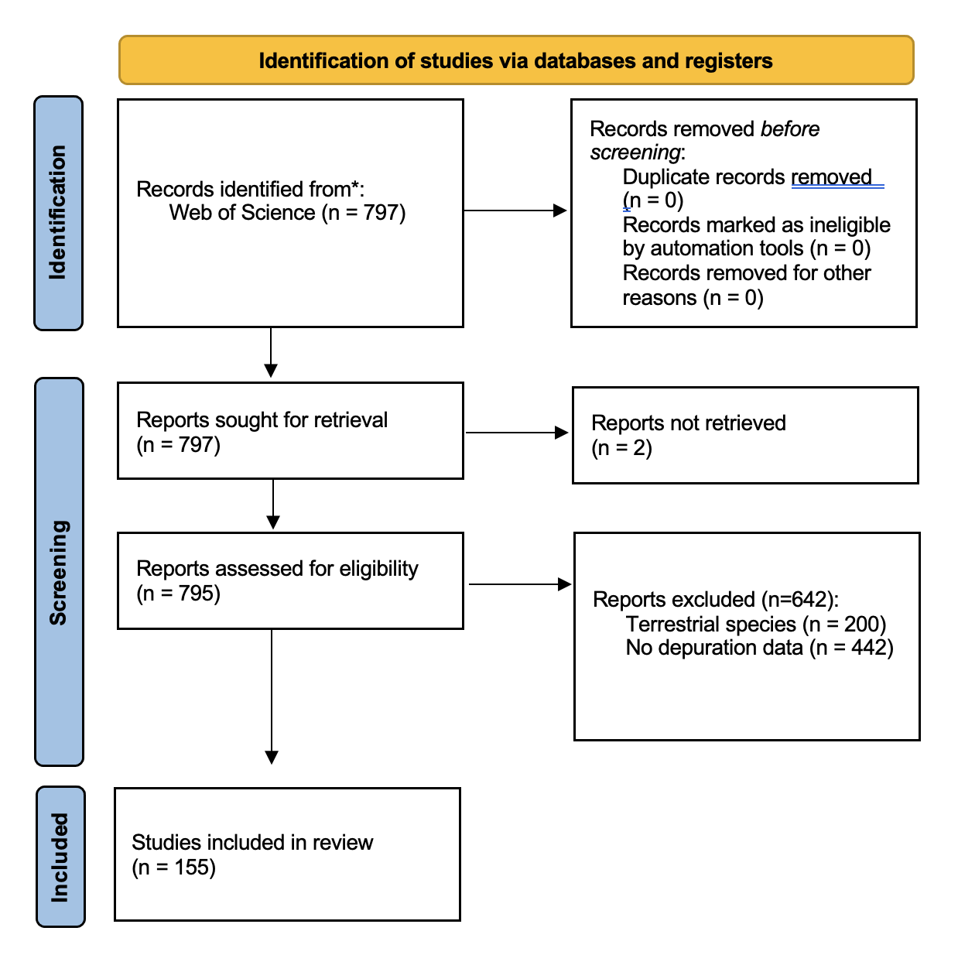

**Figure S1.** PRISMA 2020 flow diagram detailing the literature review inclusion criteria.

To-do list:

* Fine tune figure

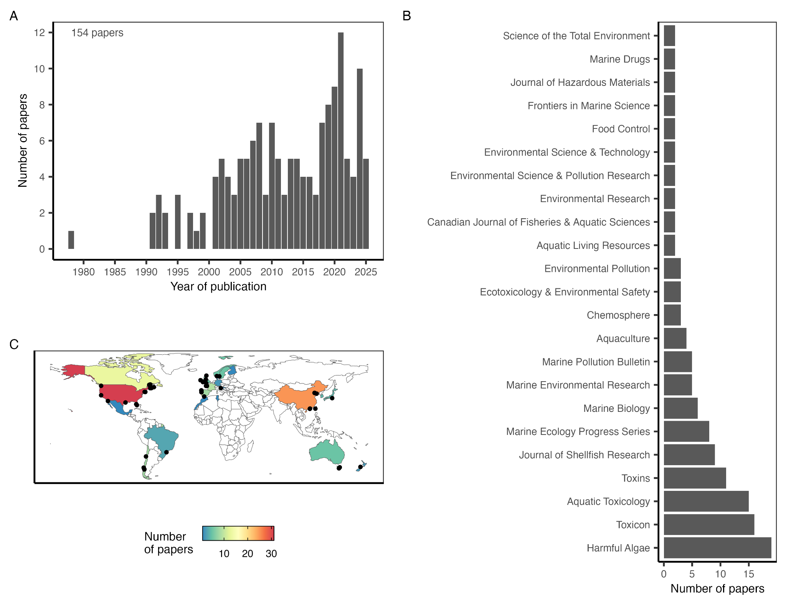

**Figure S2.** The number of papers measuring marine biotoxin depuration rates **(A)** over time, **(B)** by journal; and **(C)** by country of the lead author’s primary affiliation. In **(C)**, points mark locations where depuration rates have been quantified from field monitoring data.

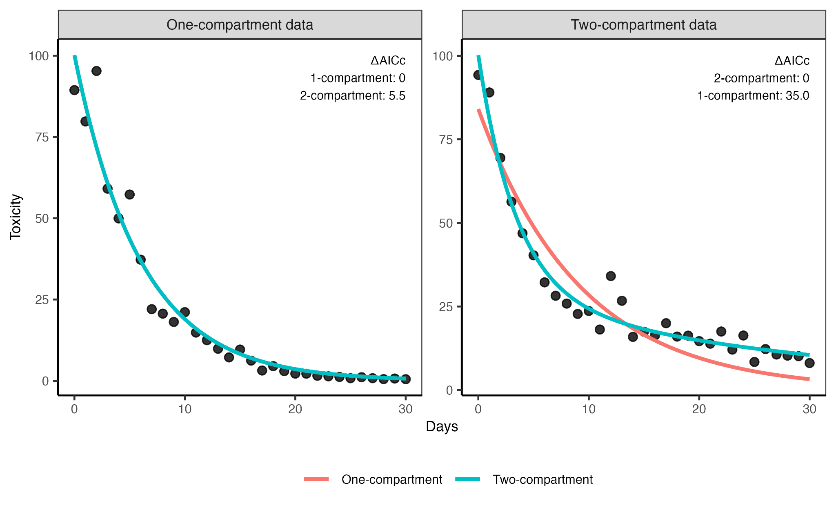**Figure S3.** One- (red) and two-compartment (blue) exponential decay models fit to data generated from a one-compartment (left) and two-compartment (right) exponential decay process. Each dataset was evaluated with small-sample corrected Akaike information criterion (AICc) to identify the more parsimonious model; in both cases, the model corresponding to the true data-generating process was favored. The ΔAICc values are shown in the top-right.

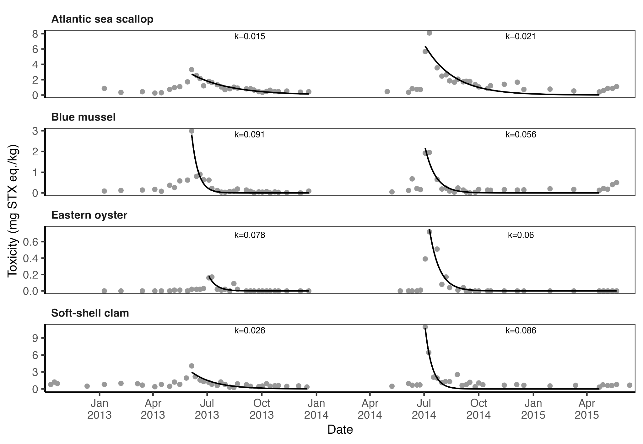**Figure S4.** An illustration of the methods for estimating paralytic shellfish toxin (PST) depuration rates from biotoxin monitoring data on four shellfish species from Deadmans Harbour, New Brunswick, Canada. Data are from [(Rourke et al., 2021)](https://www.zotero.org/google-docs/?z2z0r6). The black line shows the fit of a one-compartment depuration model to the depuration phase of annual toxin events; the exponential decay constant (k) associated with each curve is printed above the curve.

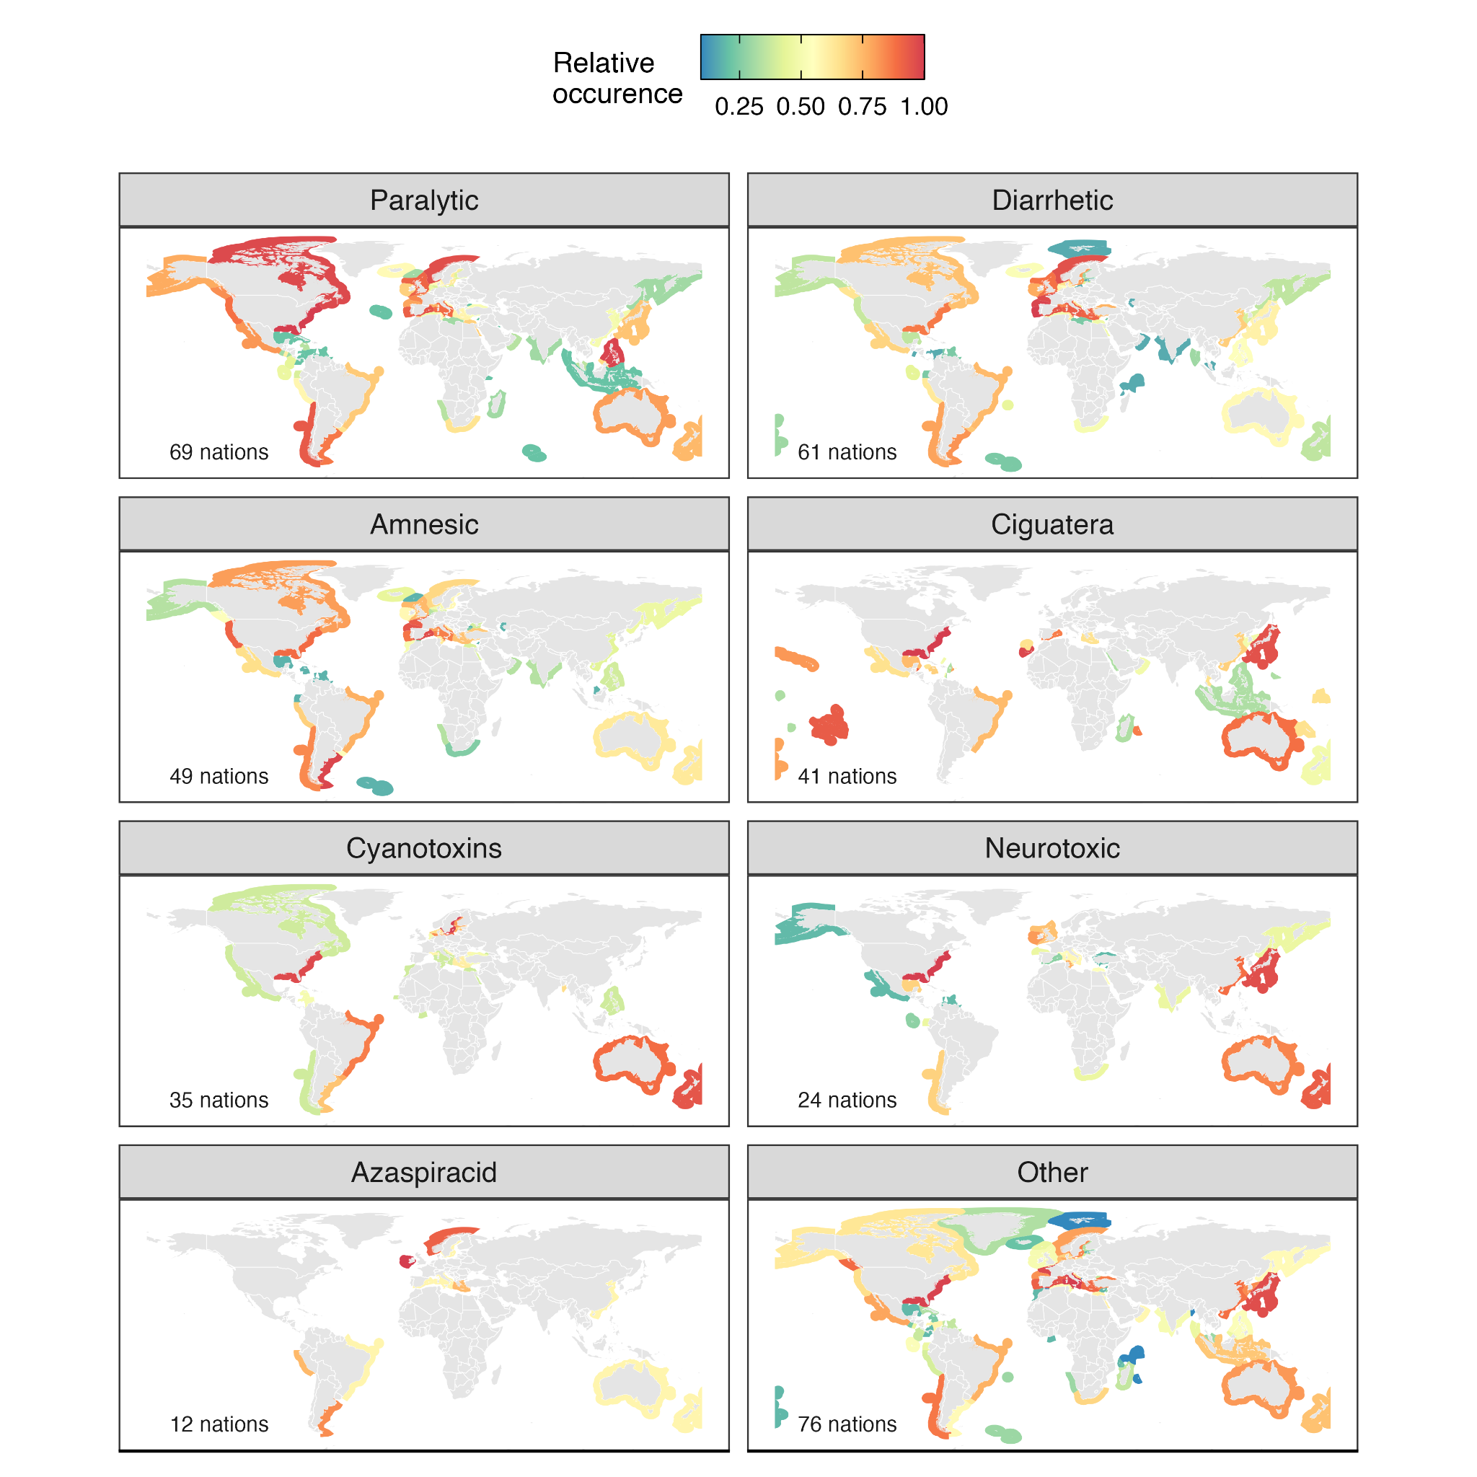**Figure S5.** Exclusive economic zones (EEZs) exposed to harmful algae and their associated public health risks. Shaded EEZs have HAB species present based on OBIS. Syndromes are sorted by the number of EEZs with observations of HAB species; the number of EEZs impacted (out of 257) is printed in the bottom right.

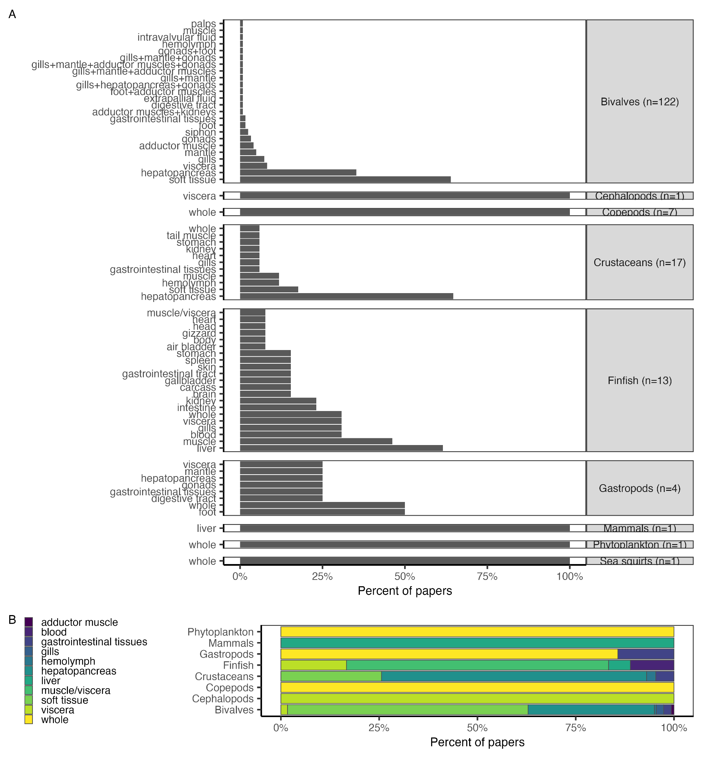**Figure S6.** Panel **A** shows the frequency with which different tissues are evaluated for biotoxin depuration rates by taxonomic class. The x-axis represents the percent of papers on species within each class evaluating depuration rates for each tissue. The number of papers on species within each class is printed in the class label. Tissues are ordered in increasing frequency (bottom to top). Panel **B** shows the frequency with which different tissues are evaluated for biotoxin depuration rates by taxonomic class in papers in which only a single tissue is evaluated.

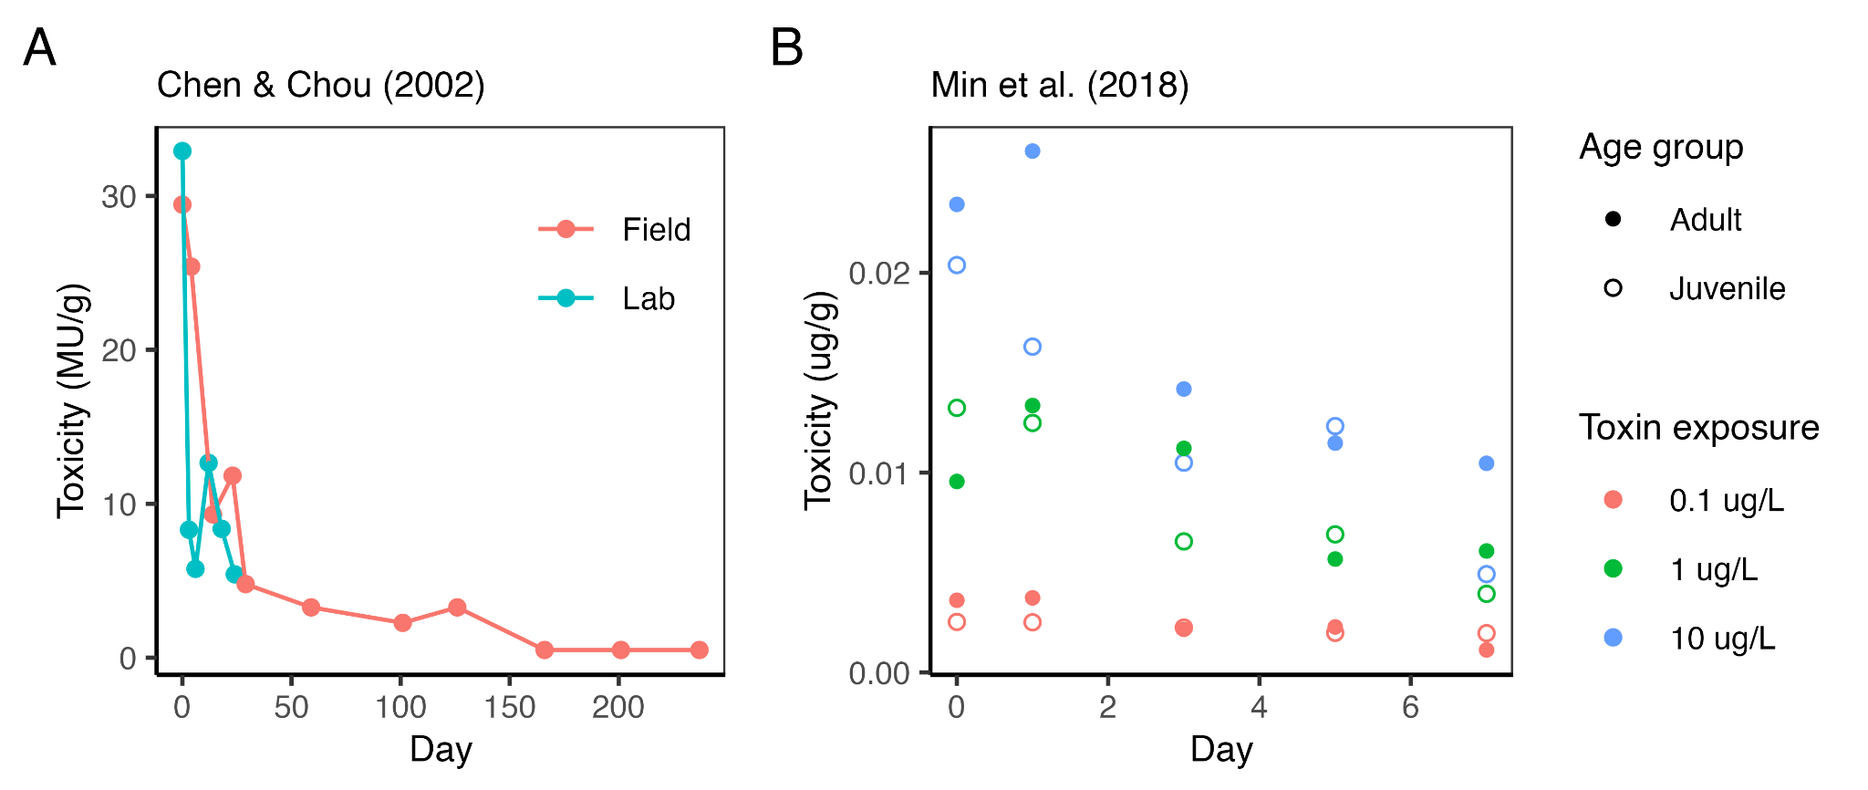

**Figure S7.** A comparison of exponential decay rates among the experimental treatments evaluated in **(A)** Chen and Chou (2002) and **(B)** Min et al. (2018). Data were extracted from each paper using WebPlotDigitizer [(Rohatgi, 2025)](https://www.zotero.org/google-docs/?9mzQHr). Depuration rates were measured as either the *k* parameter from a one-compartment exponential decay model or the *k1* parameter from a two-compartment model based on whichever model offered the most parsimonious fit. The rates are printed in the top-right corner of each plot.

* Add fits
* Add k parameters
* Assess statistical difference between k parameters

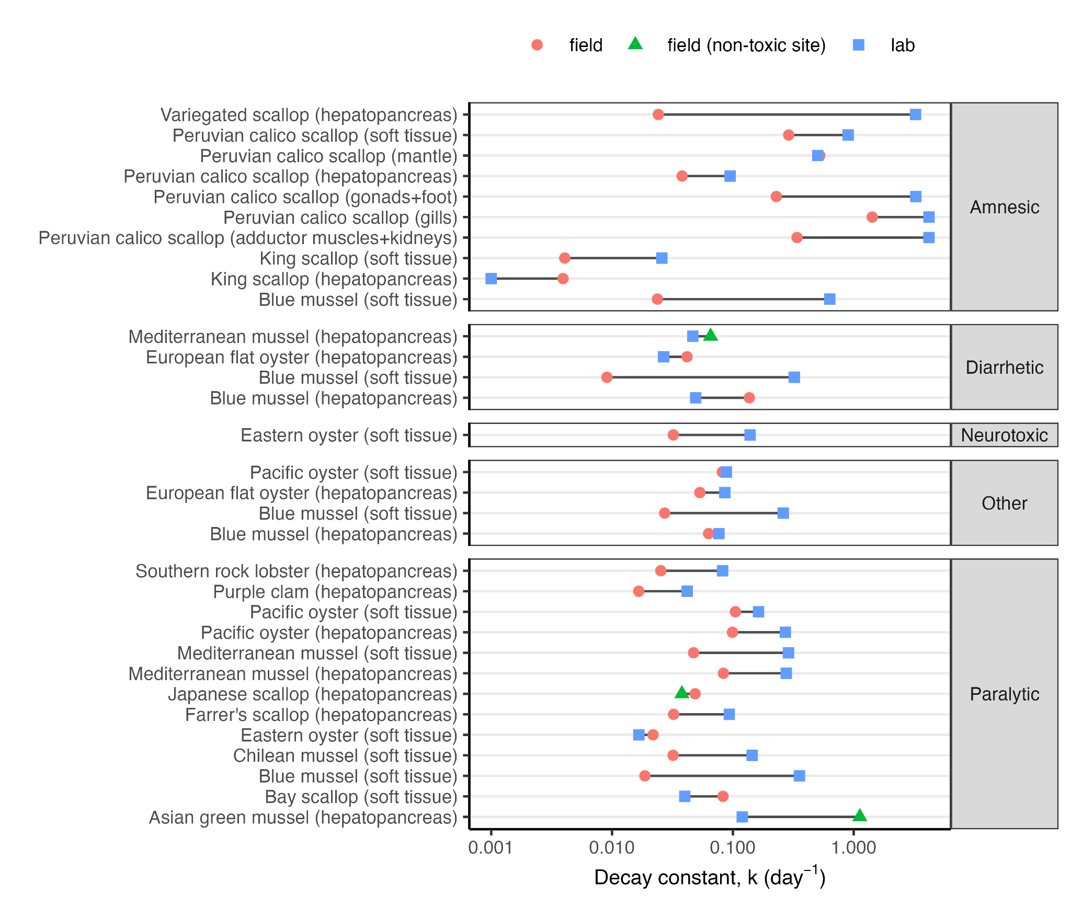**Figure S8.** A comparison of average depuration rates in the field versus the lab by species, tissue, and toxin. In general, depuration is faster in the lab than in the field.

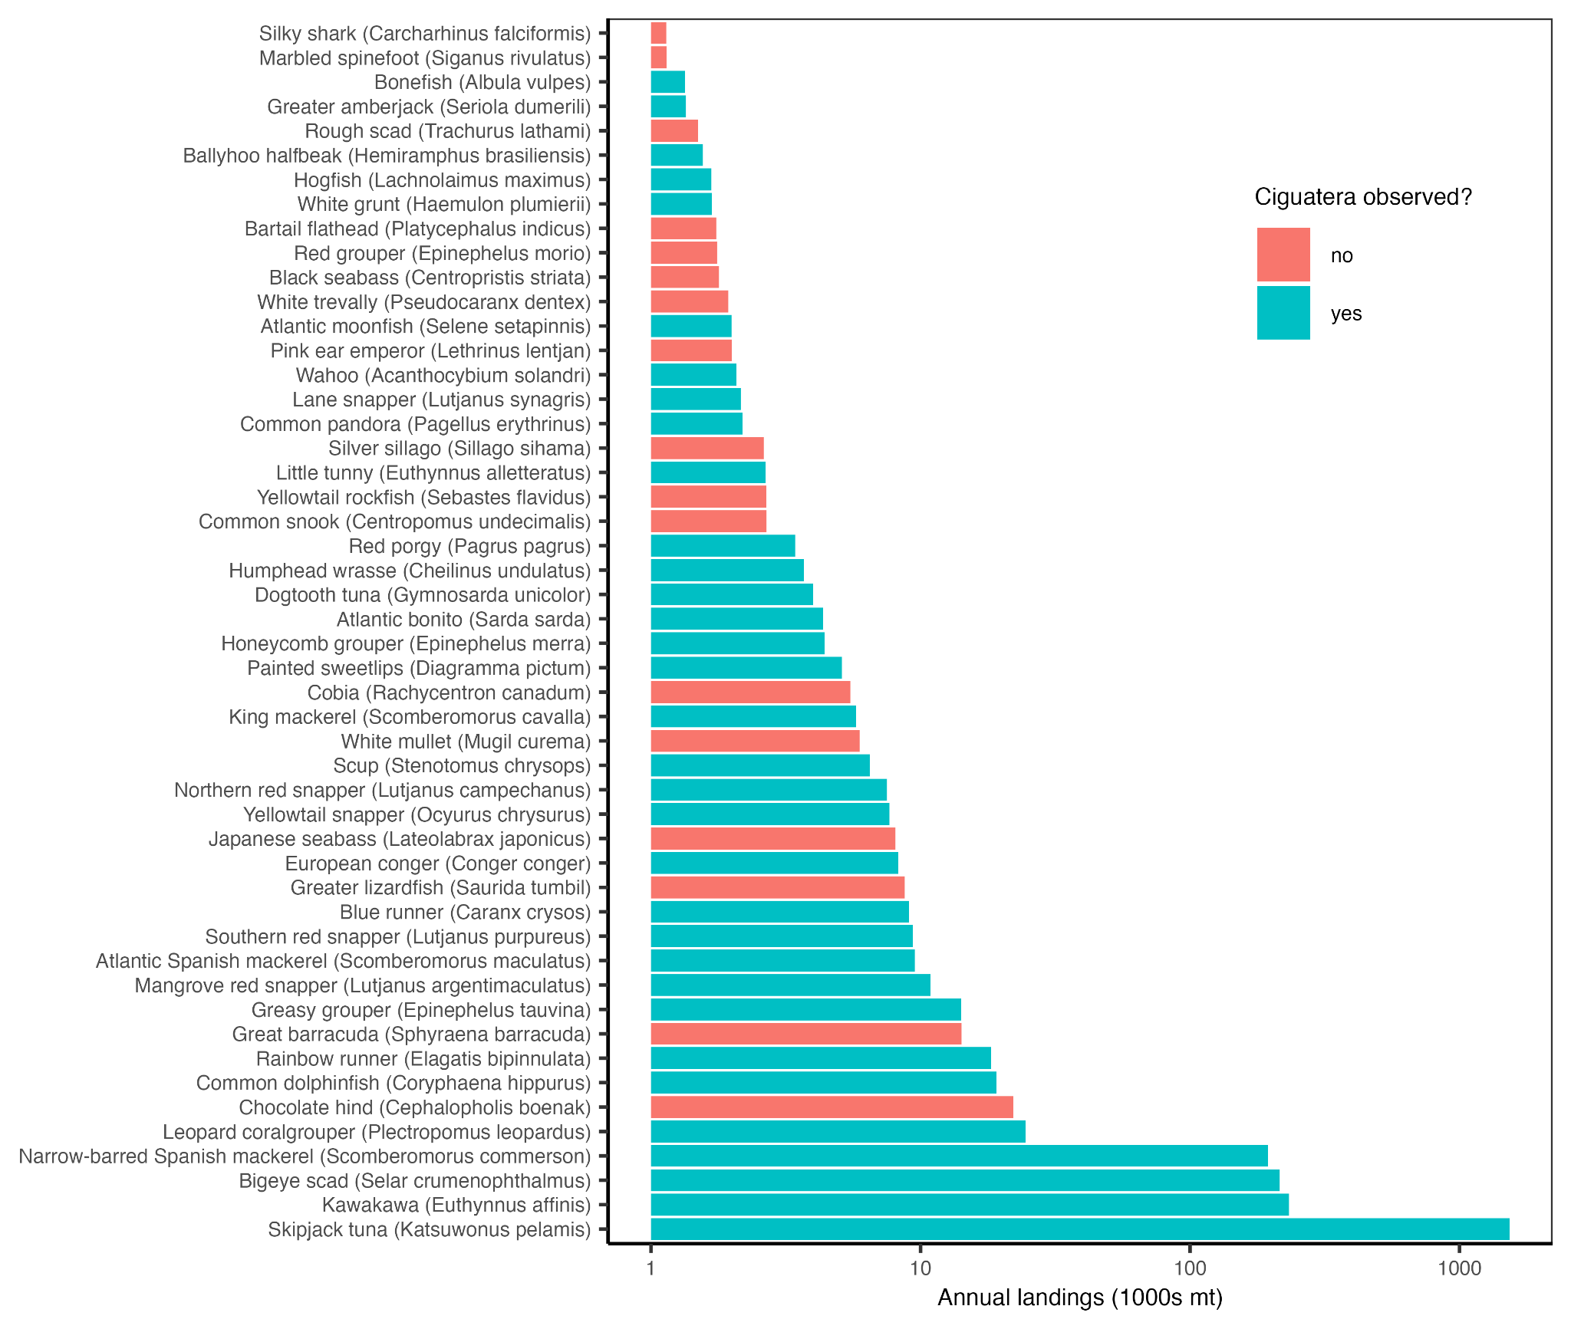

**Figure S9.** The top-50 marine finfish vulnerable to ciguatera most frequently landed by fisheries from 2014-2023 from countries with known ciguatera occurrences. Marine finfish vulnerable to ciguatera were identified as those with reported ciguatera occurrences (known) and large (>25 cm max length), reef-associated, non-herbivorous marine finfish speculated to be vulnerable to ciguatera. Ciguatera depuration rates have not been studied for any of these species.

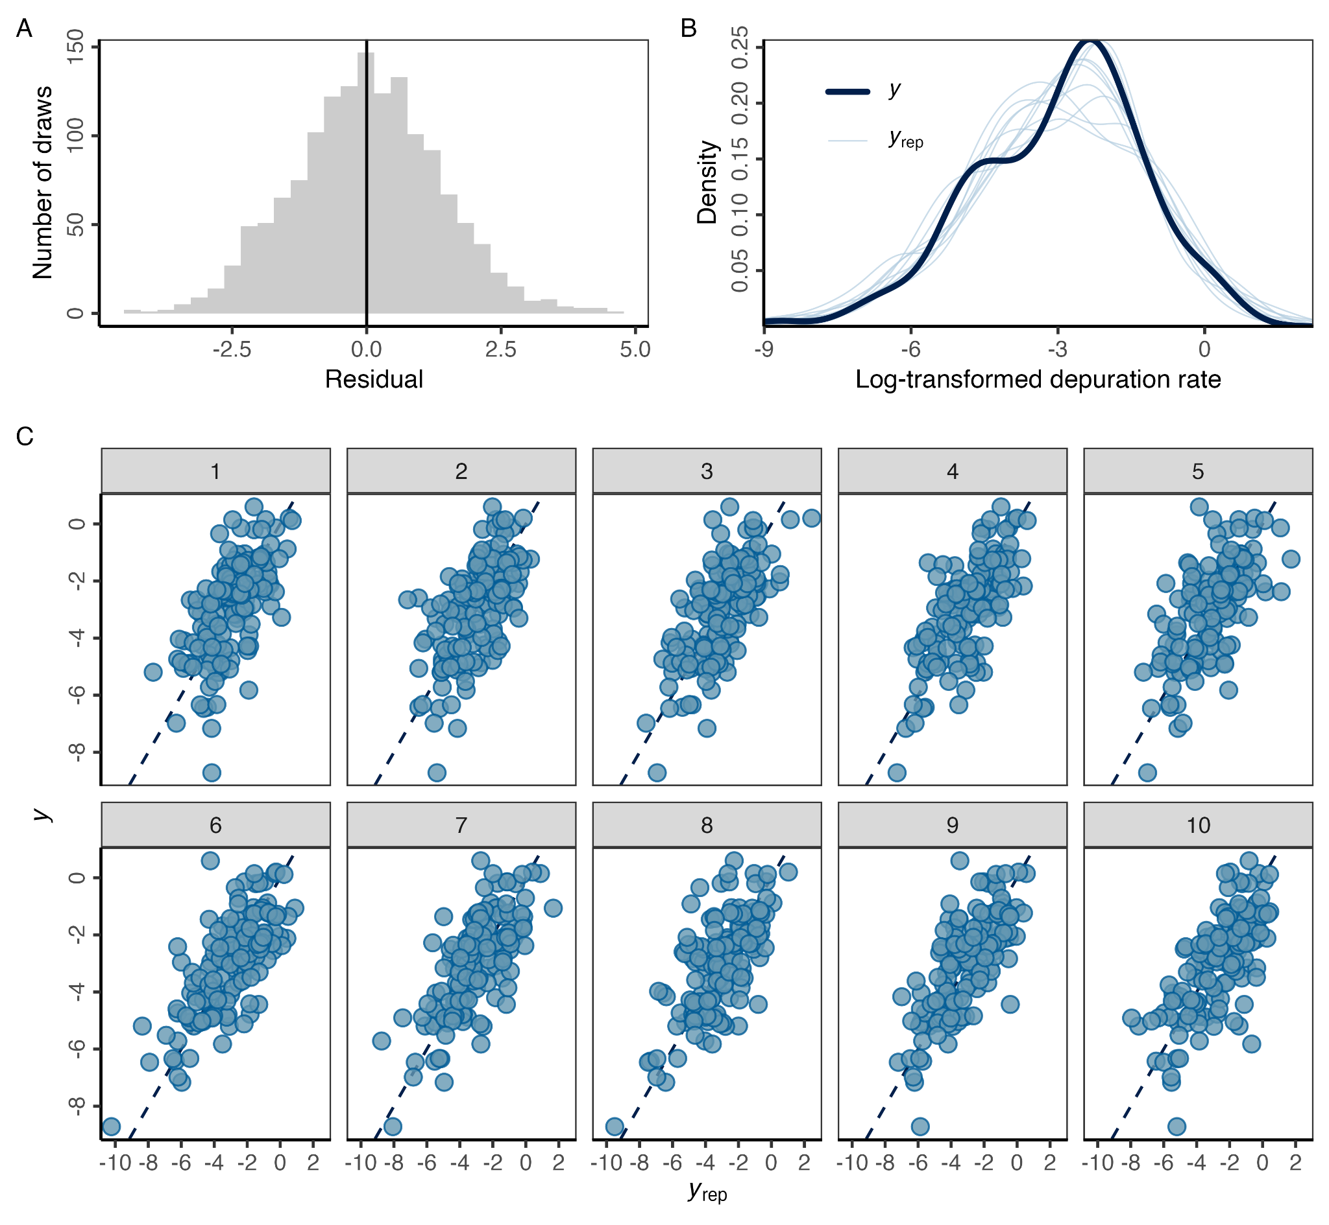**Figure S10.** Model diagnostic plots for the best performing Bayesian regression model showing **(A)** the distribution of the residuals in 10 posterior draws; **(B)** distribution of the response variable in the data (*y*) versus 10 posterior draws (*yrep)*; and **(C)** correlation between the response variable in the data (*y*) versus 10 posterior draws (*yrep)*. In **(C)**, the diagonal line represents the one-to-one line and each facet represents a set of posterior draws.

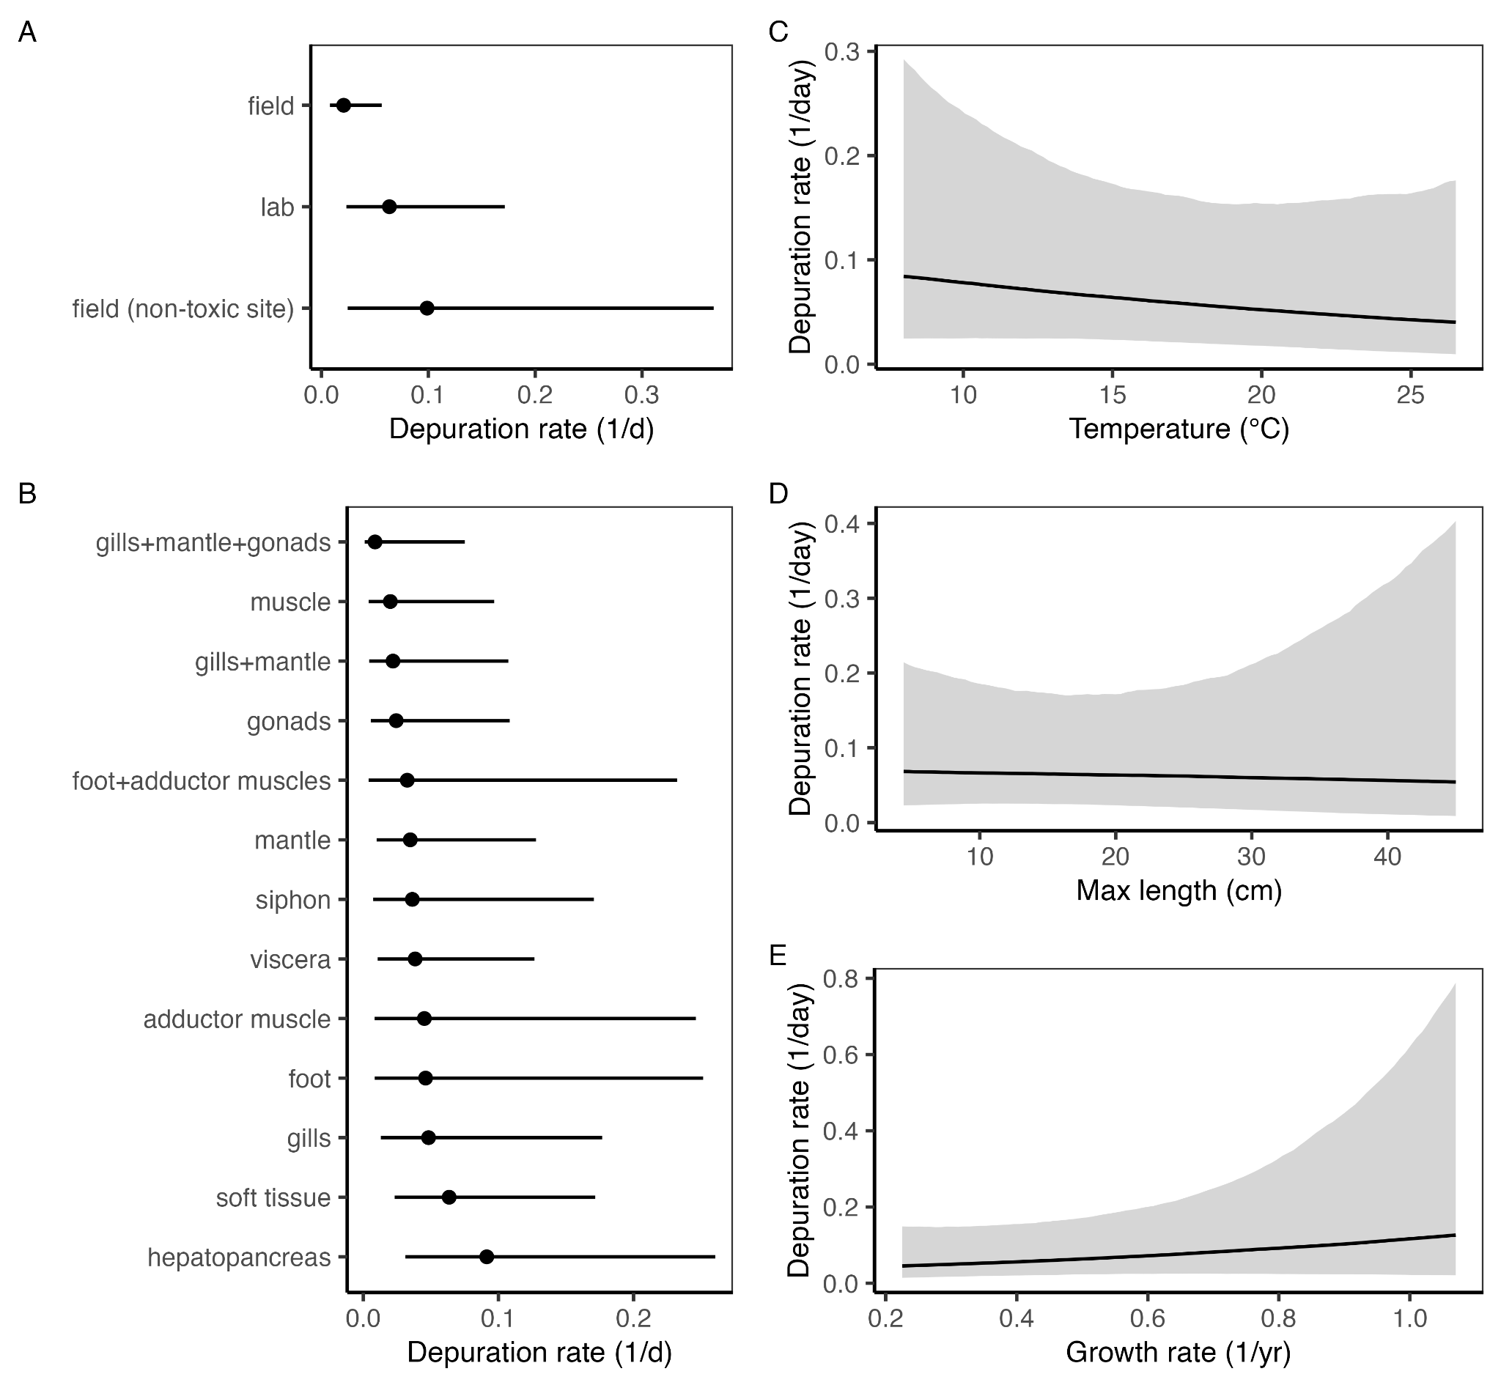**Figure S11.** The conditional effects of the **(A)** location; **(B)** tissue, (**C)** preferred temperature, **(D)** maximum length, and **(E)** von Bertalanffy growth rate fixed effects variables included in the best performing Bayesian regression model. Conditional effects illustrate the depuration rate expected for each fixed effect value when other fixed and random effects are held at their average. In **(A)** and **(B)**, points represent the median and lines represent the 95% credible interval. In **(C**-**D)**, lines represent the median and sharing indicates the 95% credible interval.

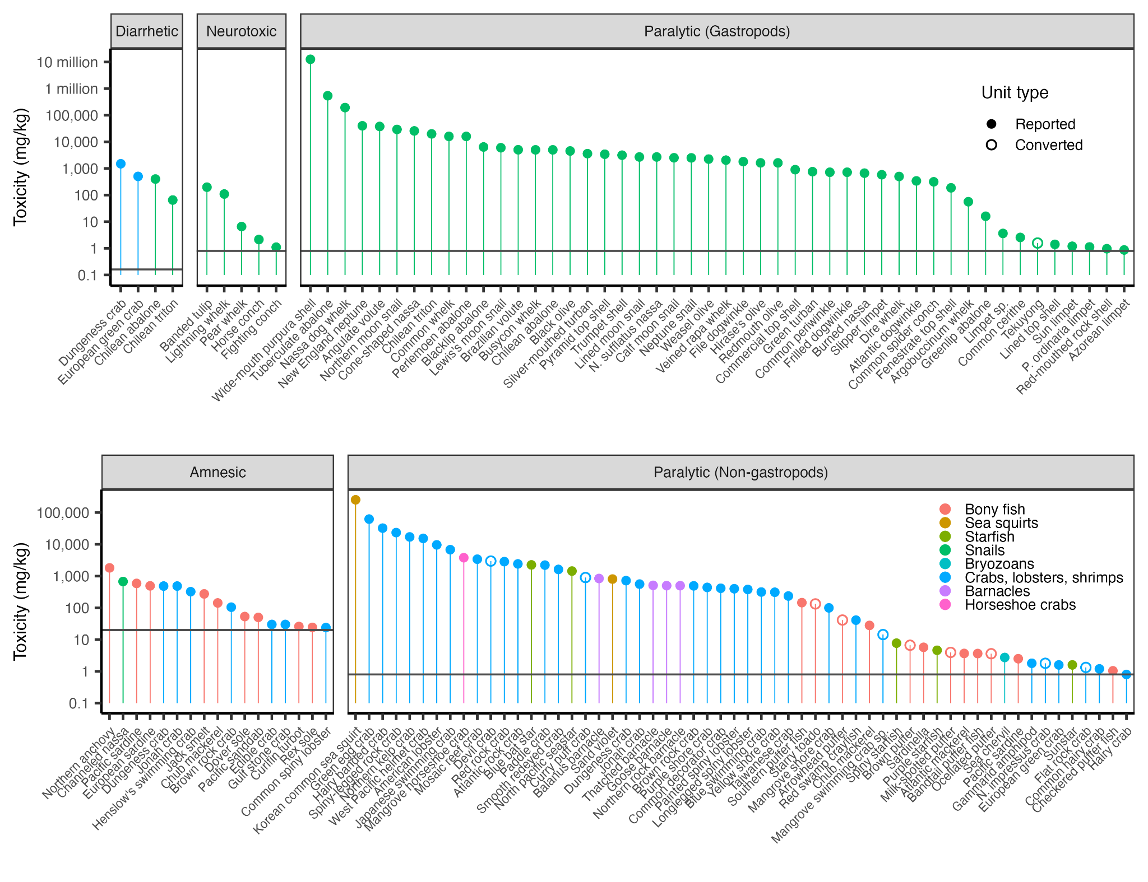**Figure S12.** Maximum biotoxin toxicities observed in non-bivalve species reported in select review papers [(Costa et al., 2017; Deeds et al., 2008; Lefebvre and Robertson, 2010)](https://www.zotero.org/google-docs/?QcWIJr) relative to the most common international action thresholds [(Langlois and Morton, 2018)](https://www.zotero.org/google-docs/?LKnXun), which are indicated by the solid horizontal lines. Note that toxicities in units of mg/kg, μg/g, and ppm are all numerically equivalent (i.e., the y-axis can be directly interpreted as μg/g or ppm). When necessary, we converted PST mouse units (MU) to μg assuming that 1 MU equals 0.18 μg STX equivalents [(Arnich and Thébault, 2018)](https://www.zotero.org/google-docs/?nAO6DE); converted toxicities are shown by open circles.

To-do list:

* Mark which are consumed or not consumed by people